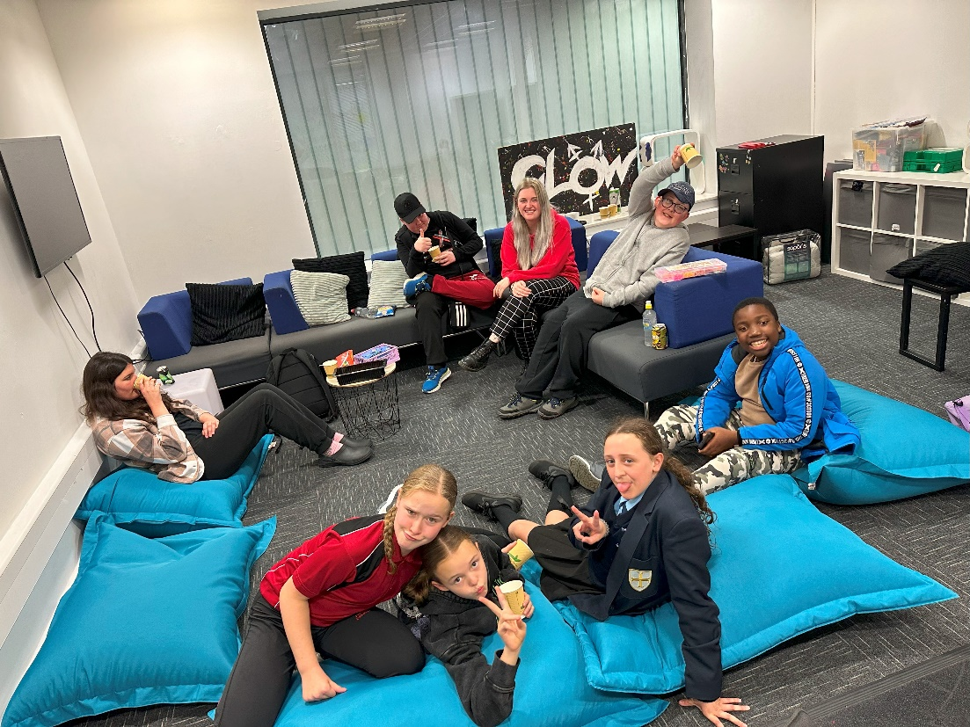

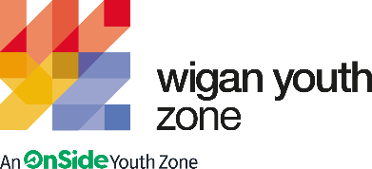
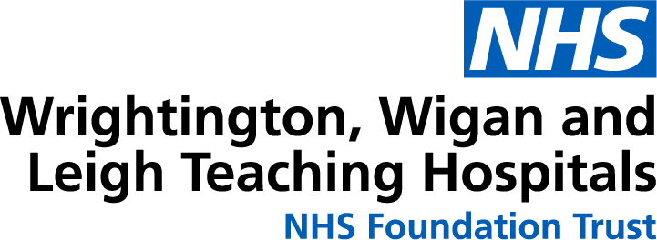

wwl OUTREACH ENGAGEMENT WORKER
  - Job Description

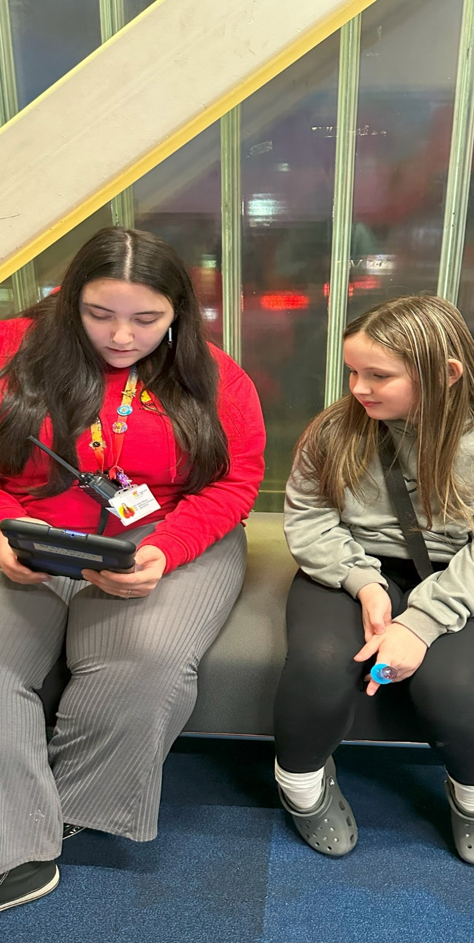 | COMPANY: Wigan Youth Zone (Employer)  LOCATION: Wigan Youth Zone and Royal Albert Edward Infirmary (RAEI)  SALARY: up to 26k  BENEFITS:  - 33 days annual leave (including bank holidays) pro rata. Plus, additional leave for length of service,  - Hybrid work,  - Birthdays off,  - Gym access,  - Training and CPD including first aid, safeguarding and health and safety,  - Career development opportunities,  - Cycle to work scheme,  - Strong team culture,  - Workplace pension,  - Free eye tests,  - Discounted access for children to attend WYZ holiday club (£2 a day),  - Access to Lifeline Plus: Virtual medical care.  POSTED: 23rd October 2025  CLOSING: 9th November 2025  First interviews: TBC  Second interviews: TBC  SPECIALISM: Youth Work  REPORTS TO: Head of Operations / Head of Youth Work.  CONTRACT TYPE: Fixed term (12 months) with opportunity to extend, if pilot is successful.  HOURS: 40 hours (including 30 minutes unpaid lunchbreak)  WORK PATTERN:  Wigan Youth Zone – Tues (10:00-18:00) and Weds (13:00-21:00)  RAEI – Thurs-Sat (12.00-20.00)  ORGANISATION TYPE: Charity
  OVERVIEW

Role Outline:
This role is designed to act as a vital bridge between young people aged 8–19 who attend Rainbow Ward and the Emergency Department (ED) at Royal Albert Edward Infirmary (RAEI) and Wigan Youth Zone (WYZ) - and the wider network of youth services available across the borough. The post-holder will play a key role in building trust-based relationships with young people during vulnerable moments in their lives—often during repeat or emergency hospital visits—and use these interactions as opportunities to connect them with positive, supportive environments outside of the hospital setting.
This is an innovative and pioneering initiative, launched as a collaboration between WWL NHS Foundation Trust and Wigan Youth Zone, aimed at supporting young people in new and meaningful ways. The role represents a unique opportunity to shape a brand-new programme from the ground up, with the ambition of creating a sustainable model that can continue beyond the initial 12-month pilot. The post holder will set up a youth voice group within the hospital and will be an advocate for young people within WWL..
We are seeking an independent, proactive self-starter who brings creativity, empathy, and out-of-the-box thinking. The successful candidate will be instrumental in designing and delivering a youth-centred approach that not only responds to immediate needs but also contributes to long-term wellbeing and engagement. This is a chance to make a lasting impact on how health and youth services work together to support young people in Wigan.

Knowledge and Understanding
Knowledge of the issues affecting young people in today’s society and how to plan activities with a view to raising awareness around relevant topics.
To be empathetic and approachable person who will listen to young people and support them with relevant information, advice and guidance.
In-depth knowledge of the Lundy Model of Participation, including its four key concepts: Space, Voice, Audience, and Influence, and how these can be embedded in youth work practice to ensure meaningful participation of young people in decision-making processes.
An ability to work with a diverse range of young people including; ages, gender, sexuality, needs and abilities.
Knowledge and understanding of emotional wellbeing, mental health and how to sign post onto other relevant services and/or undertake work around positive coping strategies and how to keep safe.
Understanding of the principles of working with children and young people including behaviour that challenges and trauma informed practice.
Knowledge of health and safety, diversity awareness and safeguarding best practice and how these relate to children and young people.
Delivery of activities within an equality framework.
To lead from the front following our vision and values and embedding these in our offer.

Qualifications
Introduction to Youth Work and Community Work NVQ/VRQ Level 2 – Desirable

What will you need to succeed:

EXPERIENCE
Experience in delivering inclusive activities, working with children and young people (aged 8 plus) | Essential
Experience of working with young people with additional needs, disabilities or long-term illnesses | Desirable
Experience of supporting young people who are underachieving and/or have social/ emotional barriers to participation | Essential
Experience of working in a team and alongside volunteers | Essential
Experience of dealing with safeguarding issues within a multi-agency setting | Essential
Experience of working with partners and collaborating on projects | Desirable
SKILLS
Ability to work with young people to develop their skills by providing programmes of activities. | Essential
Ability to develop good professional relationships with children, young people and adults | Essential
Ability to coach, encourage, motivate and provide reliable support to children and young people | Essential
Confident in working with young people on a 1-2-1 basis | Essential
Ability to identify and challenge discrimination and discriminatory behaviour, taking appropriate action as necessary | Essential
Strong active listening and communication skills to understand and respond to young people and adults | Essential
KNOWLEDGE AND UNDERSTANDING
Understanding the principles of working with children and young people | Essential
Understanding of issues affecting young people’s lives | Essential
Ability to deliver high quality activity programmes with children and young people who face social exclusion, disadvantage and disaffection | Desirable
Knowledge of Health and Safety, diversity awareness and safeguarding best practice and how these relate to children and young people | Essential

WHat you will be doing

Key Responsibilities
- Build relationships with young people in Rainbow Ward and A&E to understand their interests, needs, and experiences.
- Refer young people to WYZ services and other borough-wide partners to support ongoing engagement post-hospital.
- Prioritise frequent attendees, as identified by WWL staff.
- Facilitate conversations with young people about their experiences of WWL services, identifying what works and what could improve.
- Create forums for young people to express their views and co-design service improvements.
- Work with WWL colleagues to implement changes and communicate outcomes back to young people.
- Be embedded within the WYZ team, acting as a familiar face during sessions and helping young people connect with other youth workers.
- Distribute and track free WYZ passes given to young people post-WWL visit.
- Monitor engagement and provide feedback to WWL on how to enhance the WYZ offer.
- Support the development of early-help interventions based on recurring needs identified through youth engagement.
- Attend youth and health networking events across the Borough promoting the partnership and building relationships to signpost young people.

General
- To be alert to issues of safeguarding child protection, ensuring the welfare and safety of Youth Zone members is promoted and safeguarded, and to report any child protection concerns to the designated Child Protection Officers using the safeguarding policies, procedures and practice (training to be provided).
- To assist with any promotional activities and visits that take place at the Youth Zone.
- To actively promote the Youth Zone and positively contribute towards increasing Youth Zone membership.
- To adhere to Wigan Youth Zone policies at all times, with particular reference to Health and Safety, Child Protection and Equal Opportunities.
Other duties
- To carry out any other duty with the Youth Zone and WWL provision and facility, and within the competencies of the post holder, as directed by your line manager or a senior manager.

Special Requirements

- A willingness to work unsociable hours when required.
- The ability and willingness to travel to meetings and events both in the region and beyond.
- The job holder will be required to adhere to WWL and Youth Zone’s policies at all times, with particular emphasis on Equal Opportunities and Safeguarding.
- In accordance with our Child Protection and Safeguarding procedures, this position requires an enhanced DBS check and business satisfactory references.
Please note that in line with our Safeguarding Policy, you must be aged 21 for this role as you will be working with all age-groups. All applicants must also be inactive as members for at least 12 months.

what is wigan youth zone?

Wigan Youth Zone is a purpose built, state-of-the-art youth facility in Wigan town centre which opened in June 2013. It offers young people from across Wigan the opportunity to meet friends, have new experiences, learn new skills and access the support they need to develop and achieve their potential.

The Youth Zone is open to all young people across Wigan aged from 8 to 19 (up to 25 with additional needs), striving to offer something for everyone, regardless of their interests or abilities. With almost 15 dedicated areas to choose from including our four 40-metre floodlit football pitches, art room, music room and climbing wall – there’s something for everyone here at Wigan Youth Zone.

Our aim is simple, to provide the town’s young people with somewhere to go, something to do and someone to talk to.

what do you need to do next

Please complete our application form and return it to hr@wiganyouthzone.org

84% of our Team would recommend Wigan Youth Zone as an employer to their family and friends

