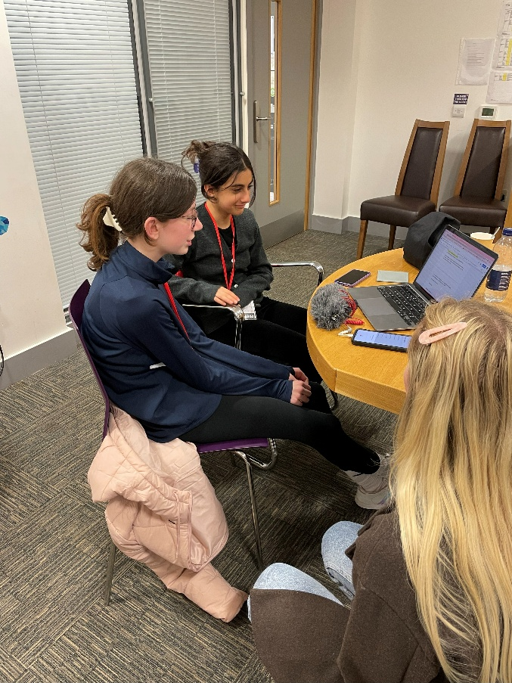

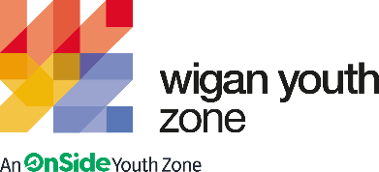

Multi-Media youth worker
Job Description

zz | COMPANY: Wigan Youth Zone  LOCATION: Wigan Youth Zone  SALARY: £12.35 per hour  BENEFITS:  - 33 days annual leave (including bank holidays) pro rata. Plus, additional leave for length of service.  - Hybrid work,  - Birthdays off,  - Gym access,  - training and CPD including first aid, safeguarding and health and safety,  - Career development opportunities,  - Employee assistance programme.  - Cycle to work scheme,  - Strong team culture,  - Workplace pension,  - Free eye tests,  - Discounted to £2 access to holiday club for WYZ staff.  - Access to Lifeline Plus: Virtual medical care  POSTED: 17th November 2025  CLOSING: 12th December 2025 (please apply early, we reserve the right to close this vacancy upon finding a suitable candidate)  First interviews: W/C 15th December  Second interviews: W/C 15th December  SPECIALISM: Film/Media/Radio/Podcasting  REPORTS TO: Head Of Arts  CONTRACT TYPE: Permanent  HOURS: Part time 7 hours permanent plus other casual hours available (funding dependant)  WORK PATTERN:  Sunday 11-7pm (permanent)  Optional Friday 4-9pm (fixed term until April)  All hours will be face-to-face delivery with young people and will include a weekend shift.  ORGANISATION TYPE: Charity
  OVERVIEW
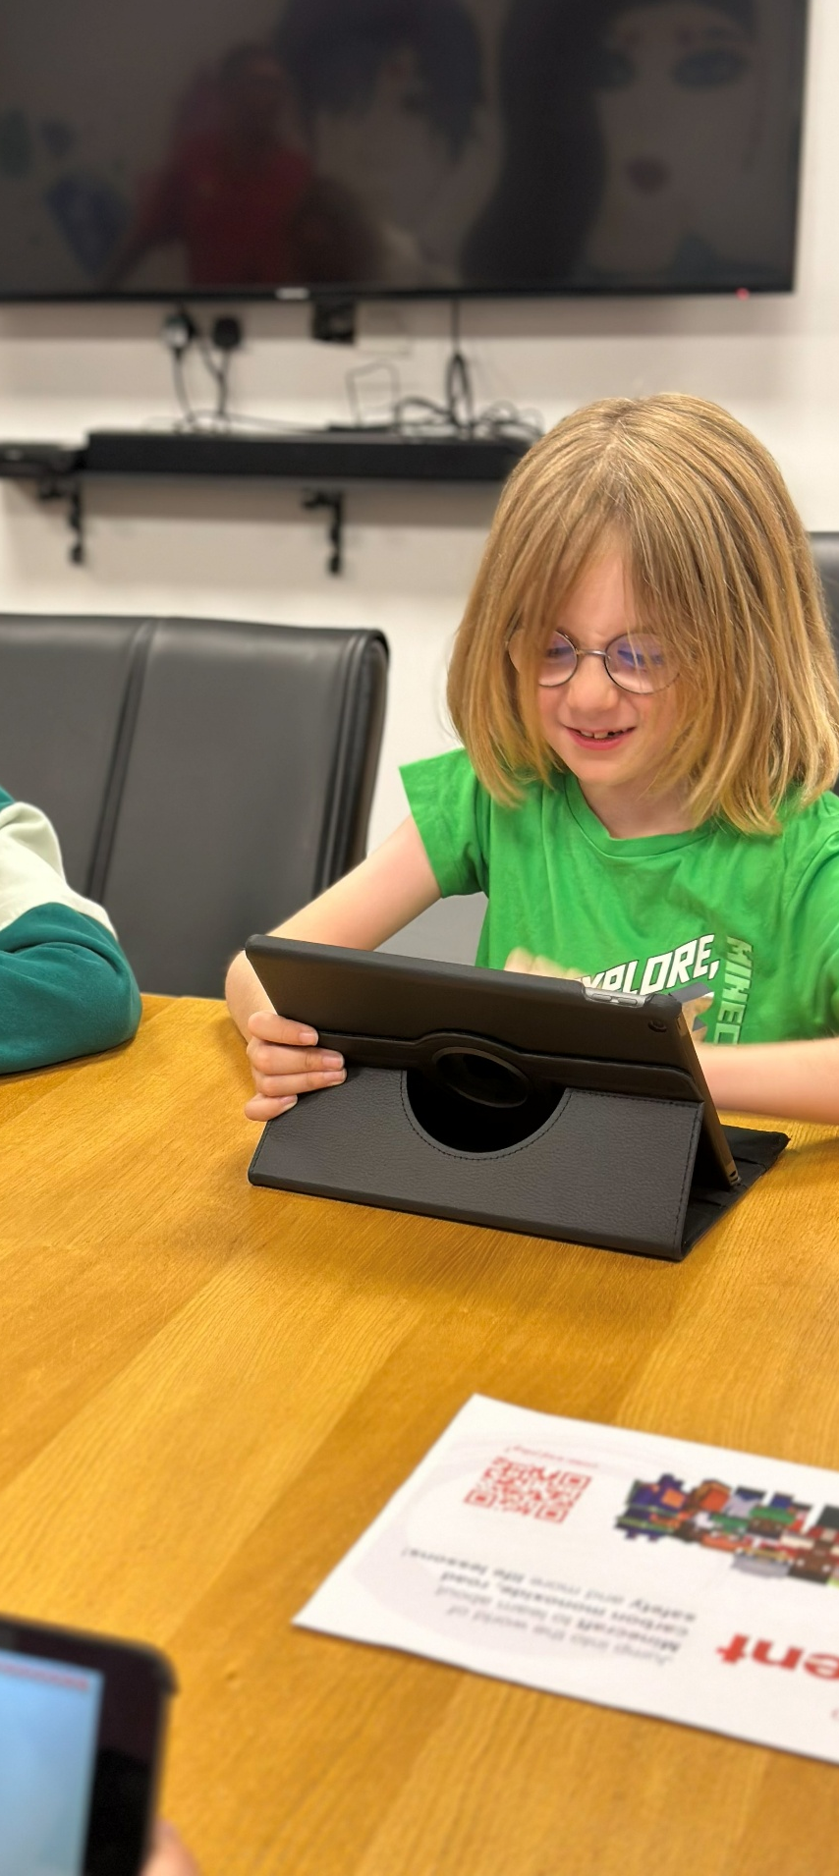

who we are looking for:
We are seeking a dynamic and versatile Media Youth Worker to join our team and support their line manager in the delivery of sessions across a range of Junior and Senior sessions. We currently have a purpose-built radio booth that is currently not being used, and we are looking for a passionate person with relevant experience to drive forward a new programme.
We are looking for someone who is confident in working with young people aged 8-19, as well as those up to 25 with additional needs, providing tailored support and creating an inclusive environment where everyone can thrive.
The ideal candidate will be an all-rounder with a passion for working with young people and a strong background in various multi-media disciplines. This role involves mentoring and inspiring youth through creative expression, with a focus on one or more of the following skills: Film, Multimedia, Podcasting and Animation.
They should also possess effective communication and interpersonal skills, allowing them to connect with young people from diverse backgrounds. Empathetic and patient, they provide a safe and supportive environment where young people feel valued and heard.

Knowledge and Understanding
- Media Production: Understanding of multi-media production, recording techniques, and/or media creation, including videography and editing and/or broadcasting.
- Youth Development: Knowledge of the developmental stages and needs of young people, particularly in the context of creative expression.
- Safeguarding and Child Protection: Familiarity with safeguarding policies and procedures to ensure the safety of young participants.
- Behaviour Management: Techniques for managing and positively influencing youth behaviour on music/media sessions -
- Diversity and Inclusion: Awareness of cultural, social, and individual diversity, and strategies to create an inclusive environment.
- Communication Skills: Effective verbal and non-verbal communication techniques tailored to different age groups and needs.
- Youth Engagement Strategies: Experience using methods to engage and motivate young people in music and media activities.
- Health and Safety: Understanding of health and safety regulations and practices within a youth zone setting, especially related to equipment use.
- Programme Planning and Delivery: Experience in designing, planning, and delivering engaging music and media programmes.
- Conflict Resolution: Techniques for resolving conflicts and mediating disputes among young people.
- Emotional Intelligence: Ability to recognize and respond to the emotional needs of young people.
- Teamwork and Collaboration: Working effectively with colleagues, volunteers, and external partners.
- Technology and Media Tools: Proficiency with digital tools and media software used in music production and videography.
- Mentorship and Coaching: Providing guidance and support to help young people develop their creative skills and achieve their goals.

Qualifications
Introduction to Youth Work and Community Work NVQ/VRQ Level 2 – Desirable
Relevant multi-media/broadcasting qualifications or equivalent experience - Desirable

What will you need to succeed:

EXPERIENCE
Experience in delivering music or media activities, working with children and young people (aged 8 plus) | Essential
Experience of working with young people with additional needs or disabilities | Desirable
Experience of supporting young people who are disaffected, underachieving and / or have social / emotional barriers to participation | Desirable
Experience of working in a team and alongside volunteers | Desirable
Experience of dealing with safeguarding issues within a multi-agency setting | Essential
SKILLS
Ability to work with young people to develop their skills by providing music/media programmes of activities, services and facilities that are fun and enable young people and adults | Essential
Ability to develop good professional relationships with children, young people and adults | Essential
Ability to coach, encourage, motivate and provide reliable support to children and young people | Essential
Confident in working with young people on a 1-2-1 basis | Essential
Confident working with larger groups of young people (20+) | Essential
Ability to identify and challenge discrimination and discriminatory behaviour, taking appropriate action as necessary | Essential
KNOWLEDGE AND UNDERSTANDING
Understanding the principles of working with children and young people | Essential
Understanding of issues affecting young people’s lives | Essential
Ability to deliver high quality activity programmes with children and young people who face social exclusion, disadvantage and disaffection | Desirable
Knowledge of Health and Safety, diversity awareness and safeguarding best practice and how these relate to children and young people | Essential

WHat you will be doing

- You will be part of our Creative Arts team facilitating creative activities with young people.
- Most sessions will be group work with young people, in either open access or closed-door sessions and focused sessions with targets in engagement and projects. You will also be responsible for tracking young people’s progression via our Wheel System.
- Support young people’s goals and aspirations in the creative arts.
- To be a positive role model and create a positive and fun environment in which to motivate and encourage young people to reach their potential.
- To be creative and encourage young people to do the same – involving them in all the steps of participation.
- To help record and evaluate the sessions and involve young people in the evaluation process.
- To ensure the participation of young people in activities and that their ideas contribute fully in the delivery and evaluation of activities.
- To always promote and safeguard the welfare of children and young people.
- To be an active member of the team and operate in line with the values and principles of Wigan Youth Zone.

General
- To be alert to issues of safeguarding child protection, ensuring the welfare and safety of Youth Zone members is promoted and safeguarded, and to report any child protection concerns to the designated Child Protection Officers using the safeguarding policies, procedures and practice (training to be provided);
- To assist with any promotional activities and visits that take place at the Youth Zone.

- To actively promote the Youth Zone and positively contribute towards increasing Youth Zone membership.
- To always adhere to Wigan Youth Zone policies, with reference to Health and Safety, Child Protection and Equal Opportunities.

Other duties
- To carry out any other duty with the Youth Zone provision and facility operations, and within the competencies of the post holder, as directed by your line manager or a senior manager.

Special Requirements

A willingness to work unsociable hours when required
DBS clearance and committed to Safeguarding children
The ability and willingness to travel to meetings and events both in the region and beyond

The job holder will be required to always adhere to the Youth Zone’s policies, with particular emphasis on Equal Opportunities and Safeguarding. Attendance at events and conferences will sometimes be required.

In accordance with our Child Protection and Safeguarding procedures, this position requires an enhanced DBS check and business satisfactory references.

Please note that in line with our Safeguarding Policy, you must be aged 21 or over to work in our Senior Sessions and 19+ to work on our Junior Sessions and Holiday Clubs. All applicants must also be inactive as members for at least 12 months.

what is wigan youth zone?

Wigan Youth Zone is a purpose built, state-of-the-art youth facility in Wigan town centre which opened in June 2013. It offers young people from across Wigan the opportunity to meet friends, have new experiences, learn new skills and access the support they need to develop and achieve their potential.
The Youth Zone is open to all young people across Wigan aged from 8 to 19 (up to 25 with additional needs), striving to offer something for everyone, regardless of their interests or abilities. With almost 15 dedicated areas to choose from including our four 40-metre floodlit football pitches, art room, music room and purpose built in house radio station– there’s something for everyone here at Wigan Youth Zone.
Our aim is simple, to provide the town’s young people with somewhere to go, something to do and someone to talk to.

what do you need to do next

Please complete our application form and return it to hr@wiganyouthzone.org

88% of our Team would recommend Wigan Youth Zone as an employer to their family and friend

