|  |  |  |  |  |
| --- | --- | --- | --- | --- |
|  | | | | |
|  |  | | |  |
| wellbeing Youth Worker | | | | |
|  | | Job Description |  | |

|  |  |  |
| --- | --- | --- |
|  | |  | | --- | | OVERVIEW |   **COMPANY:** Wigan Youth Zone  **LOCATION:** Wigan Youth Zone  **SALARY:** £12.35 per hour  **BENEFITS:**   * 33 days annual leave (including bank holidays) pro rata. Plus additional leave for length of service. * Hybrid work, * Birthdays off, * Gym access, * training and CPD including first aid, safeguarding and health and safety, * Career development opportunities, * Employee assistance programme, * Cycle to work scheme, * Strong team culture, * Workplace pension, * Free eye tests, * Discounted to £2 access to holiday club for WYZ staff.   **POSTED: 24th September 2025**  **CLOSING: 8th October 2025**  **First interviews: TBC**  **Second interviews: TBC**  **SPECIALISM:** Youth Work/Well-being knowledge  **REPORTS TO:** Well-being Co-Ordinator  **CONTRACT TYPE:** Fixed-term until 25th July 2027  **HOURS:** Part time 9 hours per week  **WORK PATTERN:**  Tuesday 4-8pm and Friday 4-9pm  All hours will be face-to-face delivery with young people and will include a weekend shift.  **ORGANISATION TYPE:** Charity |

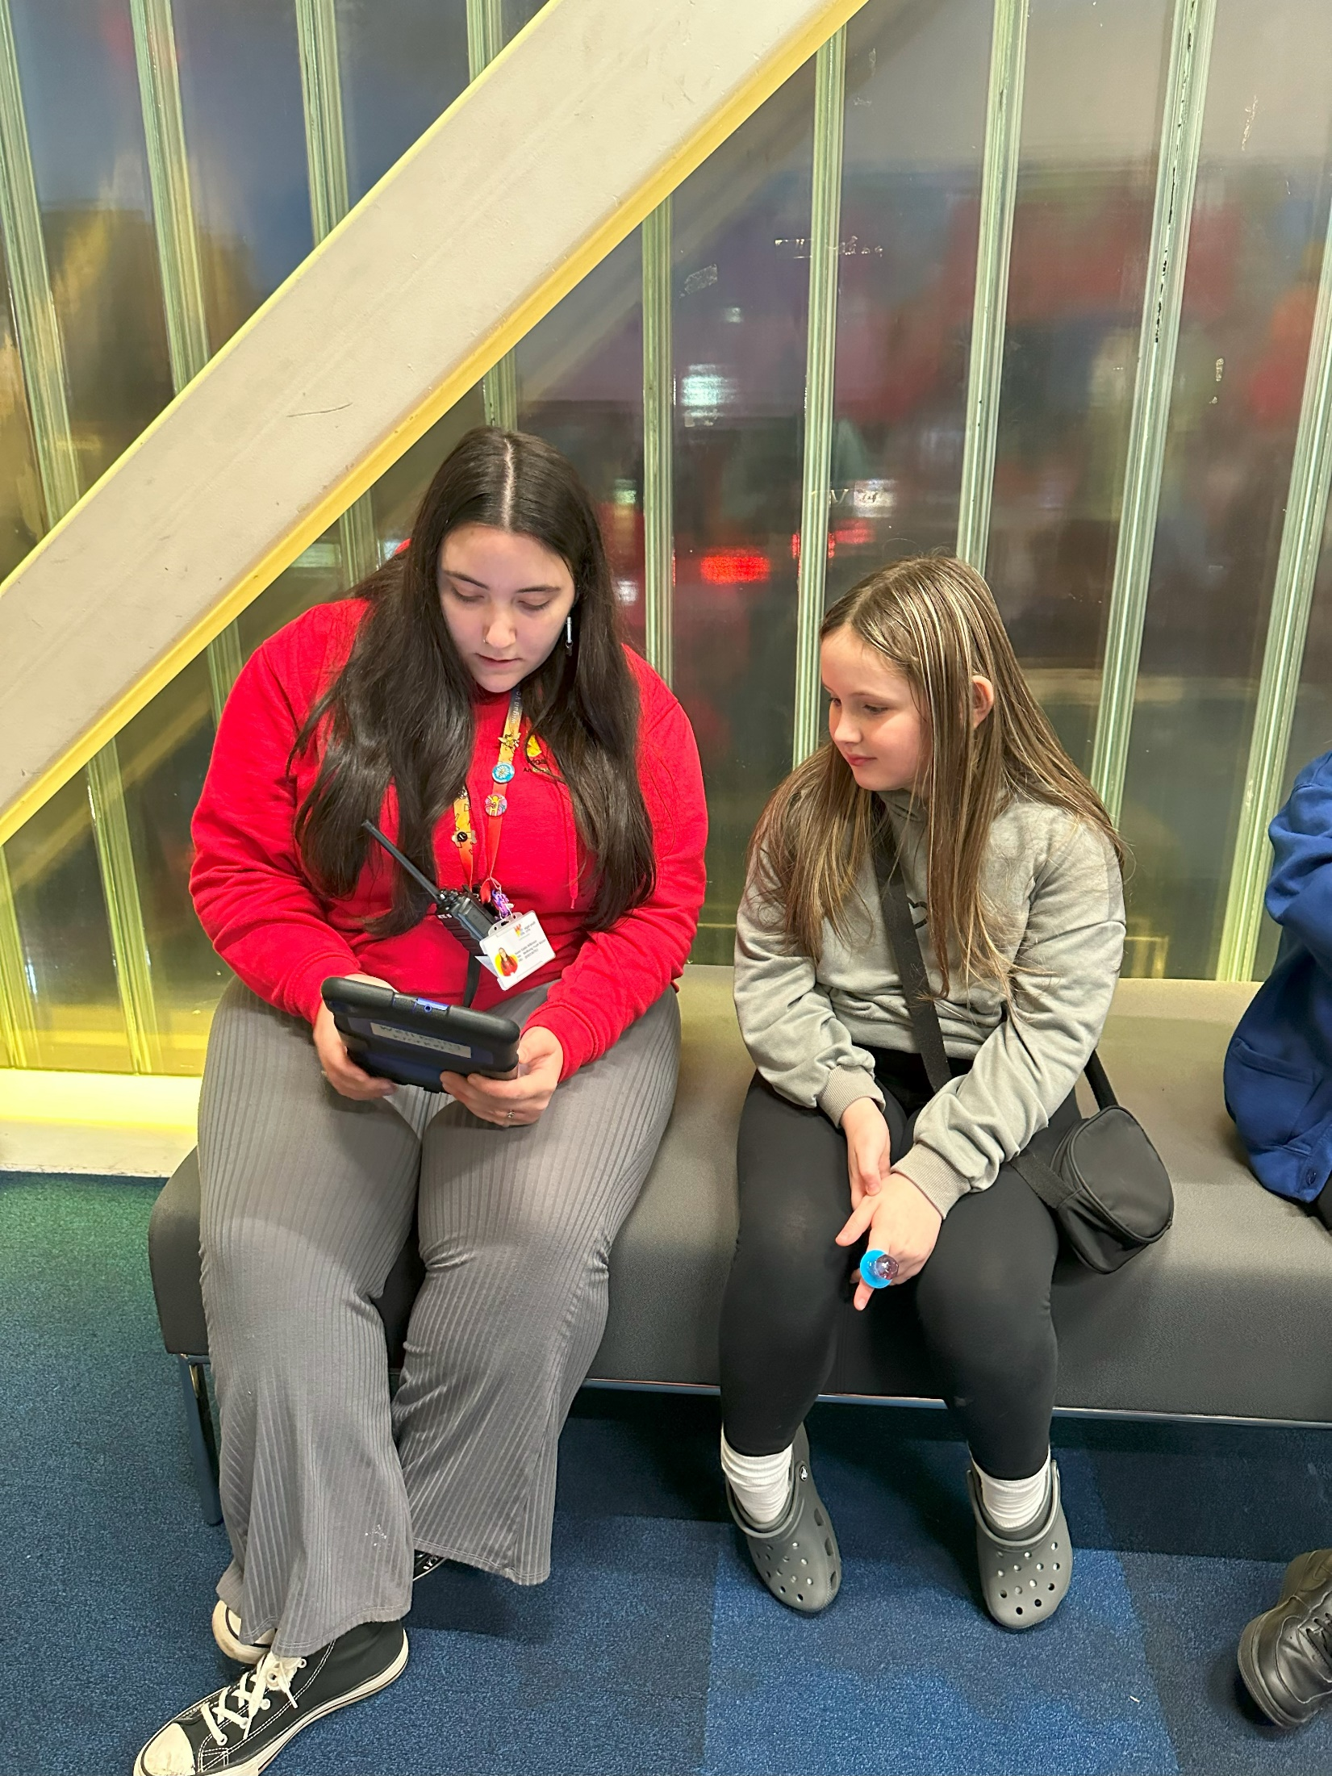

|  |
| --- |
| who we are looking for: |

We are looking for an empathetic and approachable individual with strong listening skills and a solid understanding of the challenges young people face in today’s society. The ideal candidate will be confident supporting young people both in one-to-one and group settings, offering guidance to help them make informed decisions and navigate a range of personal and social challenges. The role requires someone who can help create an inclusive, welcoming environment where all young people feel seen, safe, and supported. A key part of this role involves signposting young people to appropriate services when necessary.

|  |
| --- |
| Knowledge and Understanding |

* A strong awareness of the issues and challenges facing young people in today’s society, with the ability to plan and deliver activities that raise awareness and promote discussion around relevant topics.
* An empathetic and approachable manner, with the ability to listen actively and offer appropriate information, advice, and guidance to young people.
* Confidence and experience in working with a diverse range of young people, including those of different ages, genders, sexualities, needs, and abilities.
* Knowledge of emotional well-being and mental health, including how to support young people with difficulties, promote positive coping strategies, and signpost to appropriate services when needed.
* An understanding of the principles of youth work, including how to manage and respond to challenging behaviour in a supportive and constructive way.
* A sound understanding of safeguarding, equality, diversity, and health and safety, and how to apply these practices effectively when working with children and young people.
* Experience in delivering activities within an equality framework

|  |
| --- |
| Qualifications |

Introduction to Youth Work and Community Work NVQ/VRQ Level 2 – Desirable

|  |  |
| --- | --- |
| What will you need to succeed: | |
| **EXPERIENCE** |  |
| Experience working with children and young people (aged 8 plus) in a 1;1 basis and in group settings | Essential |
| Experience of working with young people with additional needs or disabilities | Desirable |
| Experience of supporting young people who may have social / emotional challenges | Desirable |
| Experience of working in a team and alongside volunteers | Desirable |
| Experience and understanding of safeguarding issues faced by young people and best practice | Essential |
| **SKILLS** |  |
| Ability to work with young people and engage them in group work to help promote welfare, aspirations/achievements. | Essential |
| Ability to develop good professional relationships with children, young people and vulnerable adults | Essential |
| Ability to coach, encourage, motivate and provide consistent support to children, young people and vulnerable adults | Essential |
| Confident in working with young people on a 1;1 basis | Essential |
| Ability to identify and challenge discrimination and discriminatory behaviour | Essential |
| **KNOWLEDGE AND UNDERSTANDING** |  |
| Understanding the principles of working with children and young people | Essential |
| Understanding of issues affecting young people in today’s society | Essential |
| Ability to deliver quality well-being programmes with children and young people who face a variety of personal and social challenges | Desirable |
| Knowledge of Health and Safety, diversity awareness and safeguarding best practice and how these relate to children and young people | Essential |
| WHat you will be doing | |

* Work as part of our Wellbeing Team, providing support to young people through predominantly one-to-one sessions and occasional group work.
* In one-to-one settings, you will offer a safe, non-judgemental space for young people to talk, while providing guidance on a range of wellbeing-related topics such as mental health, substance use, self-care, peer pressure, and positive coping strategies.
* Signpost to other relevant services when appropriate.
* Track progress using our Evaluation Wheel system.
* Plan and deliver engaging group wellbeing sessions centred around key themes and national awareness events (e.g. Children’s Mental Health Week, Stress Awareness Month).
* Proactively encourage participation from young people, especially those who may not typically engage in group activities.
* Promote both mental and physical wellbeing, helping young people make informed, healthy decisions.
* Act as a positive role model and create an inclusive, supportive, and fun environment where young people feel safe and empowered to reach their full potential.
* Support the recording and evaluation of sessions, involving young people in the evaluation of activities
* Safeguard and promote the welfare of all children and young people at all times.
* Contribute to a positive team culture, working in line with Wigan Youth Zone’s values and principles.
* Support the delivery of Wigan Council’s BYOU programme 5pm-8pm on Thursdays.
* Effectively support young people from the LGBTQIA+ community by helping to create an inclusive, welcoming environment where all young people feel seen, safe, and supported, particularly when supporting Wigan Council’s BYOU sessions.

**General**

* To be alert to issues of safeguarding / child protection, ensuring the welfare and safety of Youth Zone members is promoted and to report safeguarding concerns to the WYZ Safeguarding Team in line with our safeguarding policies, procedures and practice (training to be provided);
* To assist with any promotional activities and visits that take place at the Youth Zone;
* To actively promote the Youth Zone and positively contribute towards increasing Youth Zone membership;
* To adhere to Wigan Youth Zone policies at all times, with particular reference to Health and Safety, Safeguarding and Equal Opportunities.

**Other duties**

* To carry out any other duty with the Youth Zone provision and facility operations, and within the competencies of the post holder, as directed by your line manager or a senior manager.

|  |
| --- |
| Special Requirements |

*In accordance with our Child Protection and Safeguarding procedures, this position requires an enhanced DBS check and business satisfactory references.*

*Please note that in line with our Safeguarding Policy, you must be age 21 or over to work in our Senior Sessions and 19+ to work on our Junior Sessions and Holiday Clubs. All applicants must also be inactive as members for at least 12 months.*

Adhere to the Youth Zone’s policies at all times, with particular emphasis on Equal Opportunities and Safeguarding.

A willingness to work evenings and weekends, support at community events.

|  |
| --- |
| what is wigan youth zone? |

Wigan Youth Zone is a purpose built, state-of-the-art youth facility in Wigan town centre which opened in June 2013. It offers young people from across Wigan and Leigh, the opportunity to meet friends, have fun, have new experiences, learn new skills and access the support they need to help develop and achieve their potential.

The Youth Zone is open to all young people across Wigan aged from 8 to 19 (up to 25 with additional needs), striving to offer something for everyone, regardless of their interests or abilities. With almost 15 dedicated areas to choose from including our four 40-metre floodlit football pitches, art room, music room and climbing wall – there’s something for everyone here at Wigan Youth Zone.

Our aim is simple, to provide the town’s young people with somewhere to go, something to do and someone to talk to.

|  |
| --- |
| what do you need to do next |

Please complete our application form and return it to [hr@wiganyouthzone.org](mailto:hr@wiganyouthzone.org)

# 84% of our Team would recommend Wigan Youth Zone as an employer to their family and frienDS