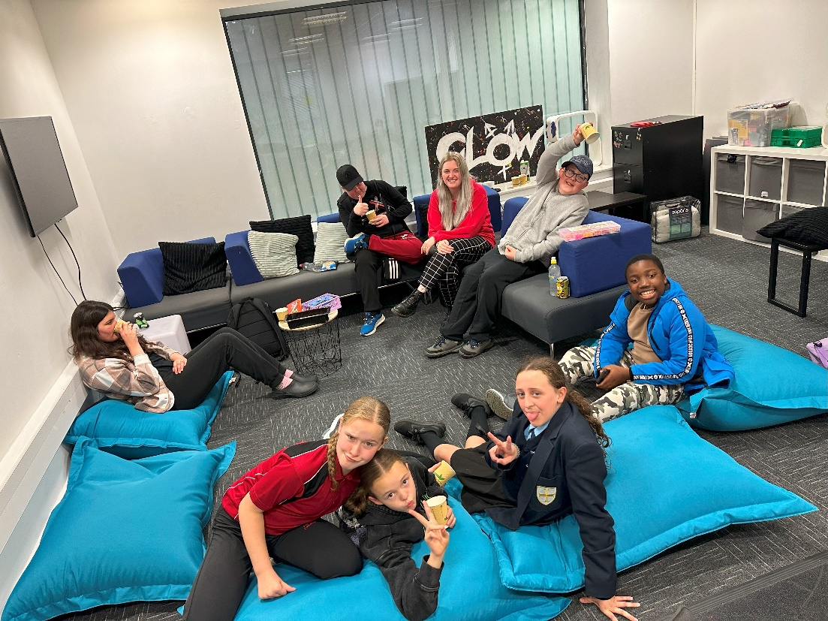

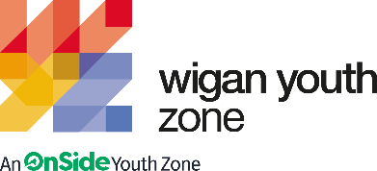

targeted Youth Work Lead
  - Job Description

Summary - The Targeted Youth Work Lead will be responsible for developing and delivering a programme that focuses on issues that affect young people in today’s society.
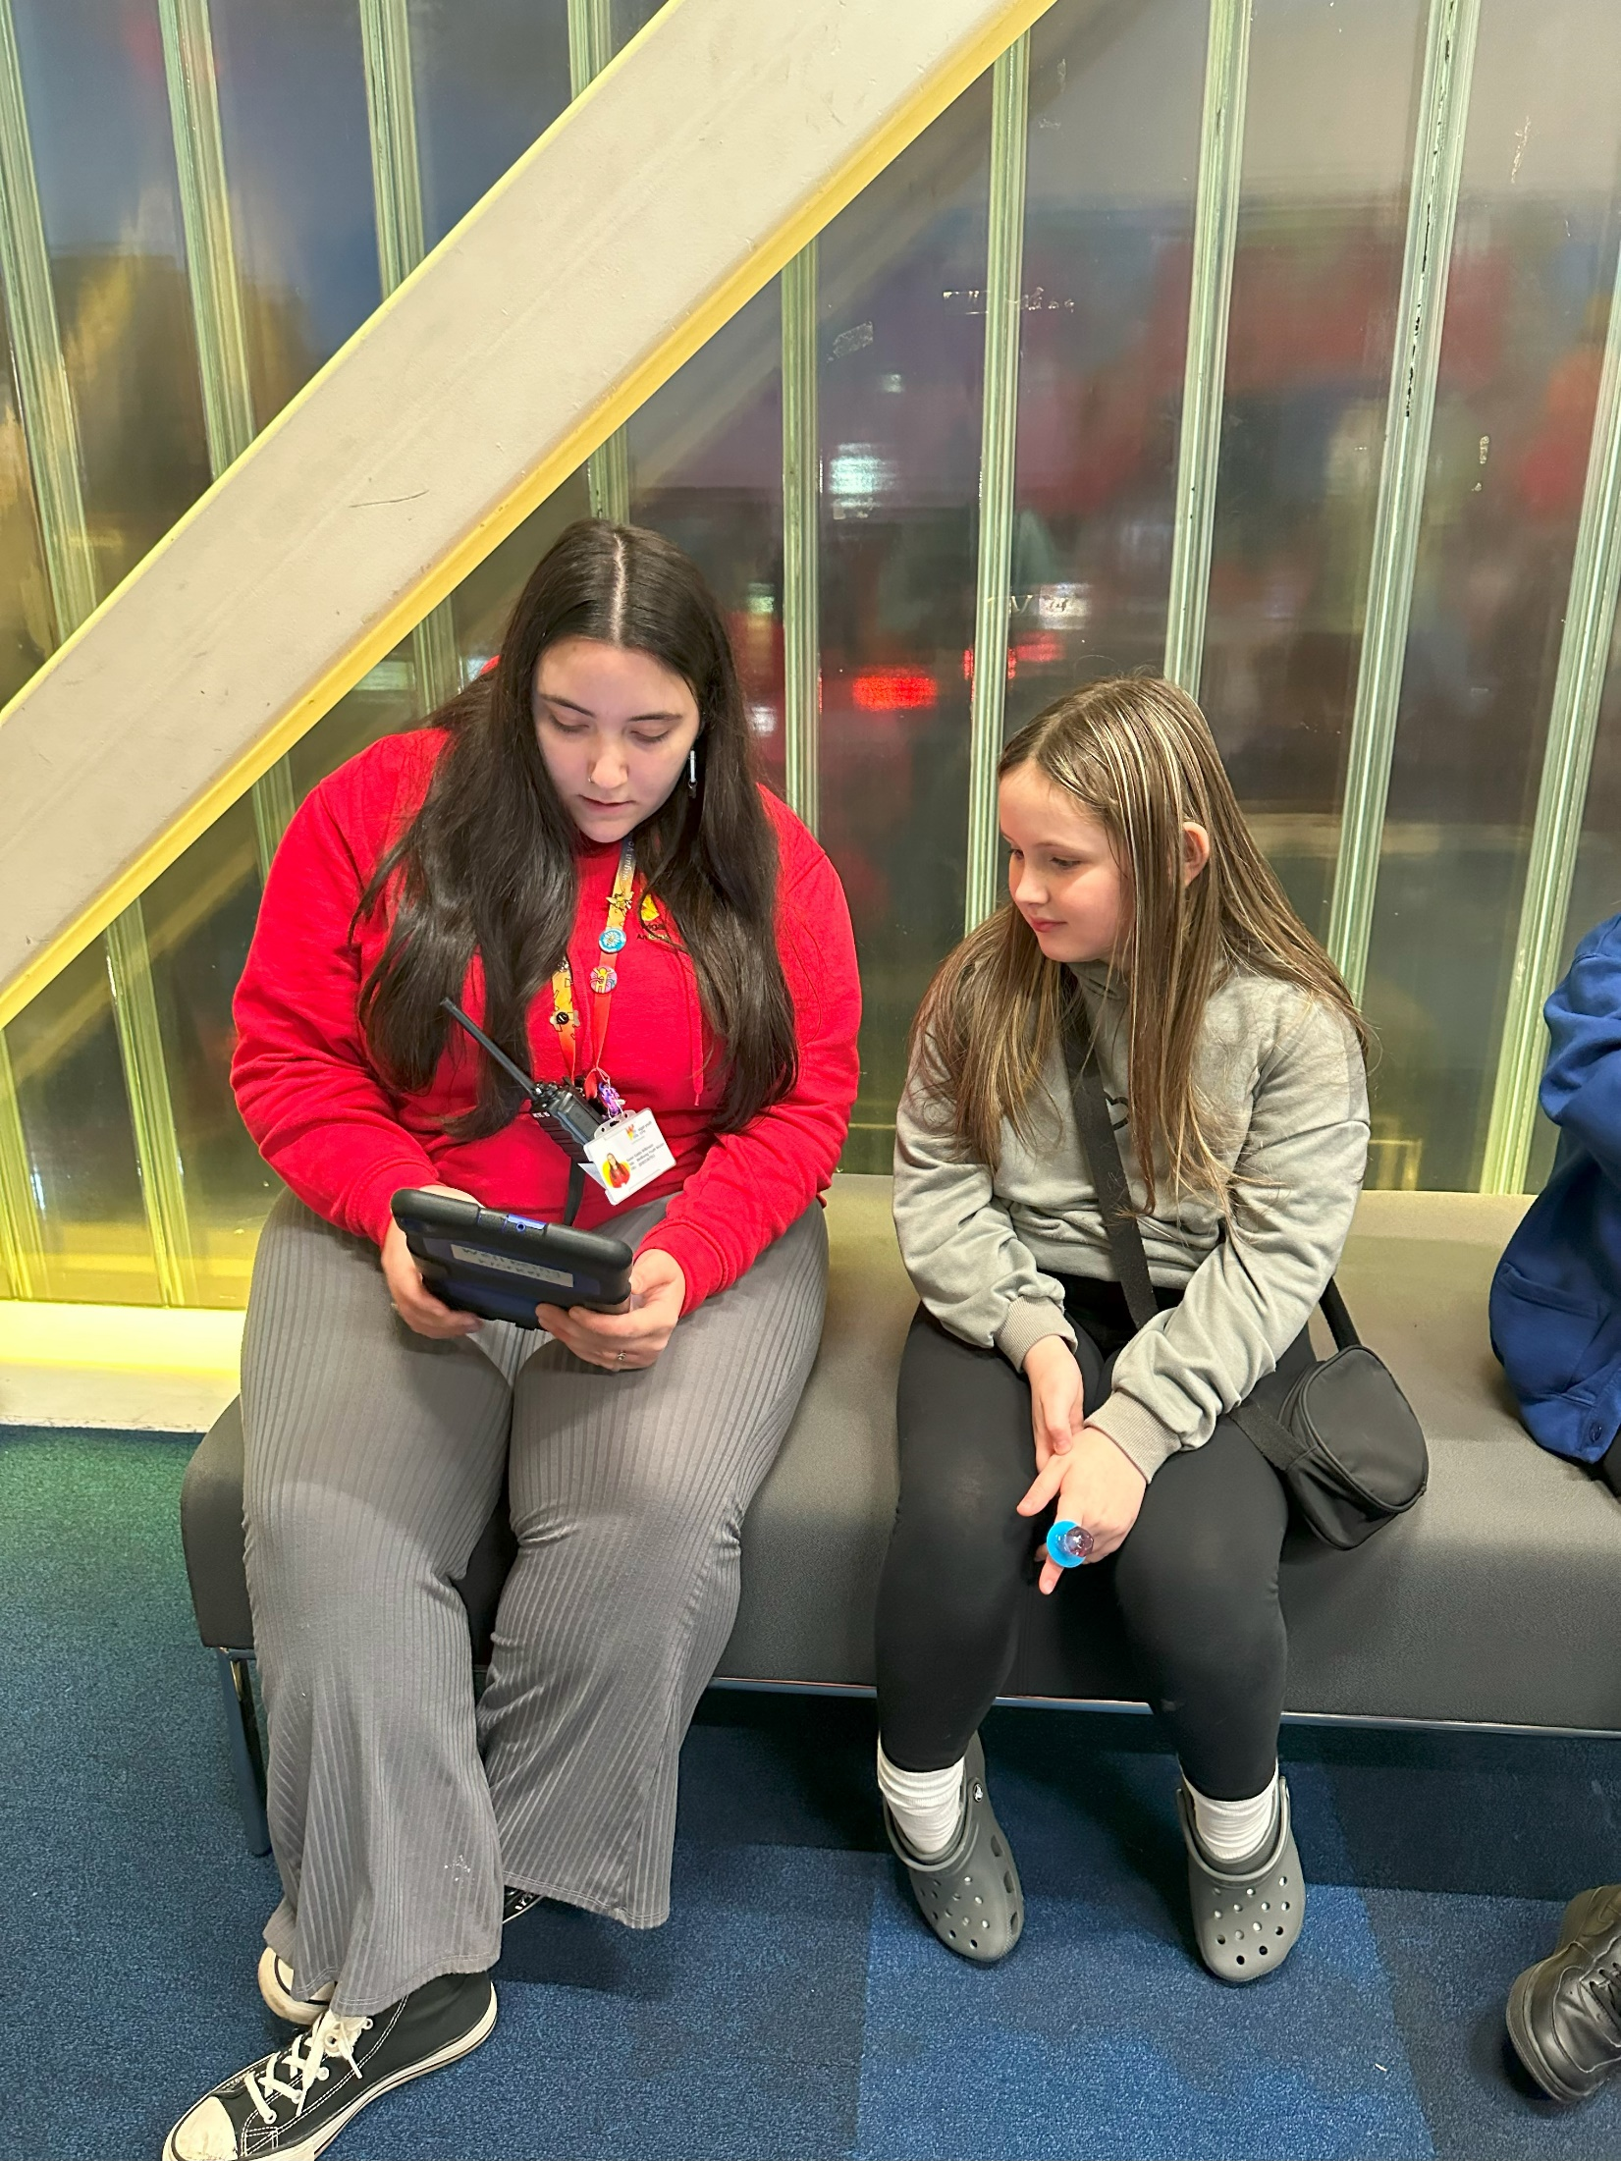 | OVERVIEW  COMPANY: Wigan Youth Zone  LOCATION: Wigan Youth Zone  SALARY: £24,609  BENEFITS:  - 33 days annual leave (including bank holidays) pro rata. Plus, additional leave for length of service.  - Hybrid work,  - Birthdays off,  - Gym access,  - training and CPD including first aid, safeguarding and health and safety,  - Career development opportunities,  - Employee assistance programme,  - Cycle to work scheme,  - Strong team culture,  - Workplace pension,  - Free eye tests,  - Discounted to £2 access to holiday club for WYZ staff.  - Access to Lifeline Plus: Virtual medical care  POSTED: TBC  CLOSING: 12th October 2025  First interviews: W/C 20th October  Second interviews: TBA  SPECIALISM: Youth Work/ Issue based youth work and Well-being knowledge  REPORTS TO: Designated Safeguarding Lead  CONTRACT TYPE: Maternity Cover – Fixed-term  HOURS: 37.5 hours per week (30 minute lunch break)  WORK PATTERN:  These hours will be face-to-face delivery with young people, admin hours prior to session (4pm)  Mondays 1-9  Wednesdays 1-9  Thursdays 1-9  Friday 1-9  Saturdays 1-9  ORGANISATION TYPE: Charity

who we are looking for:

The Targeted Youth Work Lead will be responsible for the delivery of Issue-Based Youth Work and awareness at Wigan Youth Zone’s main site. You will be required to work 5 evenings face-to-face within The Base. Delivery hours will be during our Senior Club sessions, with young people aged 11-19 an up to 25 with additional needs. The schedule will be 4pm-9pm on Monday, Wednesday, Thursday, Friday, Saturday. The admin hours will take place prior to the start of session at 4pm.
Activities that will be delivered within The Base should have a focus on Health and Well-being related topics and themes /issue-based and awareness work round as topics such as Healthy Relationships, Sexual Health, Drugs and Alcohol, Bullying, Body Image, Internet Safety to name a few.
You will also be required to develop and lead an LGBTQIA+ social and support group for young people as a safe place for young people to explore their sexuality/identities, meet new friends, engage in related issue based work with a focus on LGBTQIA+ Voice, rights and the promotion and awareness of Equality and Diversity within the youth zone and the community.
Deliver funded projects related to Health and Wellbeing such as our Period Peers program, aiming to break the stigma around Periods and promote positive language and support for young women and girls lead by their Peers.
The job will additionally require you to lead the Issue Based Youth workers in delivery of a programme for The Base and work closely with them to develop a Youth Led and exciting Issue Based Curriculum. You will work closely with our Safeguarding Lead to support the management of the budget, time sheets and supervision of the Issue Based Youth work Team. You will also support getting the resources required to deliver an exciting offer for young people which is both informally educational, inspiring and fun!

Knowledge and Understanding
Knowledge of the issues affecting young people in today’s society, with a focus on well-being related topics and informal education.
Knowledge and understanding of LGBTQIA+ rights, issues and current terminology.
An ability to work with a diverse range of young people including those who may display behaviour that Challenges.
A Trauma informed Approach (Desirable- we can offer training)
Understanding of the principles of working with children and young people
Knowledge of health and safety, equality and diversity, safeguarding best practice and how these relate to children and young people
Delivery of activities within an equality framework

Qualifications

Introduction to Youth Work and Community Work NVQ/VRQ Level 2 – Desirable

What will you need to succeed:

EXPERIENCE
Experience in working with children and young people age 11+ | Essential
Experience of working with young people with additional needs or disabilities | Desirable
Experience of supporting young people with social, emotional and behavioral difficulties | Desirable
Experience of working in a team and alongside volunteers | Desirable
Experience of identifying and reporting safeguarding issues | Essential
SKILLS
Ability to work with young people to develop their skills by providing fun and informative activities. | Essential
Ability to develop good professional relationships with children, young people and adults | Essential
Ability to coach, encourage, motivate and provide reliable support to children and young people | Essential
Confident in working with young people both in a group and on a 1-2-1 basis | Essential
Ability to identify and challenge discrimination and discriminatory behaviour, taking appropriate action as necessary | Essential
KNOWLEDGE AND UNDERSTANDING
Understanding of LGBTQIA+ current terminology and issues effecting the community | Desirable
Understanding the principles of working with children and young people | Essential
Understanding of issues affecting young people’s lives in today’s society | Essential
Ability to deliver high quality activity programmes with children and young people who face social exclusion / disadvantages | Desirable
Knowledge of Health and Safety, diversity awareness and safeguarding best practice and how these relate to children and young people | Essential

WHat you will be doing

- You will be leading our Base staff Team and Issue Based Youth Work Programme within The Base.
- Support young people’s mental and physical well-being by guiding them to make more informed choices.
- To be a positive role model and create a positive and fun environment in which to motivate and encourage young people to reach their potential.
- To help record and evaluate the sessions, and involve young people in the evaluation process
- To ensure the participation of young people in activities and that their ideas contribute fully
- To promote and safeguard the welfare of children and young people at all times
- To be an active member of the team and operate in line with the values and principles of Wigan Youth Zone.

General
- To be alert to issues of safeguarding child protection, ensuring the welfare and safety of Youth Zone members is promoted and safeguarded, and to report any child protection concerns to the designated Child Protection Officers using the safeguarding policies, procedures and practice (training to be provided);
- To assist with any promotional activities and visits that take place at the Youth Zone;
- To actively promote the Youth Zone and positively contribute towards increasing Youth Zone membership;
- To adhere to Wigan Youth Zone policies at all times, with particular reference to Health and Safety, Child Protection and Equal Opportunities.

Other duties
- To carry out any other duty with the Youth Zone provision and facility operations, and within the competencies of the post holder, as directed by your line manager or a senior manager.

Special Requirements

A willingness to work evenings and weekends when required.

DBS clearance and committed to Safeguarding children.

The ability and willingness to travel to meetings and events both in the region and beyond

The job holder will be required to adhere to the Youth Zone’s policies at all times, with particular emphasis on Equal Opportunities and Safeguarding. Attendance at events and conferences will sometimes be required.

In accordance with our Child Protection and Safeguarding procedures, this position requires an enhanced DBS check and business satisfactory references.

Please note that in line with our Safeguarding Policy, you must be age 21 or over to work in our Senior Sessions and 19+ to work on our Junior Sessions and Holiday Clubs. All applicants must also be inactive as members for at least 12 months.

what is wigan youth zone?

Wigan Youth Zone is a purpose built, state-of-the-art youth facility in Wigan town centre which opened in June 2013. It offers young people from across Wigan the opportunity to meet friends, have new experiences, learn new skills and access the support they need to develop and achieve their potential.
The Youth Zone is open to all young people across Wigan aged from 8 to 19 (up to 25 with additional needs), striving to offer something for everyone, regardless of their interests or abilities. With almost 15 dedicated areas to choose from including our four 40-metre floodlit football pitches, art room, music room and climbing wall – there’s something for everyone here at Wigan Youth Zone.
Our aim is simple, to provide the town’s young people with somewhere to go, something to do and someone to talk to.

what do you need to do next

Please complete our application form and return it to hr@wiganyouthzone.org

84% of our Team would recommend Wigan Youth Zone as an employer to their family and friend

