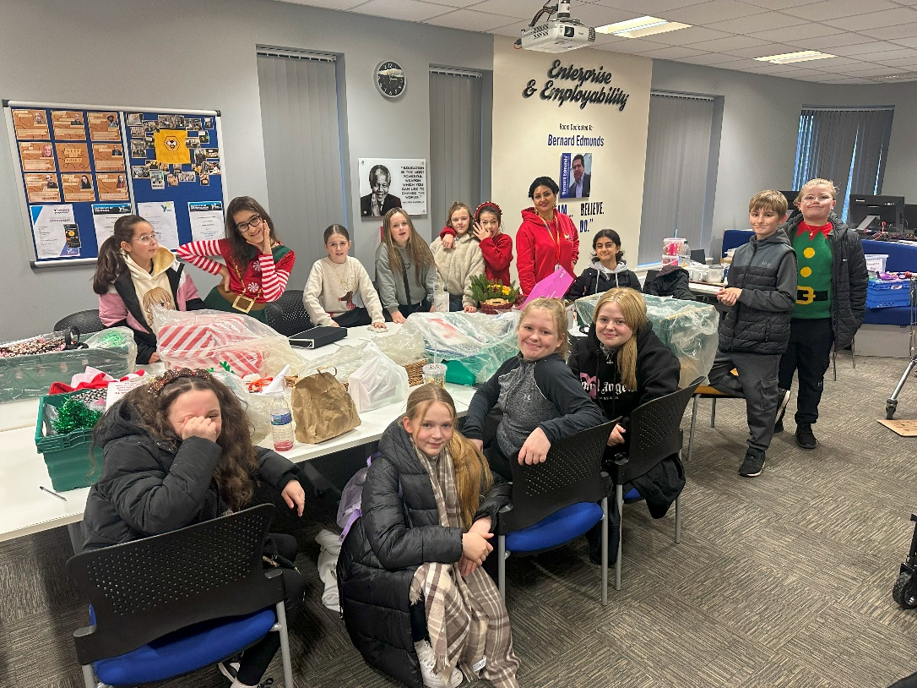

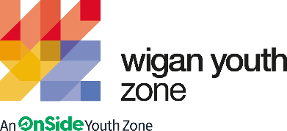

Enterprise Youth Worker
  - Job Description

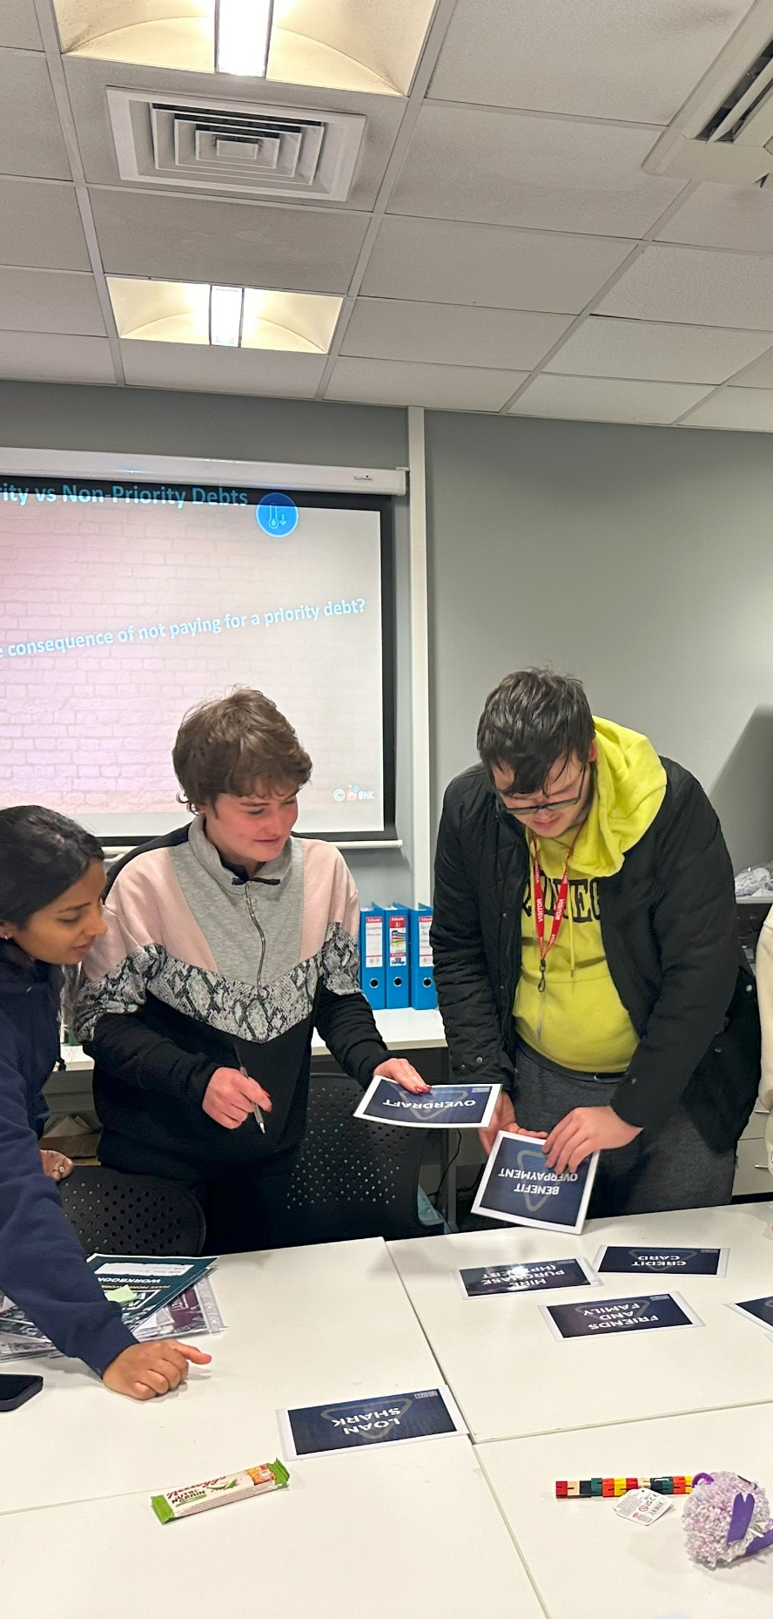 | COMPANY: Wigan Youth Zone  LOCATION: Wigan Youth Zone and Outreach  SALARY: £12.35 per hour  BENEFITS:  - 33 days annual leave (including bank holidays) pro rata. Plus additional leave for length of service.  - Hybrid work,  - Birthdays off,  - Gym access,  - training and CPD including first aid, safeguarding and health and safety,  - Career development opportunities,  - Employee assistance programme,  - Cycle to work scheme,  - Strong team culture,  - Workplace pension,  - Free eye tests,  - Discounted to £2 access to holiday club for WYZ staff.  POSTED: 10th September 2025  CLOSING: 5th October 2025  First interviews: 24th September 2025  Second interviews: N/A  SPECIALISM: Enterprise/Community/Youth Work  REPORTS TO: Enterprise and Employability Coordinator  CONTRACT TYPE: Permanent  HOURS: Part time 9 hours per week  WORK PATTERN: Fri 4pm-9pm & Sat 11am-3pm  All hours will be face-to-face delivery with young people and will include a weekend shift. There is potential for extra hours as and when required by the business.  ORGANISATION TYPE: Charity
  OVERVIEW

who we are looking for:
Someone who is passionate about working with our Junior and Senior members delivering creative and engaging Enterprise activities that will raise young people’s aspirations and inspire them to develop their Entrepreneurial and Business skills ready to create their own small businesses.
A person who wants to be an integral part of a Team where they can bring innovative project ideas to the table positively impacting the Enterprise departments yearly events planning and enhancing our fundraising achievements.
We need someone who would enjoy opening Mocktails and Dreams giving members the opportunity to upskill themselves and learn about Customer Service, cash handling and working to food hygiene and food safety standards including essential allergy information. Someone who feels confident holding research groups engaging with our members to develop new product ideas for Mocktails and Dreams yearly events.

Knowledge and Understanding
Knowledge of the issues affecting young people and an ability to work with challenging behaviour
Understanding of the principles of working with children and young people
Knowledge of health and safety, diversity awareness and safeguarding best practice and how these relate to children and young people
Delivery of activities within an equality framework

Qualifications
Business Skills - Desirable
Food Hygiene – Desirable (or willing to work towards)

What will you need to succeed:

EXPERIENCE
Experience in delivering creative craft and fun small business activities and challenges  to young people from age 8 to 19 and young adults up to age 25 | Essential
Experience of working with young people with additional needs or disabilities from age 8 up to age 25 | Desirable
Experience of owning or working for a small creative business either gifting products  or selling products at craft fayres or on sites like Etsy, Amazon Handmade, Redbubble  or Folksy | Desirable
Experience in a Customer service Role – Retail, Hospitality, Reception, Craft Markets,  Online Sales | Desirable
Experience working as part of a Team alongside Volunteers | Desirable
Experience of supporting young people who are disaffected, underachieving and / or have social / emotional barriers to participation | Desirable
Experience of dealing with Safeguarding issues within a multi-agency setting | Essential
SKILLS
A creative mindset with a passion for new ideas, designs and projects. You may have a Hobby or Craft that you enjoy doing in your spare time and your skills and experience from this can be shared with members to enable them to try it as well | Desirable
Ability to work with young people to develop their social education by providing programmes of activities, services and facilities that are fun and enable children and young adults to develop their skills | Essential
Ability to coach, encourage, motivate and provide consistent support to children and young people so they feel comfortable and confident to get involved, have a go and try something new | Essential
Strong commitment to children and young people and an ability to engage and build positive relationships with all young people, including disengaged and disadvantaged young people | Essential
Ability to develop healthy, professional relationships with children, young people and adults | Essential
Confident in managing groups of children and young adults and their behaviours | Essential
Have the ability to multitask and adapt to activity changes on session | Essential
KNOWLEDGE AND UNDERSTANDING
Understanding of the principles of working with children and young people | Essential
Knowledge of health and safety, diversity awareness and safeguarding best practice and how these relate to children and young people | Essential
Ability to deliver high quality activity programmes with children and young people who face social exclusion, disadvantage and disaffection | Desirable
Ability to identify and challenge discrimination and discriminatory behaviour, taking appropriate action as necessary | Essential

WHat you will be doing
- Delivering fun, engaging, creative and interactive sessions that motivate and inspire our members to try Enterprise
- Crafting, designing and making products using different mediums with Junior and Senior members
- Supporting the YE programmes including the £10 Tenner Challenge and the Young Enterprise Company Programme, where we will be developing young people’s business ideas and skillset
- £10 Challenge – recruiting 5 teams to take part in the project where you will help them to create their own small businesses – taking it from the young person’s initial idea, to costings, design, market research, producing a Logo, making and then selling the product
- Supporting young people to sell their small business products with pop-up shops at WYZ and at selling platforms such as local Craft Markets and Trade fairs including the annual WYZMAS markets
- Proactively researching the latest small business and craft trends suitable for working with young people, being open to trying new innovative and inventive trends
- Attending departmental planning sessions bringing fresh ideas to the table
- Researching project and product ideas and putting together orders for resources inline with budgets
- Using a variety of Cricut machines to create products during sessions
- Support your line manager in delivering more sustainable projects
- Be flexible due to department requirements and business needs
- Support Wigan Youth Zones yearly events
- Support the department in Fundraising for WYZ
- Have or be willing to work towards a Food Hygiene Certificate (funded by WYZ) to support young people working on Mocktails and Dreams our very own food and drink based Enterprise business
- Support with our Employability programmes as and when required

Special Requirements

- A willingness to work unsociable hours when required
- DBS clearance and committed to Safeguarding children
- The ability and willingness to travel to meetings and events both in the region and beyond

The job holder will be required to adhere to the Youth Zone’s policies at all times, with particular emphasis on Equal Opportunities and Safeguarding. Attendance at events and conferences will sometimes be required.

In accordance with our Child Protection and Safeguarding procedures, this position requires an enhanced DBS check and business satisfactory references.

Please note that in line with our Safeguarding Policy, you must be age 21 or over to work in our Senior Sessions and 19+ to work on our Junior Sessions and Holiday Clubs. All applicants must also be inactive as members for at least 12 months.

what is wigan youth zone?
Wigan Youth Zone is a purpose built, state-of-the-art youth facility in Wigan town centre which opened in June 2013. It offers young people from across Wigan the opportunity to meet friends, have new experiences, learn new skills and access the support they need to develop and achieve their potential.
The Youth Zone is open to all young people across Wigan aged from 8 to 19 (up to 25 with additional needs), striving to offer something for everyone, regardless of their interests or abilities. With almost 15 dedicated areas to choose from including our four 40-metre floodlit football pitches, art room, music room and climbing wall – there’s something for everyone here at Wigan Youth Zone.
Our aim is simple, to provide the town’s young people with somewhere to go, something to do and someone to talk to.

what do you need to do next
Please complete our application form following the link below
https://app.smartsheet.com/b/form/d852810831d84133b4aea32dfb8436af

84% of our Team would recommend Wigan Youth Zone as an employer to their family and friends

