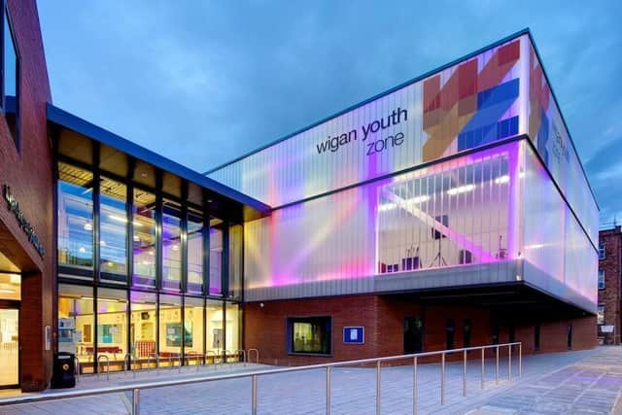



Community fundraiser
 |  | - Job Description
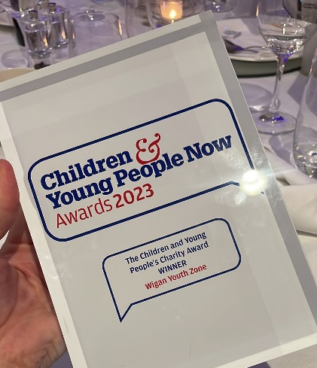  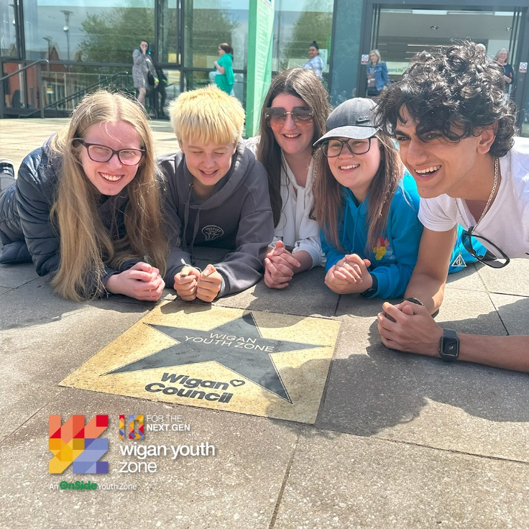 |  |  | COMPANY: Wigan Youth Zone  LOCATION: Parsons Walk, Wigan, WN1 1RU  SALARY: £25-27k per annum  BENEFITS:  - 33 days annual leave (including bank holidays) pro rata plus additional leave for length of service  - Hybrid work  - Birthdays off  - Gym access  - Training and CPD including first aid, safeguarding and health and safety  - Career development opportunities  - Employee assistance programme  - Cycle to work scheme  - Strong team culture  - Workplace pension  - Free eye tests  - Discounted to £2 access to holiday club for WYZ staff  - Access to Lifeline Plus: Virtual medical care.  POSTED: 16th October 2025  CLOSING: 15th November 2025  Interviews for this role will take place on going and we reserve the right to withdraw the job ad when the right candidate has been found.  SPECIALISM: Fundraising/Management  REPORTS TO: Head of Fundraising  CONTRACT TYPE: Permanent  HOURS: 37.5 hours per week  WORK PATTERN:  Office-based work at Wigan Youth Zone with flexibility  ORGANISATION TYPE: Charity
  OVERVIEW

who we are looking for:

We are seeking a motivated and dynamic Fundraising Officer to help us achieve our ambitious fundraising goals. In this role, you will be responsible for generating £40,000 annually from new corporate support, as well as securing income from community and WYZ events by building sustainable partnerships with local businesses and groups. You will create, test, and manage individual giving campaigns, engage businesses in our Charity of the Year Programme, and identify new fundraising opportunities, including third-party events. The successful candidate will also reduce costs through in-kind donations, maintain accurate fundraising records using Salesforce, and plan, deliver, and evaluate annual fundraising and “in aid of” events. Strong communication skills are essential, as you will work closely with community stakeholders to foster lasting relationships and support the growth of our fundraising initiatives.

Knowledge and Understanding
We are looking for a candidate with excellent people skills and the ability to build strong professional relationships with both young people and adults. You will be confident working on your own initiative as well as part of a team, with strong planning, organisational, monitoring, evaluation, and prioritisation skills. The role requires someone who can work effectively under pressure while managing multiple priorities. Moderate ICT skills are also essential.
Above all, we are seeking someone who is passionate about changing the lives of young people and making a positive impact in the community. You will play a key role in supporting and empowering young people, helping them reach their potential while contributing to the wider community.

Qualifications
- No specific requirements.

What will you need to succeed:
We are looking for a candidate with experience in community or event fundraising, who can build strong relationships with individuals, businesses, and groups. You will be confident in planning and managing fundraising events and budgets, with excellent communication and presentation skills. The role requires someone who can work independently, manage priorities effectively, and lead volunteers or teams. Proficiency in MS Office is essential, along with a strong commitment to Wigan Youth Zone’s values and safeguarding standards. Flexibility to work unsociable hours and travel as required is needed. Above all, we are seeking someone who is passionate about supporting young people through charity work and making a lasting impact in the community.
EXPERIENCE
Experience of meeting challenging financial targets for both new business and account management | Essential
Experience in managing a pipeline of potential partners /donors and aligning their interests with an organisation's needs | Essential

SKILLS
Ability to make face-to-face approaches for support from companies and the ability to negotiate | Essential
Strategic, target-driven approach to fundraising and marketing activity | Essential
Outstanding influencing and client-facing skills, with an ability to communicate confidently with high-level individuals and decision-makers | Essential
Excellent report writing skills, incorporating statistics, case studies and external references | Essential
Strong interpersonal and networking skills to build positive, personal, and organisational relationships and convey the Youth Zone’s work with confidence and credibility | Essential
Ability to think conceptually and creatively to develop profitable fundraising products and proposals for supporters | Essential
Strong organisational skills, with a structured and methodical approach to work, a clear focus on results, and an ability to work to multiple deadlines | Essential
IT literate and a confident user of Salesforce | Essential

what you will be doing
- Generate new corporate partnerships with a value of at least five-figures per year, per new relationship.
- Craft persuasive and motivating pitches and proposals to secure new corporate supporters by producing high-quality written proposals and making verbal presentations/face-to-face asks to various audiences.
- Manage a pipeline of potential corporate supporters and devise effective engagement strategies that drive income.
- Ensure existing corporate partners support at an appropriate financial level, encouraging them to increase support where possible.
- To provide excellent donor-focused stewardship of existing corporate donors involving the senior management team and trustee board as appropriate to maximise retention and increase levels of support over time.
- Investigate new corporate income streams such as payroll giving.
- Create a suite of engagement opportunities, ensuring there are opportunities for businesses across all sectors.
- Use existing WYZ events and campaigns, and create new ones as appropriate, to boost employee engagement and ensure total staff engagement is achieved.
- Keep accurate records of prospect and Patron engagement, using Salesforce to record engagement activities and KPIs.
- To work alongside marketing colleagues to ensure awareness of WYZ across the community and among potential corporate supporters is strong.
- To ensure you are continuously fully updated with WYZ delivery and impact.
- To ensure adherence to the relevant charity legislation and the Institute of Fundraising’s Codes of Practice.
- To generate written and financial reports for management as required.
- To carry out other reasonable duties, as requested by the Head of Fundraising or other member of the Senior Management Team, including attendance at events and meetings, as and when required.
- This role may also require some evening and weekend working.
General
- To be alert to issues of safeguarding child protection, ensuring the welfare and safety of Youth Zone members is promoted and safeguarded, and to report any child protection concerns to the designated Child Protection Officers using the safeguarding policies, procedures, and practice (training to be provided).

- To assist with promotional activities and visits at the Youth Zone.

- To actively promote the Youth Zone and contribute to increasing Youth Zone memberships.

- To always adhere to Wigan Youth Zone policies concerning Health and Safety, Child Protection and Equal Opportunities

- Ensuring that we as a team are fully adhering to Wigan Youth Zone’s core values of community, aspiration, belonging, respect, inclusivity and teamwork.

Special Requirements

- DBS clearance and committed to Safeguarding children.

- The job holder will be required to adhere to the Youth Zone’s policies at all times, with particular emphasis on Equal Opportunities and Safeguarding.

In accordance with our Child Protection and Safeguarding procedures, this position requires an enhanced DBS check and business satisfactory references.
Please note that in line with our Safeguarding Policy, you must be age 21 or over to work in our Senior Sessions and 19+ to work on our Junior Sessions and Holiday Clubs. All applicants must also be inactive as members for at least 12 months.

what is wigan youth zone?
Wigan Youth Zone is a purpose built, state-of-the-art youth facility in Wigan town centre which opened in June 2013. It offers young people from across Wigan the opportunity to meet friends, have new experiences, learn new skills and access the support they need to develop and achieve their potential.
The Youth Zone is open to all young people across Wigan aged from 8 to 19 (up to 25 with additional needs), striving to offer something for everyone, regardless of their interests or abilities. With almost 15 dedicated areas to choose from including our four 40-metre floodlit football pitches, art room, music room and climbing wall – there’s something for everyone here at Wigan Youth Zone.
Our aim is simple, to provide the town’s young people with somewhere to go, something to do and someone to talk to.

what do you need to do next
Please email HR@wiganyouthzone.org to request an application form once completed return to this email address.

88% of our Team would recommend Wigan Youth Zone as an employer to their family and frieNDS

