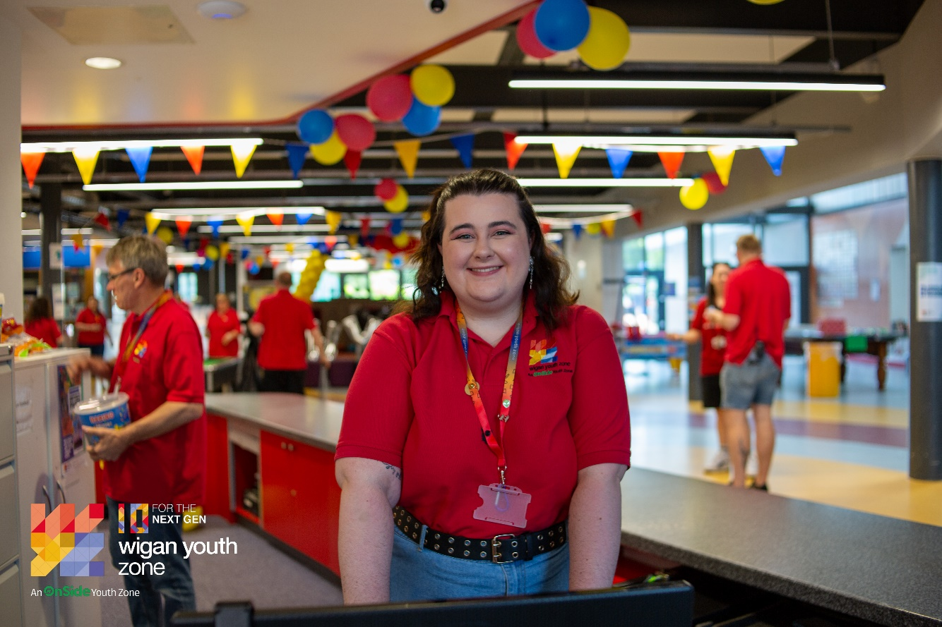

|  |  |  |  |  |
| --- | --- | --- | --- | --- |
|  | | | | |
|  |  | | |  |
| Receptionist | | | | |
|  | | Job Description |  | |

|  |  |  |
| --- | --- | --- |
|  | |  | | --- | | OVERVIEW |   **COMPANY:** Wigan Youth Zone  **LOCATION:** Wigan Youth Zone  **SALARY:** £12.35 per hour  **BENEFITS:** 33 days annual leave (including bank holidays) pro rata. Plus, additional leave for length of service.   * Hybrid work, * Birthdays off, * Gym access, * training and CPD including first aid, safeguarding and health and safety, * Career development opportunities, * Employee assistance programme, * Cycle to work scheme, * Strong team culture, * Workplace pension, * Free eye tests, * Discounted to £2 access to holiday club for WYZ staff. * Access to Virtual Medical Care * Access to Work Well programme   **POSTED:** 7th August 2025  **CLOSING:**  21st August 2025  **First interviews:** 2nd September 2025  **Second interviews:** 4th September 2025  **SPECIALISM:** Reception/Customer service  **REPORTS TO:** Head of Reception  **CONTRACT TYPE:** Permanent  **HOURS:** Part time- 13 hours  Sunday 11am till 7pm  Monday 3pm till 9pm.  All hours will be face-to-face delivery with young people and will include a weekend shift.  **ORGANISATION TYPE:** Charity |

|  |
| --- |
| who we are looking for: |

An enthusiastic and experienced person to take responsibility for the reception area and act as the first point of contact for members, visitors and the general public.

|  |
| --- |
| Knowledge and Understanding |

Knowledge of the issues affecting young people and an ability to work with challenging behaviour

Understanding of the principles of working with children and young people

Knowledge of health and safety, diversity awareness and safeguarding best practice and how these relate to children and young people

Delivery of activities within an equality framework

|  |
| --- |
| Qualifications |

GCSE or equivalent Literacy and Numeracy – Essential

|  |
| --- |
| What will you need to succeed: |

|  |  |
| --- | --- |
| **EXPERIENCE** |  |
| Experience at working a reception desk or entrance point | Essential |
| Working in a customer facing environment | Essential |
| Dealing with general public | Essential |
| Use of Management Information Systems | Essential |
| Ability to engage with all types of people from young people, community members  and colleagues to official visitors and Board Directors  Ability to pay attention to detail, be thorough and organised | Desirable |
| Willingness to support the Youth Work team in ensuring a safe and fun environment for all Youth Zone members | Desirable |
| Experience of working in a team and alongside volunteers | Desirable |
| Experience providing information, advice, guidance and support to young people | Desirable |
| Excellent timekeeper | Essential |
| **SKILLS** |  |
| Excellent written and verbal communication | Essential |
| IT Literate | Essential |
| Ability to coach, encourage, motivate and provide reliable support to children and young people | Essential |
| Strong commitment to children and young people and an ability to engage and build positive relationships with all young people, including disengaged and disadvantaged young people | Essential |
| Ability to develop good professional relationships with children, young people and adults | Essential |
| Knowledge of Health and Safety, Diversity Awareness and Safeguarding best practice and how these are related to children and young people | Desirable |
| Ability to identify and challenge discrimination and discriminatory behaviour, taking appropriate action as necessary | Essential |

|  |
| --- |
| WHat you will be doing |

* To take responsibility for maintaining the reception area at Wigan Youth Zone and providing a welcoming environment.
* To act as the first point of contact for Youth Zone members, staff, volunteers, suppliers, visitors and the general public.
* To ensure visitors comply with health and safety requirements and child protection/safeguarding procedures, including the allocation of visitors’ badges;
* To deal with telephone enquiries, take and relay messages, and screen and direct calls.
* To book Youth Zone members into sessions, enter new members on to the membership database and collect entrance fees (training will be provided for the membership database but basic computer skills will be required);
* To support young people with completing membership forms;
* To cash up at the end of each Youth Zone session;
* To ensure that any administration and paperwork is up to date and completed by the end of each Youth Zone session;
* To maintain the meeting room calendar for the Youth Zone;
* To keep records up to date related to attendance, trips, events and meetings;
* To assist with any general administration functions as required.
* Website enquires to be handled within a 24 hour period, this may include forwarding the enquiry to an appropriate person.

|  |
| --- |
| Special Requirements |

* A willingness to work unsociable hours when required
* DBS clearance and committed to Safeguarding children
* The ability and willingness to travel to meetings and events both in the region and beyond

The job holder will be required to adhere to the Youth Zone’s policies at all times, with particular emphasis on Equal Opportunities and Safeguarding. Attendance at events and conferences will sometimes be required.

In accordance with our Child Protection and Safeguarding procedures, this position requires an enhanced DBS check and business satisfactory references.

*Please note that in line with our Safeguarding Policy, you must be age 21 or over to work in our Senior Sessions and 19+ to work on our Junior Sessions and Holiday Clubs. All applicants must also be inactive as members for at least 12 months.*

|  |
| --- |
| what is wigan youth zone? |

Wigan Youth Zone is a purpose built, state-of-the-art youth facility in Wigan town centre which opened in June 2013. It offers young people from across Wigan the opportunity to meet friends, have new experiences, learn new skills and access the support they need to develop and achieve their potential.

The Youth Zone is open to all young people across Wigan aged from 8 to 19 (up to 25 with additional needs), striving to offer something for everyone, regardless of their interests or abilities. With almost 15 dedicated areas to choose from, including our four 40-metre floodlit football pitches, art room, music room and climbing wall – there’s something for everyone here at Wigan Youth Zone.

Our aim is simple, to provide the town’s young people with somewhere to go, something to do and someone to talk to.

|  |
| --- |
| what do you need to do next |

Please request an application form from [HR@wiganyouthzone.org](mailto:HR@wiganyouthzone.org) and once completed return to this email address.

# 88% of our Team would recommend Wigan Youth Zone as an employer to their family and friends