outreach and detached youth worker
  - Job Description

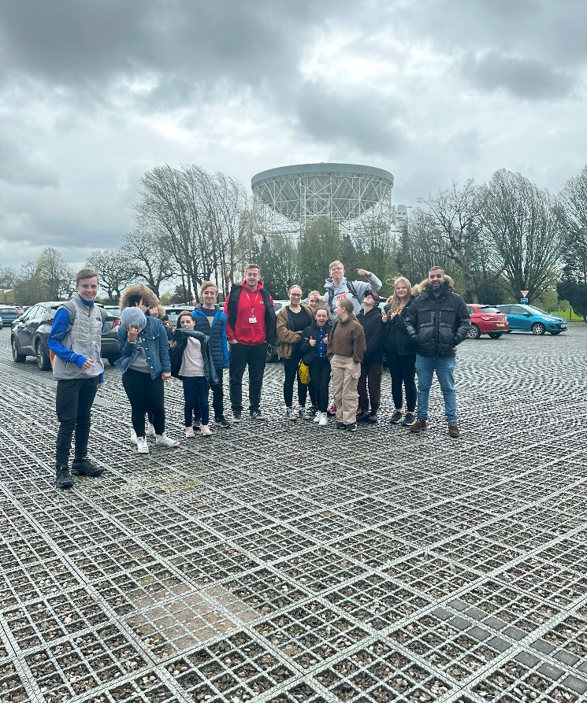  v | OVERVIEW  COMPANY: Wigan Youth Zone  LOCATION: Parsons Walk, Wigan, WN1 1RU  SALARY: £11.65 Per Hour  BENEFITS:  - 33 days annual leave (including bank holidays) pro rata. Plus additional leave for length of service.  - Hybrid work,  - Birthdays off,  - Gym access,  - training and CPD including first aid, safeguarding and health and safety,  - Career development opportunities,  - Employee assistance programme,  - Cycle to work scheme,  - Strong team culture,  - Workplace pension,  - Free eye tests,  - Discounted to £2 access to holiday club for WYZ staff.  POSTED: 08/04/2024  CLOSING: 30/04/2024  First interviews: TBA  Second interviews: TBA  SPECIALISM: Outreach/Youth Work/Community  REPORTS TO: Community Youth Work Lead  CONTRACT TYPE: Permanent  HOURS: 10 hours  WORK PATTERN:  3 evenings a week from a Tuesday to Friday with exact days to be confirmed  Session times: 16:00 : 21:00  All hours will be face-to-face delivery with young people and will include a weekend shift.  ORGANISATION TYPE: Charity

who we are looking for:

An enthusiastic Outreach and Detached Youth Worker ready to work in Worsley Hall, approaching and engaging directly with groups of young people on their own turf and within their communities. To build relationships and to help young people to stay safe whilst reducing anti-social behaviour. To support a local youth project in Worsley Hall, planning and delivering activities for Junior and Senior sessions. This role will include centre-based youth work, as well as the delivery of street-based outreach youth work, in which the candidate will follow a plan through the local community area and engage young people in their own environment. All of these elements can involve working in a challenging environment, remaining calm under pressure, dealing with challenging behaviour whilst maintaining overall discipline with good humour and continuing to engage with the young people.
Session 1: 4pm-6pm will be a 121 mentoring session with a young person.
6-9pm will be a youth club session
Session 2: 4-6pm will be a 121 mentoring session with a young person
6-9pm Street based youth work

Knowledge and Understanding
Knowledge of the issues affecting young people and an ability to work with challenging behaviour
Understanding of the principles of working with children and young people
Knowledge of health and safety, diversity awareness and safeguarding best practice and how these relate to children and young people
Delivery of activities within an equality framework

Qualifications

- Introduction to Youth/Play Work, Youth and Community Work NVQ / VRQ Level 1 or
Level 1 Sports Leaders Award – Desirable

What will you need to succeed:

EXPERIENCE
Experience in face-to-face activity delivery, working with children and young people (aged 8 plus) both in groups and individually | Essential
Experience of working with challenging young people | Essential
Experience of supporting young people who are disaffected, underachieving and / or have social / emotional barriers to participation | Essential
Experience of working in a team and alongside volunteers | Essential
Organising a programme of youth/play work activities | Essential
Experience of working with challenging young people | Essential
Residential work with young people | Desirable
SKILLS
Delivery of activities within an equality framework | Essential
Strong commitment to children and young people and an ability to engage and build positive relationships with all young people, including disengaged and disadvantaged young people | Essential
Ability to develop good professional relationships with children, young people and adults | Essential
Ability to work with young people to develop their social education by providing programmes of activities, services and facilities that are fun and enable young people to develop | Essential
Ability to coach, encourage, motivate and provide reliable support to young people | Essential
Confident in managing a group of children and young people | Desirable
Excellent written and verbal communication skills | Essential
Ability to deliver high quality activity programmes with children and young people who face social exclusion, disadvantage and disaffection | Desirable
Ability to identify and challenge discrimination and discriminatory behaviour, taking appropriate action as necessary | Essential

what you will be doing

- Make contact and establish relationships with young people in Wigan Borough;
- To encourage and enable young people to participate in a range of personally challenging activities at a local youth centre or at WYZ;
- To promote and staff buses and minibuses, enabling members to access WYZ;
- To work directly with children and young people to develop their social skills and build their confidence by delivering programmes of activities and services;
- To regularly deal with challenging behaviour in a closed environment, in a safe, fair, friendly and consistent manner;
- To directly deliver a high-quality programme of activity that is exciting, safe, varied, innovative, developmental and directly responds to the diverse needs, concerns and interests of the members;
- To work flexibly to ensure the needs of the members are met, including disadvantaged children and young people and those with disabilities or additional needs;
- To ensure that the members maintain a high standard of behaviour and discipline during sessions and on transport;
- To ensure the participation of young people in activities and that their ideas contribute fully in the delivery and evaluation of activities;
- To support and motivate other staff and volunteers working in your and other areas;
- To work with key stakeholders, including Wigan Council, GMP, Inspiring Healthy Lifestyles, local businesses, schools and other organisations;
- To maintain records of young people’s attendance and discipline, update central data and report to your line manager;
- To promote and safeguard the welfare of children and young people at all times;
- To be an active member of the team and operate in line with the values and principles of Wigan Youth Zone.

Special Requirements

- A willingness to work unsociable hours when required
- DBS clearance and committed to Safeguarding children
- The ability and willingness to travel to meetings and events both in the region and beyond
- The job holder will be required to adhere to the Youth Zone’s policies at all times, with particular emphasis on Equal Opportunities and Safeguarding. Attendance at events and conferences will sometimes be required.

In accordance with our Child Protection and Safeguarding procedures, this position requires an enhanced DBS check and business satisfactory references.

Please note that in line with our Safeguarding Policy, you must be age 21 or over to work in our Senior Sessions and 19+ to work on our Junior Sessions and Holiday Clubs. All applicants must also be inactive as members for at least 12 months.

what is wigan youth zone?

Wigan Youth Zone is a purpose built, state-of-the-art youth facility in Wigan town centre which opened in June 2013. It offers young people from across Wigan the opportunity to meet friends, have new experiences, learn new skills and access the support they need to develop and achieve their potential.
The Youth Zone is open to all young people across Wigan aged from 8 to 19 (up to 25 with additional needs), striving to offer something for everyone, regardless of their interests or abilities. With almost 15 dedicated areas to choose from including our four 40-metre floodlit football pitches, art room, music room and climbing wall – there’s something for everyone here at Wigan Youth Zone.
Our aim is simple, to provide the town’s young people with somewhere to go, something to do and someone to talk to.

You will benefit from:

Salary: £11.65 per hour
33 days annual leave (including bank holidays) pro-rata,
Additional leave for length of service up to 38 days,
Birthdays off,
Gym access,
Training and CPD including First Aid, Safeguarding and Health and Safety,
Career development opportunities,
Access to our Employee Assistance Programme,
Cycle to work scheme,
Strong team culture,
Work place pension,
Free eye tests.
Discounted to £2 per day access to holiday club for children of WYZ staff

what do you need to do next
Email your CV at HR@wiganyouthzone.org

88% of our Team would recommend Wigan Youth Zone as an employer to their family and friend

