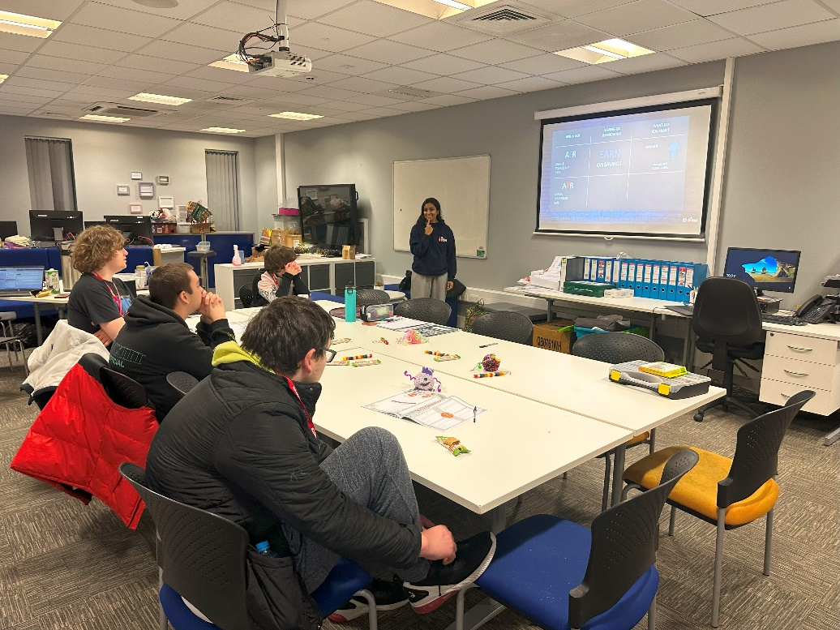

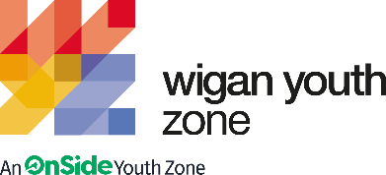

life skills and employability advisor
  - Job Description

OVERVIEW
COMPANY: Wigan Youth Zone
LOCATION: Wigan Youth Zone and Outreach
SALARY: £22,700 - £24,000 per annum (pro rata)
BENEFITS:
- 33 days annual leave (including bank holidays) pro rata. Plus additional leave for length of service.
- Hybrid work,
- Birthdays off,
- Gym access,
- training and CPD including first aid, safeguarding and health and safety,
- Career development opportunities,
- Employee assistance programme,
- Cycle to work scheme,
- Strong team culture,
- Workplace pension,
- Free eye tests,
- Discounted to £2 access to holiday club for WYZ staff.
POSTED: 15th April 2024
CLOSING: 6th May 2024
First interviews: W/C 13th May 2024
Second interviews: TBA
SPECIALISM: Employability/Life Skills/ Community/Youth Work
REPORTS TO: Enterprise and Employability Coordinator
CONTRACT TYPE: Fixed term – 10 months March 2024 – January 2025
HOURS: Full time 40 hours per week
WORK PATTERN:
All hours will be face-to-face delivery with young people and will include a weekend shift.
ORGANISATION TYPE: Charity

who we are looking for:

The role of the Life and Employability Skills Advisor is to deliver weekly one to one sessions and group workshops to young people aged 16 to 25. You will be supporting each person to reach their personal goals and go into positive destinations such as Volunteering, Training or Employment.
You will be completing initial assessments and then creating learning plans based around everyone’s needs, building on confidence, self-esteem and wellbeing to break down barriers enabling them to be able to achieve their end goals.
You will need to plan your time effectively in order to ensure all databases and records are up to date and completed in a timely manner in line with contract compliance requirements.
You will support your line manager in recruiting Cohorts of young people onto the programme, ensuring they are retained through motivating and engaging sessions so that our targets and outcomes are achieved. This may include going out into the community identifying new recruitment opportunities.
The role will include brokering relationships with local employers, colleges and training providers to be able to offer the best available opportunities for the young people we will be working with.

Knowledge and Understanding
Knowledge of the issues affecting young people and an ability to work with challenging behaviour
Understanding of the principles of working with children and young people
Knowledge of health and safety, diversity awareness and safeguarding best practice and how these relate to children and young people
Delivery of activities within an equality framework

Qualifications
GCSE or equivalent Literacy and Numeracy – Essential

A professional Youth Work or teaching qualification at Level 3 or above (or equivalent) - Desirable

What will you need to succeed:

EXPERIENCE
Proven experience of working with young people aged 8 to 19 (25 with disabilities) in  a range of settings both in groups and individually | Essential
Proven experience of engaging vulnerable, disengaged or hard to reach young people | Essential
Experience working in a team and with volunteers | Essential
Experience of delivering employability programmes and workshops to with young people | Essential
Experience supporting NEET 16-25 year olds into positive - Destinations | Essential
Experience of monitoring and evaluation processes | Desirable
Experience managing externally funded projects | Desirable
Experience of supporting young people who are disaffected, underachieving and / or have social / emotional barriers to participation | Desirable
Experience of working in a team and alongside volunteers | Desirable
Experience providing information, advice, guidance and support to young people | Desirable
Experience of dealing with safeguarding issues within a multi-agency setting | Essential
Experience of working with challenging young people | Essential
SKILLS
Excellent written and verbal communication | Essential
Ability to coach, encourage, motivate and provide reliable support to children and young people | Essential
Strong commitment to children and young people and an ability to engage and build positive relationships with all young people, including disengaged and disadvantaged young people | Essential
Ability to develop good professional relationships with children, young people and adults | Essential
Ability to work with young people to develop their social education by providing programmes of activities, services and facilities that are fun and enable young people to develop | Essential
Knowledge or recruitment and selection process | Desirable
Knowledge of Health and Safety, Diversity Awareness and Safeguarding best practice and how these are related to children and young people | Desirable
Ability to deliver high quality activity programmes with children and young people who face social exclusion, disadvantage and disaffection | Desirable
Ability to identify and challenge discrimination and discriminatory behaviour, taking appropriate action as necessary | Essential

WHat you will be doing

- To work within the Wigan Youth Zone Employability Skills team delivering the targeted SLA contract at all stages from:
  - Recruitment
  - Delivery
  - Retention
  - Positive Outcomes
- Develop meaningful relationships with young people to support them, whilst maintaining professional boundaries, in order to achieve positive outcomes.
- To motivate, encourage and engage young people to be confident in participating fully in sessions.
- Based on each individual’s needs, provide personalised support and high quality advice and guidance working through their ILP to enable young people to realise their own potential and overcome personal and practical barriers,.
- Implement effective and timely reviews documented in line with the programmes compliance and monitoring requirements.
- Job Brokering for students, working with local employers and patrons to secure live opportunities for our young people.
- Carry out regular review and evaluations including capturing the outcomes and positive impacts, recording soft and hard outcomes, presenting case studies and celebrating the achievements of young people.
- To achieve KPI’s set by the Board, Chief Executive, Head of Operations and external funders, including for example, progression into Volunteering, Employment and training or the development of employability skills.
- To ensure all Targets for recruitment and outcomes are met.
- To deliver accreditation such as PEARL to young people, including taking responsibility for related administration.
- To develop effective joint working practices with job centres, supported housing groups, young carers, training providers and other agencies to ensure a holistic approach in service delivery to young people, including representing Wigan Youth Zone at meetings with partner agencies.
- To manage the budget and other resources effectively to maximise the benefits to young people.
- To work with the Youth Zone staff to identify opportunities and funding for additional experiences and openings for young people relating to enterprise and employability
- To collaborate with the offer at Leigh and be available at Community Events and special occasions to support the Wigan Youth Zone team.
- Carry out any other reasonable duties as requested by management.

Special Requirements

- A willingness to work unsociable hours when required
- DBS clearance and committed to Safeguarding children
- The ability and willingness to travel to meetings and events both in the region and beyond

The job holder will be required to adhere to the Youth Zone’s policies at all times, with particular emphasis on Equal Opportunities and Safeguarding. Attendance at events and conferences will sometimes be required.

In accordance with our Child Protection and Safeguarding procedures, this position requires an enhanced DBS check and business satisfactory references.

Please note that in line with our Safeguarding Policy, you must be age 21 or over to work in our Senior Sessions and 19+ to work on our Junior Sessions and Holiday Clubs. All applicants must also be inactive as members for at least 12 months.

what is wigan youth zone?

Wigan Youth Zone is a purpose built, state-of-the-art youth facility in Wigan town centre which opened in June 2013. It offers young people from across Wigan the opportunity to meet friends, have new experiences, learn new skills and access the support they need to develop and achieve their potential.
The Youth Zone is open to all young people across Wigan aged from 8 to 19 (up to 25 with additional needs), striving to offer something for everyone, regardless of their interests or abilities. With almost 15 dedicated areas to choose from including our four 40-metre floodlit football pitches, art room, music room and climbing wall – there’s something for everyone here at Wigan Youth Zone.
Our aim is simple, to provide the town’s young people with somewhere to go, something to do and someone to talk to.

You will benefit from:

Salary: £22,700 - £24,000 per annum
33 days annual leave (including bank holidays) pro-rata,
Additional leave for length of service up to 38 days,
Birthdays off,
Gym access,
Training and CPD including First Aid, Safeguarding and Health and Safety,
Career development opportunities,
Access to our Employee Assistance Programme,
Cycle to work scheme,
Strong team culture,
Work place pension,
Free eye tests.
Discounted to £2 per day access to holiday club for children of WYZ staff

what do you need to do next
Please complete our application form following the link below
https://app.smartsheet.com/b/form/d852810831d84133b4aea32dfb8436af

88% of our Team would recommend Wigan Youth Zone as an employer to their family and friend

