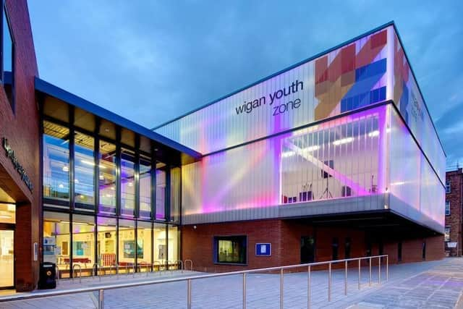

GRANTS & TRUSTS COORDINATOR
  - Job Description
OVERVIEW
COMPANY: Wigan Youth Zone
LOCATION: Parsons Walk, Wigan, WN1 1RU
SALARY: £26 - £30k per annum depending on experience
BENEFITS:
- 33 days annual leave (including bank holidays) pro rata plus additional leave for length of service
- Hybrid work
- Birthdays off
- Gym access
- Training and CPD including first aid, safeguarding and health and safety
- Career development opportunities
- Employee assistance programme
- Cycle to work scheme
- Strong team culture
- Workplace pension
- Free eye tests
- Discounted to £2 access to holiday club for WYZ staff
POSTED: 17th April 2024
CLOSING: 8th May 2024
SPECIALISM: Coordination and reporting on funded projects as well as funding applications
REPORTS TO: Grants & Trusts Manager
CONTRACT TYPE: Permanent
HOURS: 37.5 hours per week
WORK PATTERN:
Office based work at Wigan Youth Zone with flexibility to offer 1 day per week remote working
ORGANISATION TYPE: Charity

who we are looking for:

We are looking for a great communicator, someone who can create compelling stories of success when reporting back to funders and submitting new funding applications. Excellent attention-to-detail and financially literacy are both important.
You will need experience of managing projects and budgets or supporting others to manage projects and budgets. Experience in a fundraising role may be an advantage.
Strong interpersonal skills are essential for the role, as well as the ability to manage competing priorities and deadlines, and self-manage a workload whilst supporting colleagues within the team. In this role you will need a good working knowledge of MS Office 365 and Salesforce to manage grant programme data effectively.

Knowledge and Understanding
- Knowledge of the funding cycle from the early stage of new opportunities through to grant management.
- Good knowledge of MS Office 365 applications and skills to develop, use and interrogate Salesforce and Excel data.

Qualifications
- No specific requirements.

What will you need to succeed:

EXPERIENCE
Suitable and proven experience of reporting to funders on project delivery. | Essential
Awareness of the youth work sector and/or a keen interest in issues affecting children and young people. | Desirable

Proven experience in project coordination and delivery, including ensuring projects are delivered on time and to budget. | Essential
Experience of working in a fundraising team submitting, or contributing to, four and five figure grant applications. | Desirable
SKILLS
Creating and setting up project monitoring and evaluation to meet funders’ requirements, supporting managers and frontline staff to be able to effectively manage the grants. | Essential
Proven ability to evaluate quantitative and qualitative data, and to demonstrate reflective thinking. | Essential
Excellent verbal and written communication skills including reporting programme information in a clear and structured manner to a range of audiences. | Essential
Well-developed diplomacy and interpersonal skills to be able to relate to and understand the needs of colleagues and their projects, and funders expectations. | Essential
Strong working knowledge of MS Office 365 applications with skills to develop use and interrogate Salesforce CRM and Excel data. | Essential
Ability to manage time effectively, and work with minimal supervision. | Essential

what you will be doing
You'll work as part of an established and successful fundraising team to secure and steward four and five-figure grants from trusts, foundations and institutions in the UK.

This will include a portfolio of new and existing funders with varied day-to-day tasks. You'll submit funding proposals and manage existing grants, as well as prepare high-quality feedback reports and deliver outstanding stewardship.

If you have experience in trust, foundation and grant writing, relationship building, engagement and stewardship of donors, this role is for you. This is a fabulous opportunity to make your mark on young lives in Wigan and take our fundraising to the next level.

Key duties include:
Project Coordination
- Working alongside frontline colleagues to oversee delivery of a portfolio of funded projects and services, to grant specifications.

- Monitoring the progress of grants against agreed targets, troubleshooting, and providing advice and support as necessary.
Grant Administration
- Undertake grants administration with finance team by processing grant claims, raising invoices, tracking payments etc.
- Monitor income and expenditure targets and provide regular progress reports and updates on performance against target.
- Collate and record activities and outcomes for reporting to project leads and senior managers on status of KPI’s etc.
Evaluation and Reporting
- Draft and submit high quality monitoring and evaluation reports to project funders in line with the requirements of each funder, and within given timescales.
- Liaise with managers and frontline staff to identify and retrieve data necessary for the preparation of monitoring and evaluation reports including case studies / impact stories.
Fundraising
- Create compelling funding applications using story-telling and persuasive language to articulate project activities, outputs, outcomes and budget.
- Identify new opportunities through trusts and foundations, writing compelling proposals, gathering and synthesising information from staff across the charity as required
- Support other team members with important bids as required.
Other requirements
- Commit to a culture of continuous improvement.
- Represent Wigan Youth Zone positively and effectively in all dealings with internal colleagues, and external partners.
- To be alert to issues of safeguarding and child protection, ensuring the welfare and safety of Youth Zone members is promoted and safeguarded, and to report any child protection concerns to the designated Child Protection Officers using the safeguarding policies, procedures and practice (training to be provided).
- To assist with promotional activities and visits that take place at the Youth Zone.
- To adhere to Wigan Youth Zone policies at all times, with reference to Health and Safety, Safeguarding and Equal Opportunities.

Special Requirements

- DBS clearance and committed to Safeguarding children.

- The job holder will be required to adhere to the Youth Zone’s policies at all times, with particular emphasis on Equal Opportunities and Safeguarding.

In accordance with our Child Protection and Safeguarding procedures, this position requires an enhanced DBS check and business satisfactory references.
Please note that in line with our Safeguarding Policy, you must be age 21 or over to work in our Senior Sessions and 19+ to work on our Junior Sessions and Holiday Clubs. All applicants must also be inactive as members for at least 12 months.

what is wigan youth zone?

Wigan Youth Zone is a purpose built, state-of-the-art youth facility in Wigan town centre which opened in June 2013. It offers young people from across Wigan the opportunity to meet friends, have new experiences, learn new skills and access the support they need to develop and achieve their potential.
The Youth Zone is open to all young people across Wigan aged from 8 to 19 (up to 25 with additional needs), striving to offer something for everyone, regardless of their interests or abilities. With almost 15 dedicated areas to choose from including our four 40-metre floodlit football pitches, art room, music room and climbing wall – there’s something for everyone here at Wigan Youth Zone.
Our aim is simple, to provide the town’s young people with somewhere to go, something to do and someone to talk to.

what do you need to do next
Email your CV to HR@wiganyouthzone.org

88% of our Team would recommend Wigan Youth Zone as an employer to their family and frieNDS

