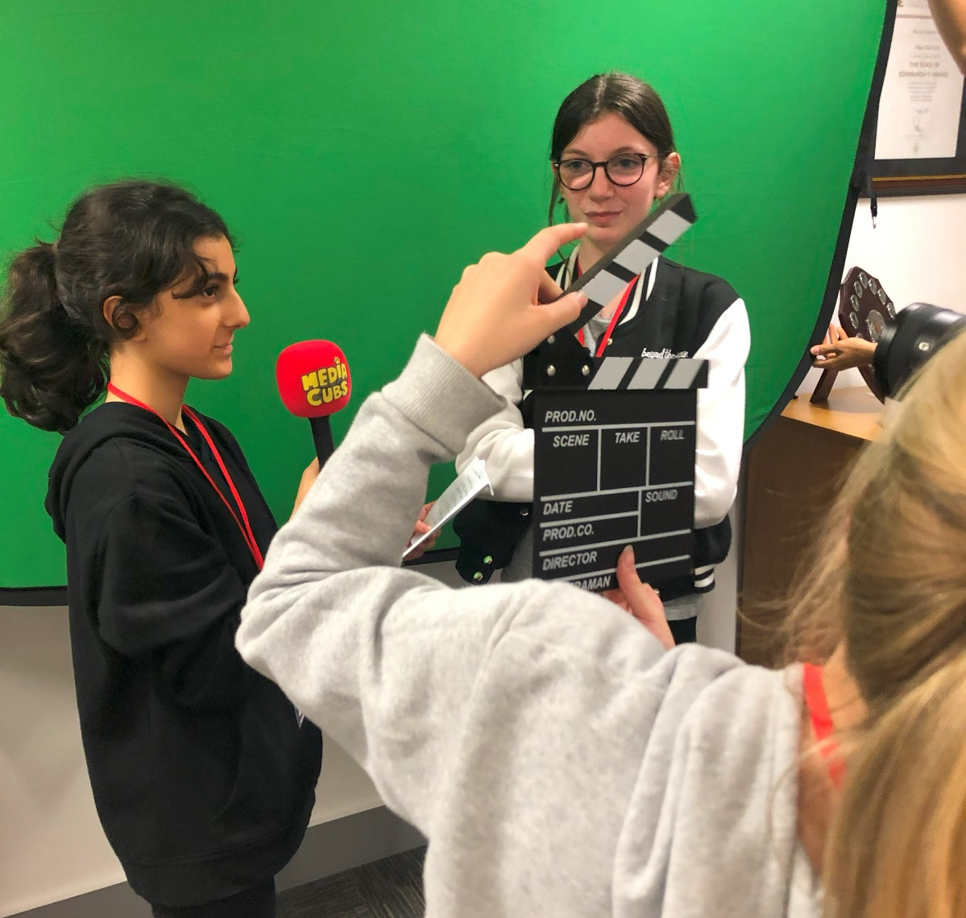

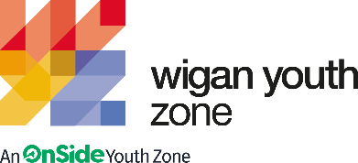

DIGITAL COMMUNICATIONS and marketing OFFICER (mat cover)
  - Job Description

OVERVIEW
COMPANY: Wigan Youth Zone
LOCATION: Parsons Walk, Wigan, WN1 1RU
SALARY: 22.5-24k per annum (depending on experience)
BENEFITS:
- 33 days annual leave (including bank holidays) pro rata. Plus additional leave for length of service.
- Hybrid work,
- Birthdays off,
- Gym access,
- Training and CPD including first aid, safeguarding and health and safety,
- Career development opportunities,
- Employee assistance programme.
- Cycle to work scheme,
- Strong team culture,
- Workplace pension,
- Free eye tests,
- Discounted to £2 access to holiday club for WYZ staff.
POSTED: Friday 5th April 2024
CLOSING: Sunday 21st April 2024
SPECIALISM: Marketing /Communication /PR
REPORTS TO: Communications and Marketing Manager
CONTRACT TYPE: Maternity Cover (10 months)
HOURS: 40 Hours
WORK PATTERN:
Monday – Friday : 10am – 6pm
All hours will be mixed with office-based, remote, delivery with young people and include weekends and evenings.
ORGANISATION TYPE: Charity

who we are looking for:
We are looking for a Digital Communications and Marketing professional with a flair for creativity, high energy, and a passion for working with young people,
You will be supporting the Marketing and Communications Manager in planning, co-ordinating, producing and publishing appropriate content for all Wigan Youth Zones social media channels and its website. You will play an important role in looking at how WYZ builds its presence online and communicates itself to all stakeholders (young people, parents, partners, funders). The role will be working directly with young people to support them to tell their stories in a creative, engaging, and fun way that showcases the Youth Zone and the impact we have made for young people in the local area. You will assist in monitoring our social media platforms and our website and make a commitment to continuous improvement to ensure positive outcomes for young people.

Knowledge and Understanding
- Varied experience in planning and delivering creative social media and marketing plans.
- Raising awareness of a charity amongst the whole community including young people, partners, funders, and potential patrons/ donors
- Understanding the engagement with a variety of stakeholders to convey Wigan Youth Zone offer, the power of youth work and how this aligns with local and national priorities.
- Portray a positive image of young people, their achievements, development, voice, contribution, etc.
- Produce high-quality, creative and modern communications that really captivate the target audience and reflect Wigan Youth Zone’s brand values

Qualifications/experience
- Degree or diploma in relevant areas
- Working with the media and delivering PR and publicity with local and regional media outlets
- Web content development and website management
- Building relationships with senior stakeholders

What will you need to succeed:

Previous digital marketing experience and ideally with a degree (or equivalent) in a relevant subject | Essential
Experience of web content development and website management | Essential
Photo and video editing software experience | Essential
Experience creating content for different digital and social media platforms and amplifying via organic and paid routes | Essential
Experience of working within a mixed office environment as the a communication/marketing expert | Desirable
Experience of using varied IT systems in digital communications | Desirable
Experience of building relationships with senior stakeholders | Desirable
Ability to design and deliver social media plans that reflect organisational core objectives | Essential
Thorough and accurate with excellent attention to detail | Essential
Confident in managing a group of children and young people along with experience working alongside young people to create engaging digital content | Desirable
Excellent written and oral communication skills and an ability to establish good professional relationships with varied stakeholders | Essential
Familiar with all the latest social media applications and how to effectively utilise them for organisational development | Essential
Knowledge of a range of relevant systems e.g. Smart Sheets, ATTAINA, Google Analytics, Google Ads, Adobe Products | Desirable
Experience in working with high-profile national media outlets e.g. BBC, ITV, The Sun, Mirror etc. | Desirable

Special Requirements

- A willingness to work unsociable hours when required
- DBS clearance and committed to Safeguarding children
- The ability and willingness to travel to meetings and events both in the region and beyond
- The job holder will be required to adhere to the Youth Zone’s policies at all times, with particular emphasis on Equal Opportunities and Safeguarding. Attendance at events and conferences will sometimes be required

WHAT YOU WILL BE DOING

- Together with the Marketing and Communications Manager, develop and implement a communications plan and social media output that is inspiring, innovative, and engaging.
- Maintain and develop online content, including video and imagery, that captures the positive impact Wigan Youth Zone has on young people; plus, the ongoing support we receive from our funders and other key stakeholders.
- Collect stories, images, videos, and statistics that are able to showcase the impact Wigan Youth Zone has for young people and in the local area.
- Use analytics to monitor and improve the effectiveness and reach of Wigan Youth Zone's online presence.
- To support the delivery team during sessions with young people, to capture content and stories used to promote and communicate the charity.
- Create digital assets to promote various day-to-day events at Wigan Youth Zone, such as Holiday Club promotion.
- To work directly with young people to develop their communication skills and give them the confidence to share their stories.
- Support the Marketing and Communications Manager with the website's weekly blogs, along with working to make the website more user-friendly and visible to beneficiaries and increase brand awareness through SEO and website iterations.
- To have great energy and establish positive relationships with young people, the wider youth work team, and visitors to the Youth Zone.
- To respond to the needs of young people and ensure Wigan Youth Zone marketing and communication is youth-led.
- Develop, execute, and manage organic and paid-for social campaigns that generate awareness of our delivery programme and fundraising events.
- Whilst looking for trends and insights, create fun and interactive content for/with young people through social media mediums such as TikTok, Instagram Stories, and Reels.

- To ensure young people are at the heart of all WYZ's communications and that their ideas contribute fully to our output.
- To assist with any promotional activities and visits that take place at the Youth Zone.
- To actively promote and be a spokesperson for the Youth Zone and positively contribute to increasing awareness and promotion of the Youth Zone.
- To be able to think on your feet and react quickly.
- To be an active member of the team and operate in line with the values and principles of Wigan Youth Zone.
- Carry out any other reasonable duties as requested by management.

what is wigan youth zone?

Wigan Youth Zone is a purpose built, state-of-the-art youth facility in Wigan town centre which opened in June 2013. It offers young people from across Wigan the opportunity to meet friends, have new experiences, learn new skills and access the support they need to develop and achieve their potential.
The Youth Zone is open to all young people across Wigan aged from 8 to 19 (up to 25 with additional needs), striving to offer something for everyone, regardless of their interests or abilities. With almost 15 dedicated areas to choose from including our four 40-metre floodlit football pitches, art room, music room and climbing wall – there’s something for everyone here at Wigan Youth Zone.
Our aim is simple, to provide the town’s young people with somewhere to go, something to do and someone to talk to.

You will benefit from:
- Salary: 22.5-24k
- 33 days annual leave (including bank holidays) pro-rata,
- Additional leave for length of service up to 38 days,
- Birthdays off,
- Gym access,
- Training and CPD including First Aid, Safeguarding and Health and Safety,
- Career development opportunities,
- Access to our Employee Assistance Programme,
- Cycle to work scheme,
- Strong team culture,
- Work place pension,
- Free eye tests.
- Discounted to £2 access to holiday club for children of WYZ staff
In accordance with our Child Protection and Safeguarding procedures, this position requires an enhanced DBS check and business satisfactory references.
Please note that in line with our Safeguarding Policy, you must be age 21 or over to work in our Senior Sessions and 19+ to work on our Junior Sessions and Holiday Clubs. All applicants must also be inactive as members for at least 12 months.

What do you need to do next:
Email your CV with a portfolio of experience / a piece of work that you are most proud of (in your preferred medium) at HR@wiganyouthzone.org

88% of our Team would recommend Wigan Youth Zone as an employer to their family and friend

