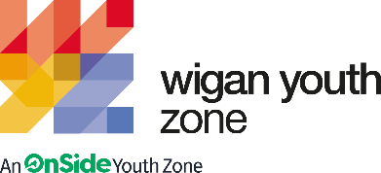

Mixed Martial Arts Coach
  - Job Description

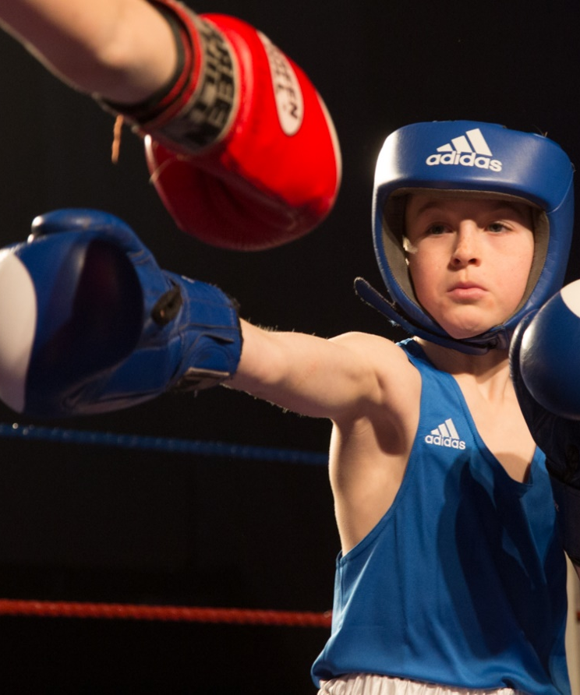  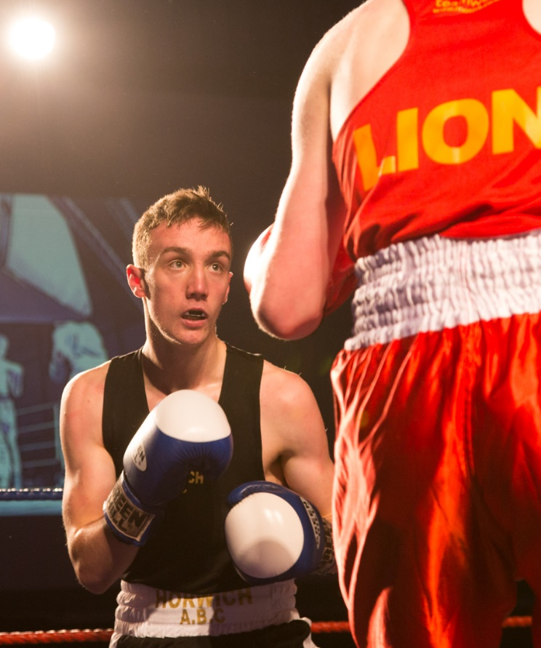  v | OVERVIEW  COMPANY: Wigan Youth Zone  LOCATION: Parsons Walk, Wigan, WN1 1RU  SALARY: £25 Per Hour  BENEFITS:  - 33 days annual leave (including bank holidays) pro rata. Plus additional leave for length of service.  - Hybrid work,  - Birthdays off,  - Gym access,  - training and CPD including first aid, safeguarding and health and safety,  - Career development opportunities,  - Employee assistance programme,  - Cycle to work scheme,  - Strong team culture,  - Workplace pension,  - Free eye tests,  - Discounted to £2 access to holiday club for WYZ staff.  POSTED: 21st March 2024  CLOSING: 11th April 2024  SPECIALISM: Mixed Martial Arts/Boxing/Kickboxing  REPORTS TO: Head of Sports  CONTRACT TYPE: Fixed Term – 12 months with high possibility to extend it for another 12 months  HOURS: 9 hours Three evening sessions of 3 hours each  WORK PATTERN:  All hours will be face-to-face delivery with young people and will include a weekend shift.  ORGANISATION TYPE: Charity

who we are looking for:

Do you love Sport and Fitness, and are you passionate about a role coaching mixed martial arts can play in changing young people’s lives? Are you passionate about giving young people in Wigan a healthy and positive future? Are you happy coaching and teaching young people? Do you want to use your skills, knowledge, and passion to give young people something to do, somewhere to go and someone to talk to?
You will ensure the boxing suite and martial arts area is well used and maintained to a high standard, offering young people a safe, exciting and challenging arena in a friendly and welcoming environment. You will provide supervision and advice to young people and support and guide members of the Youth Zone’s staff and volunteers.

Knowledge and Understanding
- Knowledge of the issues affecting young people and an ability to work with challenging behaviour
- Understanding of the principles of working with children and young people
- Knowledge of health and safety, diversity awareness and safeguarding best practice and how these relate to children and young people
- Delivery of activities within an equality framework

Qualifications

- Level 2 Coaching qualifications e.g. ABA Boxing, Kick Boxing
- Level 2 other disciplines
- First Aid Qualification

What will you need to succeed:

EXPERIENCE
Experience of working with groups of young people aged 8 to 19, or up to age 25 with a disability | Essential
Experience of delivering mixed martial arts sessions | Essential
Experience of working with young people from diverse backgrounds and with additional needs | Desirable
Experience of mixed martial arts coaching and participation | Essential
Experience of conducting equipment safety checks | Essential
Experience of working with young people with additional needs and disabilities | Desirable
SKILLS
Ability to deliver high quality mixed martial arts activities with young people | Essential
Able to work as part of a team and under own initiative | Essential
Strong commitment to children and young people and an ability to engage and build positive relationships with all young people, including disengaged and disadvantaged young people | Essential
Ability to develop good professional relationships with children, young people and adults | Essential
Ability to work with young people to develop their social education by providing programmes of activities, services and facilities that are fun and enable young people to develop | Essential
Ability to coach, encourage, motivate and provide reliable support to young people | Essential
Confident in managing a group of children and young people | Essential
Ability to deliver high quality activity programmes with children and young people who face social exclusion, disadvantage and disaffection | Desirable
Ability to identify and challenge discrimination and discriminatory behaviour, taking appropriate action as necessary | Essential

what you will be doing

- Be a role model for young people and present a positive “can do” attitude
- Take personal responsibility for own actions
- Commit to a culture of continuous improvement
- Work within the performance framework of Wigan Youth Zone and OnSide
- Represent Wigan Youth Zone positively and effectively in all dealings with internal colleagues, and external partners
- Comply with all policies and procedures, with reference to safeguarding, codes of conduct health and safety and equality and diversity to ensure all activities are accessible
- Represent Wigan Youth Zone positively and effectively in all dealings with internal colleagues, and external partners
- To be alert to issues of safeguarding and child protection, ensuring the welfare and safety of Youth Zone members is promoted and safeguarded, and to report any child protection concerns to the designated Child Protection Officers using the safeguarding policies, procedures and practice (training to be provided)
- To assist with any promotional activities and visits that take place at the Youth Zone
- To actively promote the Youth Zone and positively contribute towards increasing Youth Zone membership
- To adhere to Wigan Youth Zone policies at all times, with reference to Health and Safety, Safeguarding and Equal Opportunities
- Together with the Sports Coordinator, UFC, plan, develop and implement a comprehensive UFC mixed martial arts programme for young people, enabling them to build their confidence, social skills and overall wellbeing
- Coordinate and deliver the programme to young people
- Ensure continuous development of the programme, developing and expanding to meet the changing needs of our members
- Carry out inductions for new users and provide supervision in the boxing / martial arts area, promoting best practice and safety standards
- The role is 100% face to face delivery with young people
- Ensure the highest standards of health and safety are maintained in the mixed martial arts area and monitor safety practices whilst working.
- Ensure that all equipment necessary for each session is fit for purpose and adheres to safety standards
- Carry out regular checks, reporting any defects or faults to the Sports Coordinator .
- Assist in the provision of risk assessments and report to the relevant Session Manager any accident or incident that requires attention, completing accident report forms as appropriate
- Where possible, to deliver accredited awards, motivate, encourage and support young people to participate fully in mixed martial arts area offer
- Keep up to date on policies or procedures required for safety in the mixed martial arts area
- Ensure the mixed martial arts area is kept clean, tidy and clear of rubbish at all times

- To manage, support and coordinate necessary requirements for the mixed martial arts area programme
- To promote and safeguard the welfare of young people at all times. To promote cultural cohesion and inclusion and proactively challenge any prejudice and discrimination
- Any other duties as may reasonably be required

Special Requirements

- A willingness to work unsociable hours when required
- DBS clearance and committed to Safeguarding children
- The ability and willingness to travel to meetings and events both in the region and beyond
- The job holder will be required to adhere to the Youth Zone’s policies at all times, with particular emphasis on Equal Opportunities and Safeguarding. Attendance at events and conferences will sometimes be required.

In accordance with our Child Protection and Safeguarding procedures, this position requires an enhanced DBS check and business satisfactory references.
Please note that in line with our Safeguarding Policy, you must be age 21 or over to work in our Senior Sessions and 19+ to work on our Junior Sessions and Holiday Clubs. All applicants must also be inactive as members for at least 12 months.

what is wigan youth zone?

Wigan Youth Zone is a purpose built, state-of-the-art youth facility in Wigan town centre which opened in June 2013. It offers young people from across Wigan the opportunity to meet friends, have new experiences, learn new skills and access the support they need to develop and achieve their potential.
The Youth Zone is open to all young people across Wigan aged from 8 to 19 (up to 25 with additional needs), striving to offer something for everyone, regardless of their interests or abilities. With almost 15 dedicated areas to choose from including our four 40-metre floodlit football pitches, art room, music room and climbing wall – there’s something for everyone here at Wigan Youth Zone.
Our aim is simple, to provide the town’s young people with somewhere to go, something to do and someone to talk to.

You will benefit from:

- Salary: £25 per hour
- 33 days annual leave (including bank holidays) pro-rata,
- Additional leave for length of service up to 38 days,
- Birthdays off,
- Gym access,
- Training and CPD including First Aid, Safeguarding and Health and Safety,
- Career development opportunities,
- Access to our Employee Assistance Programme,
- Cycle to work scheme,
- Strong team culture,
- Work place pension,
- Free eye tests.
- Discounted to £2 access to holiday club for children of WYZ staff

what do you need to do next
Email your CV at HR@wiganyouthzone.org

88% of our Team would recommend Wigan Youth Zone as an employer to their family and friend

