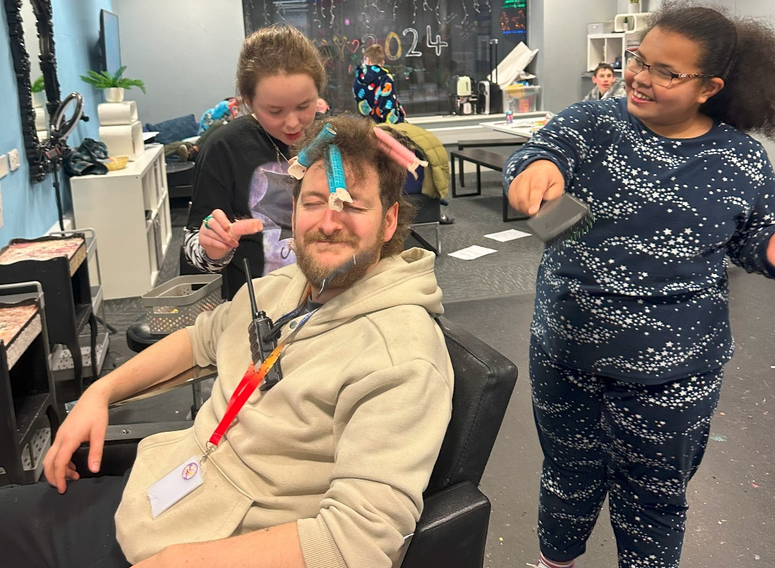

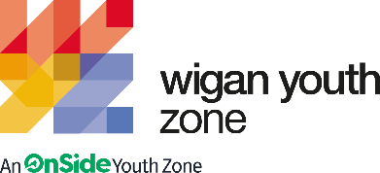

Inclusion Youth Worker
  - Job Description

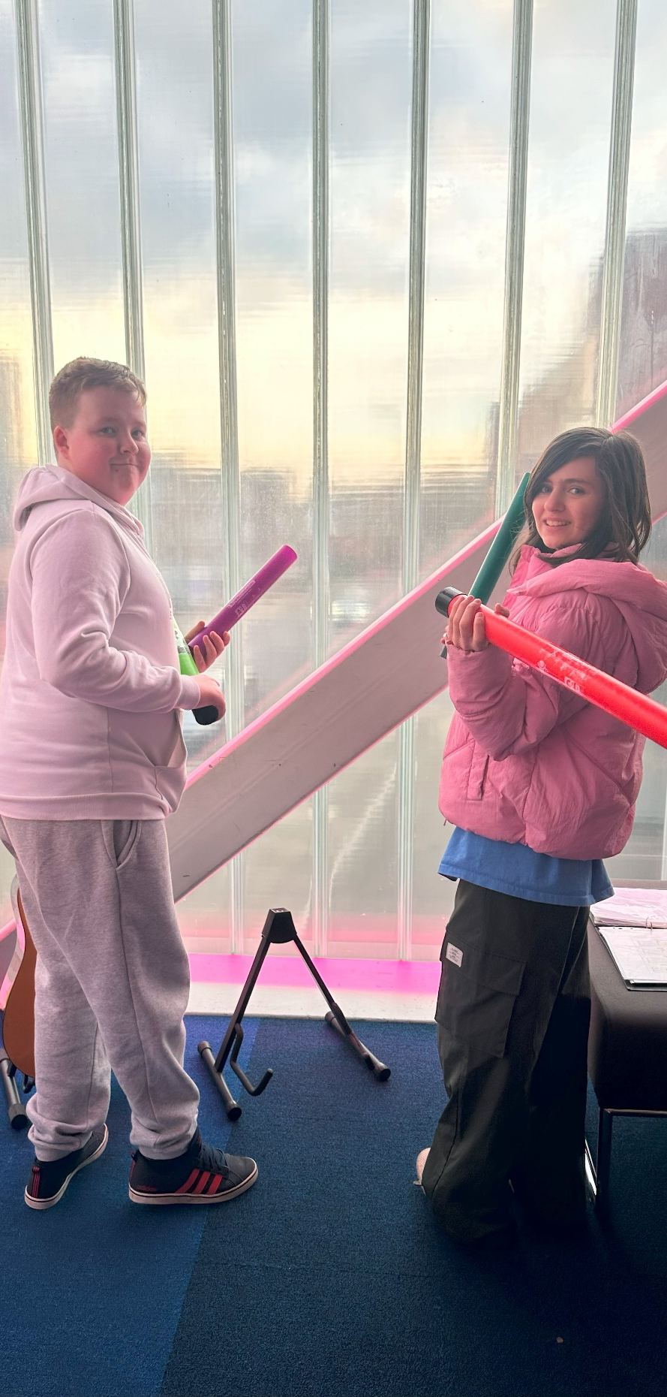 | OVERVIEW  COMPANY: Wigan Youth Zone  LOCATION: Wigan Youth Zone  SALARY: £10.61 per hour  BENEFITS:  - 33 days annual leave (including bank holidays) pro rata. Plus additional leave for length of service.  - Hybrid work,  - Birthdays off,  - Gym access,  - training and CPD including first aid, safeguarding and health and safety,  - Career development opportunities,  - Employee assistance programme,  - Cycle to work scheme,  - Strong team culture,  - Workplace pension,  - Free eye tests,  - Discounted to £2 access to holiday club for WYZ staff.  POSTED: 5th March 2024  CLOSING: 26th March 2024  First interviews: W/C 1st April 2024  Second interviews: TBA  SPECIALISM: Inclusion/SEND  REPORTS TO: Inclusion Coordinator  CONTRACT TYPE: Permanent  HOURS: Part time 13 hours per week  WORK PATTERN:  Thursday 4-9  Saturday 11-3  Sunday 4-7  (1 hour planning time/ supervision)  All hours will be face-to-face delivery with young people and will include a weekend shift.  ORGANISATION TYPE: Charity

who we are looking for:
We are looking for somebody who can ensure Wigan Youth Zone and all its activities are inclusive to all young people. The ideal candidate will support community cohesion and provide an environment where members from diverse demographics, and those with disabilities and additional support needs feel safe.
This role will have clear targets to broaden and increase overall participation rates and ensure participation is representative of the demographics of Wigan and Leigh. You will be on hand to support all young people within the youth zone by ensuring all young people are welcome and feel able to participate in all activities, no matter who they are.

Knowledge and Understanding
Knowledge of the issues affecting young people and an ability to work with challenging behaviour
Understanding of the principles of working with children and young people
Knowledge of health and safety, diversity awareness and safeguarding best practice and how these relate to children and young people
Delivery of activities within an equality framework

Qualifications
Introduction to Youth Work and Community Work NVQ/VRQ Level 2 – Essential
Relevant qualifications or awareness of SEND - Essential

What will you need to succeed:

EXPERIENCE
Face to face activity delivery, working with children and young people both in groups and individually | Essential
Experience of delivering informal education sessions to young people | Desirable
Experience working in a team and with volunteers and motivating them | Essential
Experience of working with young people’s forums to ensure young people have a voice | Desirable
Experience of supporting young people who are disaffected, underachieving and / or have social / emotional barriers to participation | Desirable
Experience of working in an outreach or detached setting and residential | Desirable
Experience providing information, advice, guidance and support to young people | Desirable
Experience of dealing with safeguarding issues within a multi-agency setting | Essential
SKILLS
Delivery of activities within an equality framework | Essential
Ability to work with young people to develop their education by providing programmes of activities, services and facilities that are fun and enable young people and adults | Essential
Ability to develop good professional relationships with children, young people and adults | Essential
Ability to coach, encourage, motivate and provide reliable support to children and young people | Essential
Excellent written and verbal communication skills | Essential
Confident in managing a group of children and young people | Essential
Ability to identify and challenge discrimination and discriminatory behaviour, taking appropriate action as necessary | Essential
Understanding the principles of working with children and young people | Essential
Understanding of issues affecting young people’s lives | Essential
Ability to deliver high quality activity programmes with children and young people who face social exclusion, disadvantage and disaffection | Desirable
Knowledge of health and safety, diversity awareness and safeguarding best practice and how these relate to children and young people | Essential

WHat you will be doing

- Ensue the individual members with additional support requirements have equality access to all the opportunities and activities available
- Support young people to take steps towards achieving personal goals and greater independence
- Encourage and support young people to engage with other young people, participate in group work and gain new experiences
- Promote all aspects of equality and inclusion to staff, members and families whilst liaising directly with their careers and social care teams to ensure effort is made to enable the member to achieve their full potential
- To support the development of positive relationship with the young people, their parents and carers
- To support and empower young people to engage in positive activities of their choice
- To work directly with children and young people to develop their social skills and build their confidence by delivering programmes of activities, services and facilities at Wigan Youth Zone which will take place during the evening and weekends and school holidays and will occasionally include residential work
- To directly deliver a high quality programme of issue based work that is exciting, safe, innovative and developmental and directly responds to the diverse needs, concerns and interest of the members.
- To understand the community issues around young people with special educational needs and disabilities. To build trust with these young people and their families and SEND support networks and partners to build strong community cohesion and inclusion.
- Positively influence the general programme of events at the Youth Zone so it is attractive to young people from diverse backgrounds and abilities.
- To ensure the participation of young people in activities that their ideas contribute fully in the delivery and evaluation of activites.
- Carry out any other reasonable duties as requested by line manager or senior manager
- Support your line manager in delivering more sustainable projects
- Be flexible due to department requirements and business needs
- Work within the performance framework of Wigan Youth Zone and OnSide
- Represent Wigan Youth Zone positively and effectively in all dealings with internal colleagues and external partners
- Support Wigan Youth Zones yearly events
- Support the department in Fundraising for WYZ

Special Requirements

A willingness to work unsociable hours when required
DBS clearance and committed to Safeguarding children
The ability and willingness to travel to meetings and events both in the region and beyond

The job holder will be required to adhere to the Youth Zone’s policies at all times, with particular emphasis on Equal Opportunities and Safeguarding. Attendance at events and conferences will sometimes be required.

In accordance with our Child Protection and Safeguarding procedures, this position requires an enhanced DBS check and business satisfactory references.

Please note that in line with our Safeguarding Policy, you must be age 21 or over to work in our Senior Sessions and 19+ to work on our Junior Sessions and Holiday Clubs. All applicants must also be inactive as members for at least 12 months.

what is wigan youth zone?

Wigan Youth Zone is a purpose built, state-of-the-art youth facility in Wigan town centre which opened in June 2013. It offers young people from across Wigan the opportunity to meet friends, have new experiences, learn new skills and access the support they need to develop and achieve their potential.
The Youth Zone is open to all young people across Wigan aged from 8 to 19 (up to 25 with additional needs), striving to offer something for everyone, regardless of their interests or abilities. With almost 15 dedicated areas to choose from including our four 40-metre floodlit football pitches, art room, music room and climbing wall – there’s something for everyone here at Wigan Youth Zone.
Our aim is simple, to provide the town’s young people with somewhere to go, something to do and someone to talk to.

You will benefit from:

Salary: £10.61 per hour
33 days annual leave (including bank holidays) pro-rata,
Additional leave for length of service up to 38 days,
Birthdays off,
Gym access,
Training and CPD including First Aid, Safeguarding and Health and Safety,
Career development opportunities,
Access to our Employee Assistance Programme,
Cycle to work scheme,
Strong team culture,
Work place pension,
Free eye tests.
Discounted to £2 per day access to holiday club for children of WYZ staff

what do you need to do next
Please complete our application form following the link below
https://app.smartsheet.com/b/form/d852810831d84133b4aea32dfb8436af

88% of our Team would recommend Wigan Youth Zone as an employer to their family and friends

