1.1 Recruitment and Selection Policy

- POLICY

Wigan Youth Zone recognises that the recruitment of a quality and diverse workforce is crucial to the success of the organisation. To achieve this we are committed to good, robust and fair recruitment processes. The process will be a positive experience for all candidates and successful candidates should be clear of their role and enthused to fulfil it. This policy offers guidance throughout the whole process from advertising a vacancy to Day one inductions.

Wigan Youth Zone is an equal opportunities employer. We recognise that discrimination can occur directly and indirectly in the recruitment and selection process. We aim to ensure that no applicant is placed at a disadvantage based on a protected characteristic as defined in the Equality Act (2010). In fulfilling this policy Wigan Youth Zone will comply with the Data Protection Act 2018 (as laid out in our Data Protection Policy) and our Equality Policy at all times

  - Safer Recruitment

Wigan Youth Zone is committed to safeguarding and promoting the welfare of children, young people and vulnerable groups. All employees and volunteers are expected to share this commitment. This policy complies with safer recruitment guidelines and reference to safer recruitment will be made throughout.

  - Recruitment of Ex-Offenders

Wigan Youth Zone actively promotes equality of opportunity for all with the right mix of talent, skills and potential. We welcome applications from a wide range of candidates, including those with criminal records. The Disclosure and Barring Service (DBS) is used to assess applicants’ suitability for positions within Wigan Youth Zone and complies fully with the DBS Code of Practice. We undertake not to discriminate unfairly against any subject of a Disclosure on the basis of conviction or other information revealed.
A Disclosure will be requested for all Youth Zone staff and volunteers. All application forms and job adverts will contain a statement that a DBS Disclosure will be requested in the event of the individual being offered the position.
The Rehabilitation of Offenders Act 1974 gives employees or prospective employees the right not to disclose any criminal offences that are spent. Those roles involving contact with children or vulnerable adults are exempt from the Act and therefore these employees, volunteers etc. are obliged to disclose any previous offences, whether spent or unspent, and including cautions.

At interview, or in a separate discussion, an open and measured discussion will take place on the subject of any offences or other matter that might be relevant to the position. Knowingly giving false information or failure to reveal information that is directly relevant to the position sought could lead to withdrawal of an offer of employment or may render the employee liable for dismissal
Having a criminal record will not necessarily prevent individuals working for Wigan Youth Zone it will depend on the nature of the position and the nature and circumstances of the offence.

- PROCEDURE

The Recruitment and Selection Procedure provides a framework and best practice guide that will assist managers in ensuring that Wigan Youth Zone attracts, selects and retains the most suitable candidate for a post using appropriate, fair, open, effective and safe methods. It is the responsibility of everyone involved in the recruitment and selection of employees to ensure that all applicants and potential applicants are treated fairly and that all decisions made within the process are objective and based on the requirements for the job

  - Vacancies

All vacancies must be approved by the CEO (and where appropriate the Board) prior to starting any recruitment process. In the case of existing posts, the appropriate manager will review and update the job description accordingly, ensuring it still accurately meets the needs of the Youth Zone and reflects the role responsibilities. Regarding new posts, the appropriate manager should produce a job description and person specification and forward this to the HR and Office Manager who will check and sign it off for advertisement.

The job description and person specification for the role(s) being recruited to should specify the individual’s responsibilities in regard to safeguarding.

  - Advertising Vacancies

The aim of advertising is to attract the right applicants for the job, and to promote the Youth Zone as an employer of choice.

Vacancies will be advertised, as a minimum, internally via email and announcements on UKG. They will also normally be advertised externally and consideration should be given to the target market, for instance, how senior the post is, how many applicants there are likely to be, and what success rate the Youth Zone have had with various publications etc. Where there is a cost involved this should be approved by the appropriate manager or CEO.

Possible advertising mediums include:

- Generic recruitment websites such as Indeed and media websites linked to press advertising. These are considerably cheaper than advertising in the press/newspapers and job seekers using the internet is fast becoming the norm
- Wigan Youth Zone’s website, Onside’s Website, Twitter, Facebook and LinkedIn
- Local Newspapers and Local Radio – should be considered for less specialised jobs
- National Newspapers – should be considered for senior roles only
- Specialist and Professional Journals – should only be considered where a specific group of potential applicants need to be reached, or where a recruitment campaign has failed to attract suitable candidates
- Local Schools, Colleges and Careers Services
- Job Fairs/Open Days - These provide an opportunity to meet with potential candidates. They provide a useful way of promoting the Youth Zone as an 'Employer of Choice'
- Recruitment Agencies/Consultants/Executive Search (Head-hunters) – These will normally only be used if normal recruitment strategies have been unsuccessful. They tend to be expensive charging a percentage of the starting salary

Adverts will normally be live for a minimum period of two weeks to ensure that it reaches as wide an audience as possible. The advert will include the following information:
- Role title, hours, salary and location
- Description of role responsibilities
- Advert closing date and interview date
- How to apply for the role
- That any appointment will be subject to a successful DBS check
- That Wigan Youth Zone are committed to safeguarding all young people – the following strap line is recommended on all adverts:

Wigan Youth Zone is committed to safeguarding and promoting the welfare of children, young people and vulnerable groups. All employees and volunteers are expected to share this commitment

If the advert is live on an external website, it would be normal practice to direct candidates to the Youth Zone’s website to access accompanying documentation such as the role profile and application form.

  - Applications

Applications will usually be in the form of an application form. In certain circumstances it may be appropriate to accept application by CV, such as when it would represent a reasonable adjustment under the provisions of the Equality Act (2010). Applications received after the closing date will not be accepted unless exceptional circumstances apply. Applications will not be accepted from Active Members until their membership has expired for at least 12 months. The only exception to this rule is for Holiday Club positions.

Application forms will be returned to HR@wiganyouthzone who will collate and distribute to the selection panel.

  - Shortlisting

Candidates will be shortlisted for interview based on their ability to meet the criteria laid out in the person specification. In the first instance, applications should be sifted into those that meet the essential criteria in the person specification. If this produces too many applications the desirable criteria should be used to further reduce the number (See Appendix 1 for an example short listing matrix)

It is good practice to short list in a methodical and objective way in order to avoid accusations of discriminatory practice and to ensure a fair and consistent process. The short listing matrix should be used which is based on the criteria set out in the role profile/person specification.

To ensure safer recruitment, gaps in employment should also be scrutinised at the short listing stage. Any anomalies or discrepancies or gaps in employment identified should be noted so that they can be taken up as part of the consideration of whether to short list the applicant, or whether they require further exploration at the interview stage.

Candidates aged between 18 and 21 years old should only be considered for positions supporting junior sessions due to authority and boundary concerns.

A member of the HR Team will notify the successful and unsuccessful applicants by email and confirm interview details and arrangements. It is not obligatory to offer individual feedback on applications at this stage. However, the short listing matrix and the reasons for rejection, in addition to applications forms for unsuccessful candidates, must be kept on file for six months.

  - Selection

Any selection process should be fair and transparent with the same process followed for all candidates. Wigan Youth Zone (and indeed any organisation) is open to challenge at any point in the recruitment process and may be called upon to objectively defend any decisions made.

Recruitment is a two-way process and therefore every effort should be made to ensure that candidates are well looked after and made to feel valued during the process. Consideration should be given to the administrative aspects of the day to ensure that the process runs smoothly. This will include booking suitable rooms, arranging refreshments and notifying reception of the names and times of arrival of candidates. The selection techniques used will be relevant to the needs of the job and organisational strategy and values but could include: interviews, psychometric testing, work sampling tasks, values based assessments, group tasks, presentations etc.

- Interviews - the panel should consist of at least 2 people. Interview questions should be role related and should always include a values based and safeguarding question. For safer recruitment purposes, their suitability to work in an environment with young people (whether directly or indirectly) should be scrutinised, as well as exploring any unexplained gaps in employment. It is also good practice to explore the following:
  - the candidate’s attitude toward children and young people
  - their motivation and reason for working with children
  - their perceptions about the boundaries of acceptable behaviour towards children
  - their ability to form and maintain professional relationships
  - their general understanding of safeguarding
  - his or her ability to support the Youth Zone’s agenda for safeguarding and promoting the welfare of children and young people

All candidates will be asked the same questions and assessed on their response to them. However, the panel are able to ask probing, follow up and clarifying questions on an individual basis. Candidates will also have the opportunity to ask questions of the interview panel at the end. For consistency, it is a good idea for the panel to use an interview scoring record (Appendix 2) and to have a good idea of what a model answer would look like. Interview notes should be thorough and legible. If there are any special conditions, such as working unsociable hours or working flexibly, the candidate should be made aware of this. Second interviews may be required where there are applicants of a similar quality or further assessment is required to discern suitability.

- Testing - well planned tests can assist greatly with the selection process by giving a more rounded picture of a candidate. As a general rule the more senior the post, the more comprehensive the assessment process should be. The purpose of testing is to replicate as far as possible the key aspects of situations that individuals are likely to encounter in the role they are being considered for. It is important that tests are chosen carefully to ensure that they are at an appropriate level and are measuring the skills needed for that particular post. Any tests designed in-house should be checked to ensure that they are measuring the competency in a reliable and fair manner and are free from bias. This is particularly important when there is a mix of internal and external candidates. If tests are being used the interview letter should contain information regarding the test and where appropriate (for instance with purchased tests) practice leaflets enclosed. In the instance of psychometric testing, feedback can only be given by an appropriately qualified person.
For the successful candidate, the recruitment paperwork will form part of their personnel file. For unsuccessful candidates all paperwork will be kept for 6 months from the date of interview and then confidentially destroyed. Interview feedback to candidates should be provided on request and be both factual and constructive. Candidates can insist on feedback in writing.

  - Offering a position

Once the interview panel have identified a preferred candidate authorisation to appoint must be sought from the relevant member of the Senior Management Team prior to any offer being made or other candidates being rejected. If the salary was advertised as a band rather than a fixed amount the Departmental Manager should make a recommendation of the proposed salary offer which will be reviewed and approved by the CEO and HR and Office Manager. Once authorisation has been given by the relevant SMT to appoint, a member of the HR Team will make an offer to the successful applicant, which will be conditional upon an Enhanced DBS check, proof of relevant qualifications, two successful references and evidence of Right to Work in the UK. When pre-employment checks have been verified, a final offer can be made. When a start date has been agreed, the contract of employment will be issued to the candidate.

It is good practice to offer unsuccessful candidates feedback on their interview/assessments. This can be done verbally or in writing.

  - Conflict of Interests
If an employee is involved in making recruitment and selection decisions, they must declare any relationship with any of the applicants to their line manager as soon as they are aware of this. No employee will be part of a recruitment panel, either shortlisting or interviewing, where they are related to an applicant. Where a more informal relationship exists employees must still declare this. In this situation the employee will not normally take part in the recruitment decision making process. In exceptional circumstances, where this will cause serious practical problems the manager may allow an employee to take part in a recruitment process where an applicant is known to them. A written record of the decision and the reasons for it should be kept on file.

- PRE-EMPLOYMENT

  - References

Two satisfactory references must be obtained and these must cover the previous 5 years. References should specifically request information on the applicant’s suitability to work with children/young people and details of any disciplinary procedures the applicant has been subject to including those where the sanction has expired. If an employer says it is not their policy to provide references, the applicant must be asked to nominate another referee.

For school or college leavers references may be accepted from a former teacher.

References should be scrutinised and any concerns resolved before making any final job offer. Information provided by the referee should be compared with the information provided by the

applicant in his or her application and any discrepancies checked. To speed up the process this can be done verbally initially but should always be followed up by written references using Wigan Youth Zones reference request form. It is important to keep written records of any telephone conversations and where there are any issues, more detailed information
should be sought where possible. (This is particularly important where a decision is made not to consider the applicant further, or where issues need to be explored).

References have two functions. Firstly, they are used to confirm the accuracy of data provided by the candidate such as dates of employment, position held etc. Secondly, they provide additional data regarding the candidate such as time-keeping, disciplinary history, quality of work etc. Although some of this data is factual, some is based on opinion and as such it should be approached with caution and used only to confirm information already gathered through the assessment process. Of the two referees, one of should be the candidate's current employer (or last employer if not currently employed). If a candidate has not given his/her current employer the reasons behind this should be explored at interview. Pre-prepared references produced by the candidate are not acceptable. Personal references are only acceptable where the candidate has not had any, or insufficient, work experience to date.

  - Right to Work in the UK

It must be checked that an applicant is allowed to work for you in the UK before they are employed. The HR and Office Manager or appropriate departmental manager must see the applicant’s original documents, check that the documents are valid with the applicant present, make and keep copies of the documents and record the date the check was made. All employers can face a civil penalty if an illegal worker is employed and haven’t carried out a correct right to work check. If an applicant has a limited right to work in the UK, further checks will need to be made. If an applicant can’t show their documents, the Home Office must be contacted to check their immigration employment status. For up to date guidance, see https://www.gov.uk/check-job-applicant-right-to-work

  - DBS Check

All offers of employment are subject to a DBS check. The HR and Office Manager or appropriate departmental manager should check the identity of a job applicant as part of a DBS check and process the check as soon as possible following job offer (see Appendix 11) Subject to 1.1, Wigan Youth Zone can withdraw a job offer if the results show anything that would make the applicant unsuitable. DBS checks apply to both prospective employees and volunteers. For up to date guidance, see https://www.gov.uk/disclosure-barring-service-check/arranging-checks-as-an-employer

  - Certificates

Certificates to evidence competence for all roles must be produced before the start of employment. Failure to do so will result in the offer of employment being withdrawn. All certificates are to be uploaded onto individual UKG profiles and will only be recognised once they have been received.

4.0 INDUCTION AND NEW STARTER INFORMATION

Within a week of employment, all new staff must complete the HR Checklist on UKG which included personal information, HMRC New Starter form, Bank Details, and relevant checklists and policies.

The content and nature of the induction process will vary according to the role and previous experience of the new member of staff or volunteer. However, the new employee should be
booked a variety of appointments/activities by their line manager once they have an electronic calendar set up. The manager is responsible for passing these details onto the new employee.

4.1 Day One Administration
On the employee’s first day, managers should check/action the following:
- That the new starter has returned a signed copy of their contract
- Their personnel file is set up with copies of all appropriate pre-employment, assessment and new starter information contained within
- The employee is aware of all health and safety and housekeeping arrangements for the building such as location of fire escapes and toilets, kitchen and storage facilities
- That the new employee has all appropriate work-related equipment and log on information
- Explain the probationary period and diarise regular one to one meeting

4.2 Safeguarding
As far as safeguarding and promoting the welfare of children and young people the induction should include information about:
- Any policies and procedures in relation to safeguarding e.g. child protection, anti-bullying, anti-racism, physical intervention or restraint, intimate care, internet safety, whistle blowing policy; code of conduct
- How and with whom any concerns should be raised
- Any other relevant personnel procedures e.g. disciplinary, managing performance and whistle blowing.

Appendix 1 – Example Short Listing Matrix

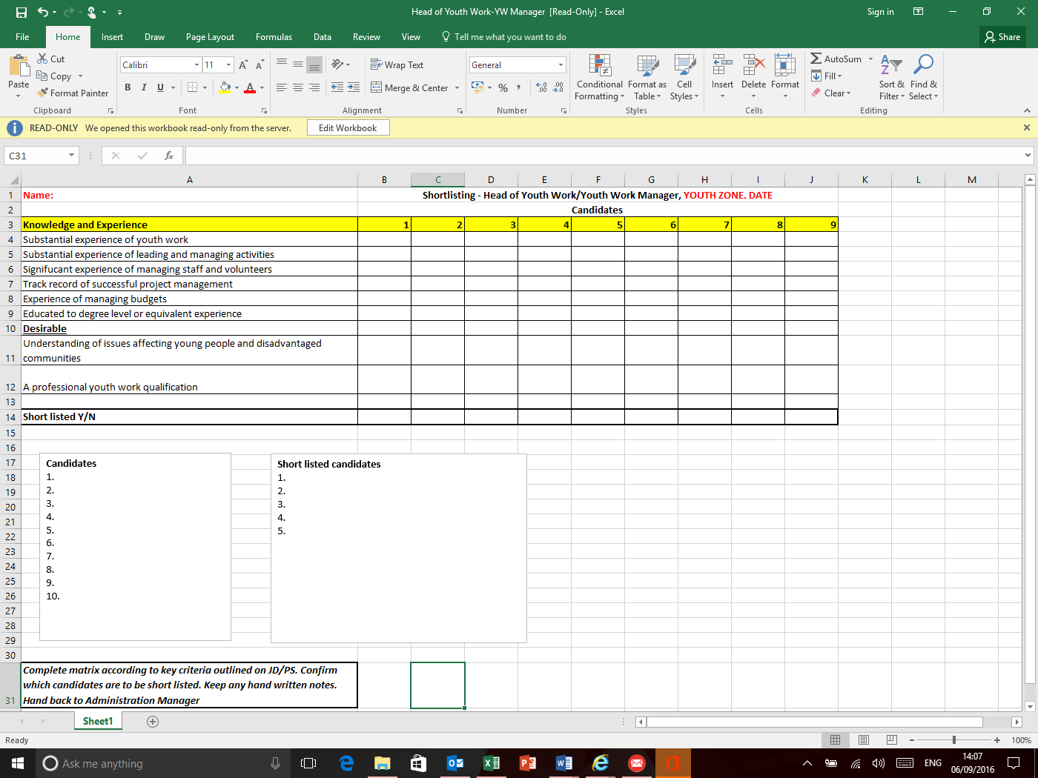

Appendix 2 – Example Interview Questions and Record

Head of Youth Work
DATE

Panel Member: Candidate:

Questions | Comments |  | Score
- This is a role is within a new charity and a brand new building in Wigan What do you think will be the priorities and challenges in the first couple of months? |  | - Recruitment and attraction strategies  - Challenge of creating and integrating a new large staff team  - Building relationships with internal and external stakeholders  - Raising awareness of the Youth Zone and the work of the charity  - Promoting the Youth Zone and encouraging active membership
- “Wigan Youth Zone” is a world class state of the art provision which to achieve its potential for transforming lives will need the very best team. Why do you want to be part of this amazing initiative and why do you think you are the right person? |  | - Values:  - Innovation  - Can Do  - Serving Young People  - Team Work  - Doing it Right  - Track record of success  - Results driven  - Substantial experience of youth work and people management  - Ability to relate to young people from all back grounds  - Genuine passion and motivation to make a difference
- Tell us about your previous experience in recruiting staff and volunteers (for example, how many did you recruit? How did you attract them? What methods did you use and how successful were you?)  Follow up:  What challenges do you think you might face with a brand new team? |  | - Innovation in recruitment  - Knowledge of recruitment practices  - Organised and proactive  - Tenacious in approach  - Able to be flexible and reactive  - Turns challenges in to opportunities  - Experience in building and developing staff
- How would you ensure that standards of behaviour in the Youth Zone are maintained? |  | - Awareness of behaviour management/safeguarding  - Training and development of staff  - Reporting procedures  - Able to have difficult conversations and deal with situations as they arise/ flexibility  - Preventative rather than reactive  - Clear communication to staff and young people re expected codes of conduct
- Please tell us about your budget management experience to date?  There will be a particular staffing budget for which you will be mainly responsible – what would you do if you had already done the rota and three staff phoned in sick on the same day? |  | - Size of budget  - Did they work with a Finance Manager or self-manage?  - Awareness of income and expenditure  - Being able to be flexible/creative under pressure  - Experience in managing a rota
- You arrive at work on the General Manager’s day off and are the most senior member of staff on duty. You have planned to spend the next few hours writing an outcomes report for a major funder which is due to be submitted that day. The lead worker for the afternoon session has called in sick and you have a message to call a parent who wishes to make a complaint about a team member in relation to a safeguarding incident. The toilets are also blocked and it is also the facilities officer’s day off. The General Manager is not contactable. What do you do? |  | - Ability to prioritise  - Effectively manage a team and delegate appropriately  - Flexibility/Adaptability  - Being creative  - Having a sense of humour  - Understanding the breadth of the role  - Takes responsibility and is proactive and solutions focussed
- A member of staff tells you that a 15-year-old member of the Youth Zone told them that another member of staff has made sexually suggestive comments to them, has asked to meet outside the youth zone and has made a Facebook friend request. How will you respond to this situation? |  | - Safeguarding policy  - Awareness of safer working practices  - Reporting and recording  - Investigation?  - Disciplinary policy and procedure  - Training and development  - Communication  - Ensuring safety and wellbeing of young person
- How would you go about implementing safeguarding policy and practice with a new team of 40 staff and 100 volunteers? |  | - Training and development  - Ensuring attendance and understanding  - Issuing policy and ensuring receipt  - Theoretical and practical training  - Best practice/case studies  - Ongoing – part of day to day practice
- Could you tell us about a time when you have had to build collaborative relationships in order to achieve a particular goal?  Who do you see as the main stakeholders of the Youth Zone? |  | - Awareness of external stakeholders  - Building relationships internally and externally  - Young people, parents, patrons, media, schools, community groups, staff, board members, volunteers
- Finally, please tell us what it is about the role and Wigan Youth Zone which has motivated you to apply for this position

1 | Poor answer
2 | Inadequate – but some relevant points
3 | Average
4 | Good answer with relevant points and examples
5 | Excellent answer – good points raised, examples and outcomes given

Signed by Panel Member_________________________________________________ Total Score______________________

