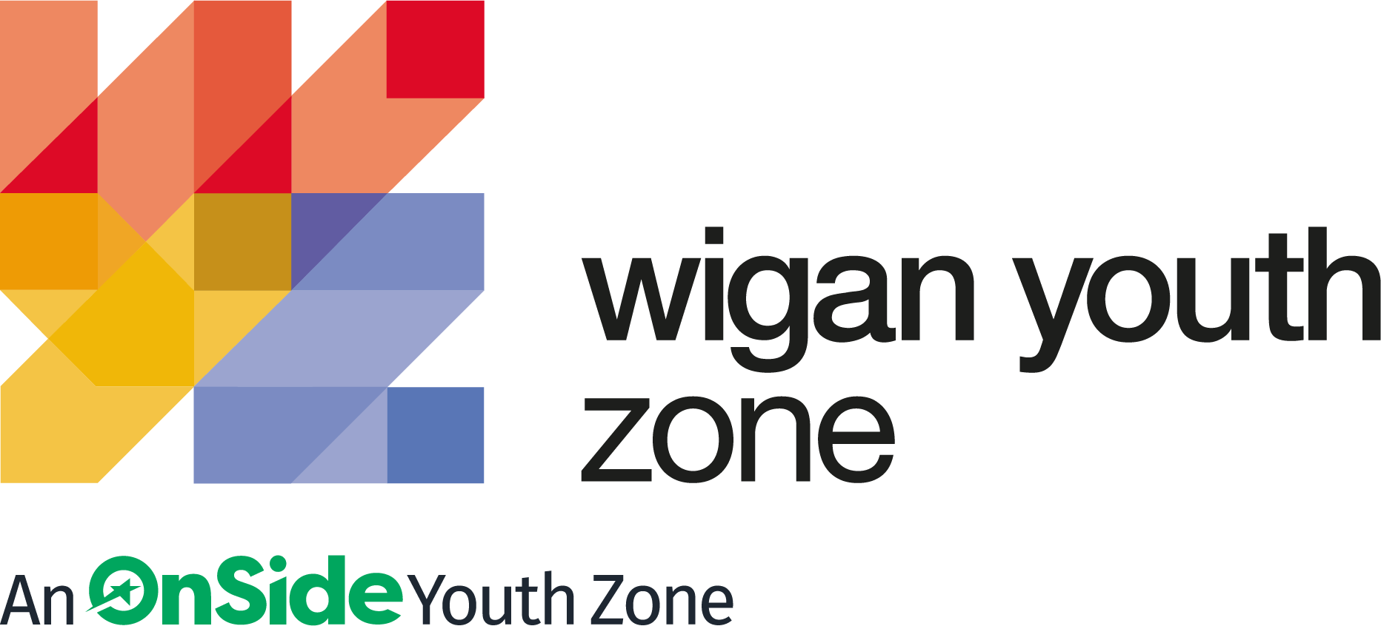

ROLE PROFILE
OUTREACH AND DETACHED YOUTH WORKER

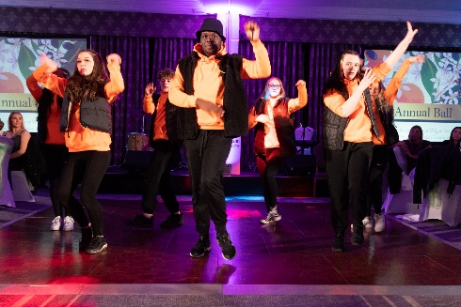
ROLE PROFILE

POST:
Outreach and Detached Youth Worker - 2 posts

SALARY:
£9.39 - £9.67

LOCATION:
Wigan Youth Zone

REPORTING TO
Outreach and Detached Coordinator

CONTRACT:
Permanent – Part time up to 20 hours per week each role

(Tues 4-8pm, Wed 4-9pm, Fri 4-9, Sat 4-9:30)

BENEFITS:
Gym access; Training opportunities and CPD delivered in-house or by partner organisations (such as Wigan Council and the OnSide Talent Academy) – including First Aid, Safeguarding and Health and Safety; Career Development Opportunities; Birthday Off; Employee Assistance Programme (EAP); Cycle to Work Scheme; Strong team culture.

We are a proud Supporter of the Greater Manchester Good Employment Charter, first of its kind in the UK, which aims to improve employment standards across GM. #GoodEmployment.

JOB PURPOSE

To work across Wigan Borough, approaching and engaging directly with groups of young people on their own turf and within their communities. To build relationships and to help young people to stay safe whilst reducing anti-social behaviour. To support a local youth project in Shakerley, planning and delivering activities for Junior and Senior sessions. To staff transport to and from Wigan Youth Zone, enabling young people to access the facilities. All of these elements can involve working in a challenging environment, remaining calm under pressure, dealing with challenging behaviour whilst maintaining overall discipline with good humour and continuing to engage with the young people.

ABOUT WIGAN YOUTH ZONE

We’re Wigan Youth Zone and our vision is to inspire and empower young people in Wigan and Leigh to fulfil their potential. We do this by giving young people in Wigan and Leigh aged 8-19 (up to 25 with additional needs) the freedom to discover themselves in an innovative, safe and social environment and to support their transition into adulthood.

Centrally located in Wigan Town Centre, Wigan Youth Zone is the largest youth club in Europe and makes a bold statement about the importance of giving young people high quality places to go in their leisure time. The two-storey building has a four-court sports hall with climbing wall, a fully fitted fitness suite, a boxing gym, dance and performing arts studios, as well as music, media and visual arts facilities.

There is also a cafe, together with recreational and social areas. Externally there are four all-weather kick-pitches and full-size skate park. In addition to the work which happens in the facility, there is also a team who work across the borough to meet young people on their turf – whether this is through street-based youth work or via a satellite centre.

The services provided by the exceptional Wigan Youth Zone staff are delivered 7 days a week, 52 weeks a year, providing local young people with somewhere to go, something to do and someone to talk to. Since opening, the Youth Zone has facilitated over 675,000 visits to over 29,000 young people with impressive outcomes for those members across a range of measures such as confidence building, facilitating positive relationships and instilling ambition for adulthood.

CONTEXT OF THE ROLE

Wigan Youth Zone, the largest youth club in Europe, is centrally located, dedicated to young people and makes a bold statement about the importance of giving young people high quality places to go in their leisure time. The two-storey building has a four-court sports hall with climbing wall, a fully fitted fitness suite, a boxing gym, dance and performing arts studios, as well as music, media and visual arts facilities. There is also a cafe, together with recreational and social areas. Externally there are four all-weather kick-pitches and full-size skate park. Wigan Youth Zone is open 7 days a week, 52 weeks a year, providing local young people with somewhere to go, something to do and someone to talk to for almost eight years, winning UK Youth’s award ‘Youth Organisation of the Year’ in 2018 and shortlisted for the ‘Youth Work Award’ in the Children and Young People Now Awards 2020.

Since opening, the Youth Zone has facilitated over 500,000 visits to over 23,000 young people with impressive outcomes for those members across a range of measures such as confidence building, facilitating positive relationships and instilling ambition for adulthood. In 2020, the Youth Zone was primed for another year of significant outcomes – starting with a record attendance in January – however, in March the operation completely changed at pace to support as many young people, and the wider community, as possible in the wake of the Coronavirus pandemic. The context of our current recruitment drive is for Wigan Youth Zone to relaunch mass universal programming over the current year, ensuring that we continue to have a positive impact on as many young people’s lives as possible in Wigan and Leigh.
Wigan Youth Zone’s Outreach and Detached team work on the streets and parks of the Borough, engaging with young people who may not be accessing any organised provisions. Building relationships with groups and individuals may lead to direct help, access to WYZ or referral to other programmes or agencies. These young people may be vulnerable, engaging in risky behaviour or may be on the edge of the criminal justice system; as such, our engagement with them could be critical to their future.

As well as street-based work, the Outreach team run community youth groups for Juniors and Seniors at Shakerley Community Centre and are looking to expand this programme to other areas. These groups run a varied programme of sports, arts, music and other activities.
Since opening, Wigan Youth Zone has run a programme of free access transport to the centre from the East of the borough, regularly bringing in an extra 50-60 young people for a Friday or Saturday session. Staffing these buses or minibuses is critical to enabling many of these young people to access our provision and allows us to serve the whole of the borough to the best of our abilities.

DUTIES AND RESPOSIBILITIES – GENERAL
- Work within the performance framework of Wigan Youth Zone and OnSide;
- Represent Wigan Youth Zone positively and effectively in all dealings with internal colleagues, and external partners;
- To be alert to issues of safeguarding and child protection, ensuring the welfare and safety of Youth Zone members is promoted and safeguarded, and to report any child protection concerns to the designated Child Protection Officers using the safeguarding policies, procedures and practice (training to be provided);
- To assist with any promotional activities and visits that take place at the Youth Zone;
- To actively promote the Youth Zone and positively contribute towards increasing Youth Zone membership;
- To adhere to Wigan Youth Zone policies at all times, with particular reference to Health and Safety, Safeguarding and Equal Opportunities.

DUTIES AND RESPONSIBILITIES – DETAILED

- To make contact and establish relationships with young people in Wigan Borough;
- To encourage and enable young people to participate in a range of personally challenging activities at a local youth centre or at WYZ;
- To promote and staff buses and minibuses, enabling members to access WYZ;
- To work directly with children and young people to develop their social skills and build their confidence by delivering programmes of activities and services;
- To regularly deal with challenging behaviour in a closed environment, in a safe, fair, friendly and consistent manner;
- To directly deliver a high quality programme of activity that is exciting, safe, varied, innovative, developmental and directly responds to the diverse needs, concerns and interests of the members;
- To work flexibly to ensure the needs of the members are met, including disadvantaged children and young people and those with disabilities or additional needs;
- To ensure that the members maintain a high standard of behaviour and discipline during sessions and on transport;
- To ensure the participation of young people in activities and that their ideas contribute fully in the delivery and evaluation of activities;
- To support and motivate other staff and volunteers working in your and other areas;
- To work with key stakeholders, including Wigan Council, GMP, Inspiring Healthy Lifestyles, local businesses, schools and other organisations;
- To maintain records of young people’s attendance and discipline, update central data and report to your line manager;
- To promote and safeguard the welfare of children and young people at all times;
- To be an active member of the team and operate in line with the values and principles of Wigan Youth Zone.

THE POWER OF YOUTH WORK

We believe all young people deserve the opportunity to shine. But opportunity is about more than bricks and mortar, sports courts and sound studios. The amazing equipment in our Youth Zones is important. But their real impact comes from the life-changing youth work that is at the heart of everything we do.
With every workout or kick a bout, every mock interview or muck around with mates, young people develop the resilience to face challenges and the skills to solve problems.

They find confidence to aim high and the determination to become who they want to be. They build positive relationships based on being given the space to talk, an understanding of their own self-worth, and a sense of belonging to something bigger.

This approach, since opening in 2013, has led to the work of the Youth Zone generating a social value for the community of over 2:1 – meaning that for every £1 generated into the charity, the impact is more than doubled. These outcomes have been continually recognised locally, regionally and nationally by a variety of award-giving organisations such as UK Youth, Children and Young People Now and the North West Charity Awards.

That’s the power of exceptional youth work.

INSIDE A YOUTH ZONE

Youth Zones give 8-19 year olds, and up to 25 for young people with additional needs, affordable access to a broad range of services. Containing state-of-the-art facilities, Youth Zones give young people the opportunity to take part in over 20 sporting, artistic, cultural and recreational activities every evening and weekend throughout the year plus all through the school holidays.

Facilities include an indoor sports hall; music room and recording studio; training kitchen; boxing gym and mixed martial arts studio; enterprise and employability room; outdoor 4G sports MUGA; wellbeing room; climbing wall; café; media room and more.

Employing high ratios of exceptional youth and activity workers and volunteers, our Youth Zones change the lives of many thousands of young people each month, delivering social impact on an incredible scale.

Wigan Youth Zone is a place of activity, adventure and fun for all young people where they can try new experiences and learn new skills. Wigan Youth Zone supports young people to reach their full potential, grow their dreams and achieve their goals.
Learn more here
https://www.wiganyouthzone.org/our-present-our-past-our-impact/

We are looking for someone who can deliver this aspiration for Wigan’s young people and share the following values:

- Is a positive role model for young people and who believes in and recognises young people’s potential

- Has a positive and “can do” attitude

- Takes responsibility for their own actions

- Is committed to a culture of continuous improvement and subscribes to a “tonight’s better than last night” philosophy

- Is willing to go the extra mile to ensure great provision for young people

SELECTION CRITERIA | REQUIREMENT
EXPERIENCE
Face to face activity delivery, working with children and young people  (aged 8 plus) both in groups and individually | Essential
Experience of working with challenging young people | Essential
Experience of supporting young people who are disaffected,  underachieving and / or have social / emotional barriers to participation | Essential
Experience of working in a team and alongside volunteers | Essential
Organising a programme of youth work activities
Residential work with young people | Desirable
SKILLS AND ABILITIES | Desirable
Strong commitment to children and young people and an ability to  engage and build positive relationships with all young people,  including disengaged and disadvantaged young people | Desirable
Ability to develop good professional relationships with children,  young people and adults | Desirable
Ability to work with young people to develop their social education  by providing programmes of activities, services and facilities that  are fun and enable young people to develop | Desirable
Ability to coach, encourage, motivate and provide reliable support to  children and young people | Essential
Confidence in managing a group of children and young people | Essential
Ability to deliver high quality activity programmes with children and  young people who face social exclusion, disadvantage and disaffection | Essential
Ability to identify and challenge discrimination and discriminatory  behaviour, taking appropriate action as necessary | Essential
Excellent written and verbal communication skills | Desirable
Good computer literacy including working knowledge of MS Outlook,  MS Word & MS Excel | Desirable
KNOWLEDGE
Knowledge of the issues affecting young people | Essential
Understanding of the principles of working with children and young people | Essential
Knowledge of recruitment and selection process | Desirable
Knowledge of health and safety, diversity awareness  and safeguarding best practice and how these relate to children  and young people | Desirable
EDUCATION AND QULIFICATIONS
Introduction to Youth Work or Youth and Community Work NVQ / VRQ  Level 1 or Level 1 Playwork | Essential
SPECIAL REQUIREMENTS
A willingness to work unsociable hours when required | Essential
DBS clearance and committed to Safeguarding children | Essential
The ability and willingness to travel to meetings and events both in  the region and beyond | Essential
Willingness to work in all weather conditions | Essential

GENERAL INFORMATION

In accordance with our Child Protection and Safeguarding procedures, this position requires an enhanced DBS check and positive references.

Please note that, for Safeguarding reasons, all applicants have to be in-active as Wigan Youth Zone members for the last 12 months before applying for roles. Also, all applicants must be over 18 to work with the Juniors’ and Holiday Club and over 21 to work with the Seniors at WYZ.

APPLICATION DETAILS
RECRUITMENT PACKAGE

SALARY:
£9.39 - £9.67 per hour

HOLIDAYS:
33 Days per annum

CLOSING DATE FOR APPLICATIONS:
16th February 2023

START DATE:
ASAP

We reserve the right to close this vacancy early if we receive sufficient applications for the role. Therefore, if you are interested, please submit your application as early as possible.

As an equal opportunities employer, we welcome applications from under-represented groups; in particular from Black, Asian and Minority Ethnic individuals, people with disabilities and members of LGBTQ+ community. Our Senior Management Team, actively ensures a culture where everyone can be themselves and thrive.

For information on how Wigan Youth Zone processes your data, go to
https://www.wiganyouthzone.org/privacy-policy/

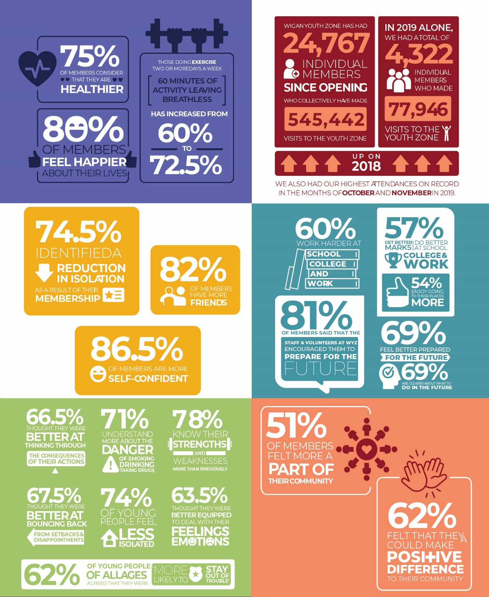

Our Vision
Our vision is to inspire and empower young people in Wigan and Leigh to fulfil their potential.

Our Mission
Our mission is to give young people in Wigan and Leigh aged 8-19 (up to 25 with a disability) the freedom to discover themselves in an innovative, safe and social environment and to support their transition into adulthood.

Our Values
Y oung person centred approach
O pen, inclusive and respectful environment
U niversal programming consistently on offer which is inspirational and aspirational
T ruly meaningful opportunities for the youth voice and empowerment
H elping young people to build positive relationships to enable them to reach their potential

