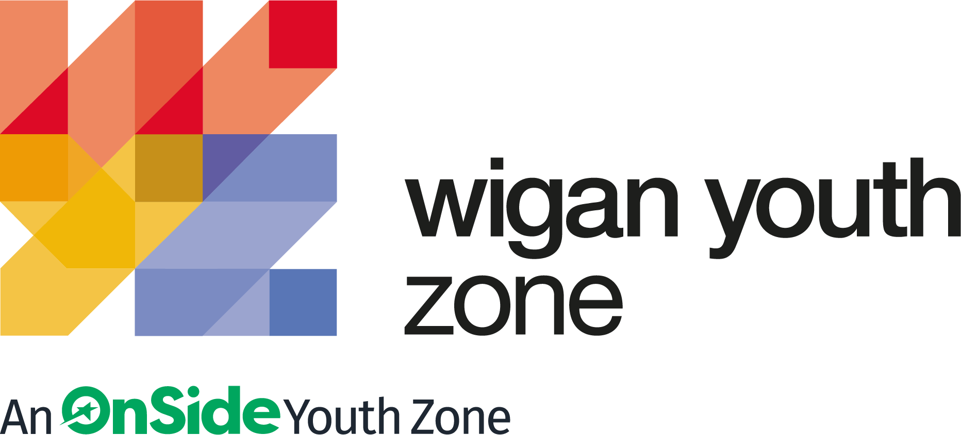

ROLE PROFILE
CATERING ASSISTANT

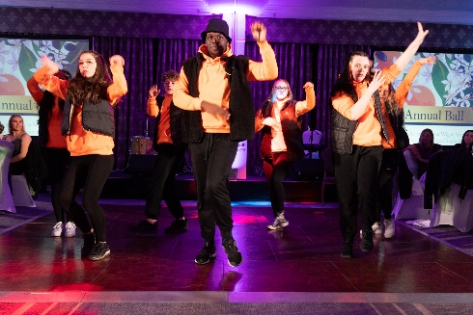
ROLE PROFILE

POST:
CATERING ASSISTANT

SALARY:
£9.39 - £9.67 per hour

LOCATION:
Wigan Youth Zone

REPORTING TO:
Catering Manager

CONTRACT:
Permanent – Part time 12 hours – Friday – 3.30pm – 7.30pm, Saturday – 3.30pm – 7.30pm and Sunday – 3.00pm – 7.00pm. Cover will also be available mid-week and during school holidays.

BENEFITS:
Gym access; Training opportunities and CPD delivered in-house or by partner organisations (such as Wigan Council and the OnSide Talent Academy) – including First Aid, Safeguarding and Health and Safety; Career Development Opportunities; Birthday Off; Employee Assistance Programme (EAP); Cycle to Work Scheme; Strong team culture.
We are a proud Supporter of the Greater Manchester Good Employment Charter, first of its kind in the UK, which aims to improve employment standards across GM. #GoodEmployment.

ROLE PURPOSE:
To help to develop, support and deliver the catering provision at the Youth Zone, ensuring that young people have access to healthy, high quality meals.
You must be able to cook inspiring dishes, be skilled in vegetarian and halal cooking, be passionate about local produce and most importantly love food.
Successful candidates for this role will take pride in creating innovative new and simple dishes and relate well to young people.

ABOUT WIGAN YOUTH ZONE
We’re Wigan Youth Zone and our vision is to inspire and empower young people in Wigan and Leigh to fulfil their potential. We do this by giving young people in Wigan and Leigh aged 8-19 (up to 25 with additional needs) the freedom to discover themselves in an innovative, safe and social environment and to support their transition into adulthood.

Centrally located in Wigan Town Centre, Wigan Youth Zone is the largest youth club in Europe and makes a bold statement about the importance of giving young people high quality places to go in their leisure time. The two-storey building has a four-court sports hall with climbing wall, a fully fitted fitness suite, a boxing gym, dance and performing arts studios, as well as music, media and visual arts facilities.

There is also a cafe, together with recreational and social areas. Externally there are four all-weather kick-pitches and full-size skate park. In addition to the work which happens in the facility, there is also a team who work across the borough to meet young people on their turf – whether this is through street-based youth work or via a satellite centre.

The services provided by the exceptional Wigan Youth Zone staff are delivered 7 days a week, 52 weeks a year, providing local young people with somewhere to go, something to do and someone to talk to. Since opening, the Youth Zone has facilitated over 675,000 visits to over 29,000 young people with impressive outcomes for those members across a range of measures such as confidence
building, facilitating positive relationships and instilling ambition for adulthood.

THE POWER OF YOUTH WORK
We believe all young people deserve the opportunity to shine. But opportunity is about more than bricks and mortar, sports courts and sound studios. The amazing equipment in our Youth Zones is important. But their real impact comes from the life-changing youth work that is at the heart of everything we do.
With every workout or kick a bout, every mock interview or muck around with mates, young people develop the resilience to face challenges and the skills to solve problems.

They find confidence to aim high and the determination to become who they want to be. They build positive relationships based on being given the space to talk, an understanding of their own self-worth, and a sense of belonging to something bigger.

This approach, since opening in 2013, has led to the work of the Youth Zone generating a social value for the community of over 2:1 – meaning that for every £1 generated into the charity, the impact is more than doubled. These outcomes have been continually recognised locally, regionally and nationally by a variety of award-giving organisations such as UK Youth, Children and Young People Now and the North West Charity Awards.

That’s the power of exceptional youth work.

INSIDE A YOUTH ZONE
Youth Zones give 8-19 year olds, and up to 25 for young people with additional needs, affordable access to a broad range of services. Containing state-of-the-art facilities, Youth Zones give young people the opportunity to take part in over 20 sporting, artistic, cultural and recreational activities every evening and weekend throughout the year plus all through the school holidays.

Facilities include an indoor sports hall; music room and recording studio; training kitchen; boxing gym and mixed martial arts studio; enterprise and employability room; outdoor 4G sports MUGA; wellbeing room; climbing wall; café; media room and more.

Employing high ratios of exceptional youth and activity workers and volunteers, our Youth Zones change the lives of many thousands of young people each month, delivering social impact on an incredible scale.

Wigan Youth Zone is a place of activity, adventure and fun for all young people where they can try new experiences and learn new skills. Wigan Youth Zone supports young people to reach their full potential, grow their dreams and achieve their goals.
Learn more here
https://www.wiganyouthzone.org/our-present-our-past-our-impact/
We are looking for someone who can deliver this aspiration for Wigan’s young people and share the following values:
Is a positive role model for young people and who believes in and recognises young people’s potential
Has a positive and “can do” attitude
- Takes responsibility for their own actions
- Is committed to a culture of continuous improvement and subscribes to a “tonight’s better than last night” philosophy
- Is willing to go the extra mile to ensure great provision for young people

DUTIES AND RESPONSIBILITIES – GENERAL

- Work within the performance framework of Wigan Youth Zone and OnSide;
- To be alert to issues of safeguarding and child protection, ensuring the welfare and safety of Youth Zone members is promoted and safeguarded, and to report any child protection concerns to the designated Child Protection Officers using the safeguarding policies, procedures and practice (training to be provided);
- To actively promote the Youth Zone and positively contribute towards increasing Youth Zone membership;
- To adhere to Wigan Youth Zone policies at all times, with particular reference to Health and Safety, Safeguarding and Equal Opportunities.

MAIN RESPONSIBILITIES

- To undertake and supervise the preparation of food and beverages served in the café area.

- To adhere to stock control procedures and ensure they are adequate and up to date.

- Ensure all kitchen equipment is regularly cleaned, reporting any faults/repairs required.

- Ensure all Health and Safety and Environmental Health requirements are adhered to, namely:-
- Reporting of all equipment not working properly.
- Reporting of any health and safety issues.
- Compliance with food hygiene regulations.
- Ensure food is stored correctly and at correct temperatures.
- Recording of all high risk food temperatures on delivery and prior to service, if applicable.
- To support with ordering and control of all stock.
- Cash handling and the subsequent financial administration in line with WYZ financial procedures.
- Maintain a clean working environment as set out in the cleaning schedule by ensuring regular cleaning of all work surfaces, storerooms and ancillary areas.

- Clearing tables, washing up, and other general cleaning duties.
- Undertake such other additional duties which may result from changing circumstances

PERSON SPECIFICATION
Applicants will be expected to demonstrate these experience, skills, abilities and attributes.

SELECTION CRITERIA | REQUIREMENT
EXPERIENCE
Experience of working in a catering environment | Essential
Knowledge of Health, Safety and Environmental issues | Essential
Experience of working in a team and alongside volunteers | Desirable
Experience of working with challenging young people | Desirable
Experience of youth work | Desirable
Skills and Abilities
Ability to prioritise and be self-motivated | Essential
Ability to communicate clearly and follow instructions | Essential
Ability to develop good professional relationship with children, young people and adults | Essential
Ability to communicate with a wide range of people and relate well to young people | Essential
Knowledge and Understanding
Understanding of the principles of working with children and young people | Desirable
Understanding of issues affecting young people’s lives | Desirable
Knowledge of health and safety, diversity awareness and safeguarding best practice and how these relate to children and young people | Desirable
Qualifications
Level 2 Food Hygiene Certificate | Essential
NVQ Level 3 Catering or other recognised Catering qualification | Desirable
Advanced Food Hygiene Certificate | Desirable
Personal Attributes
Positive and enthusiastic | Essential
A flexible attitude to work and a willingness to perform a variety of duties to ensure an efficient and effective service | Essential
A real passion for good food | Essential
Calm under pressure and with a “can do” attitude | Essential
Punctual and reliable | Essential
Commitment to personal and professional development | Essential
A flexible attitude to work and a willingness to perform a variety of duties to ensure an efficient and effective service | Essential
Willing and able to work in the evenings, at weekends and in a residential setting | Essential

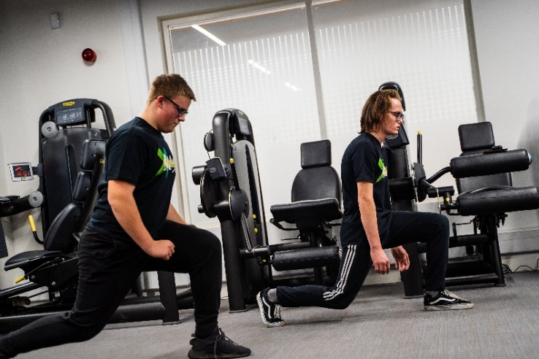

GENERAL INFORMATION

In accordance with our Child Protection and Safeguarding procedures, this position requires an enhanced DBS check and positive references.

Please note that, for Safeguarding reasons, all applicants have to be in-active as Wigan Youth Zone members for the last 12 months before applying for roles. Also, all applicants must be over 18 to work with the Juniors’ and Holiday Club and over 21 to work with the Seniors at WYZ.
WORK PATTERN:
Permanent Part time – 12 hours
Working hours:
Friday and Saturday – 3.30pm – 7.30pm
Sunday – 3.00pm – 7.00pm
RECRUITMENT PACKAGE

SALARY:
£9.39 - £9.67 per hour

HOLIDAYS:
33 Days per annum (pro rata)

APPLICATION DETAILS

CLOSING DATE FOR APPLICATIONS:

12/12/2022

START DATE:
ASAP

As an equal opportunities employer, we welcome applications from under-represented groups; in particular from Black, Asian and Minority Ethnic individuals, people with disabilities and members of LGBTQ+ community. Our Senior Management Team, actively ensures a culture where everyone can be themselves and thrive.

For information on how Wigan Youth Zone processes your data, go to
https://www.wiganyouthzone.org/privacy-policy/

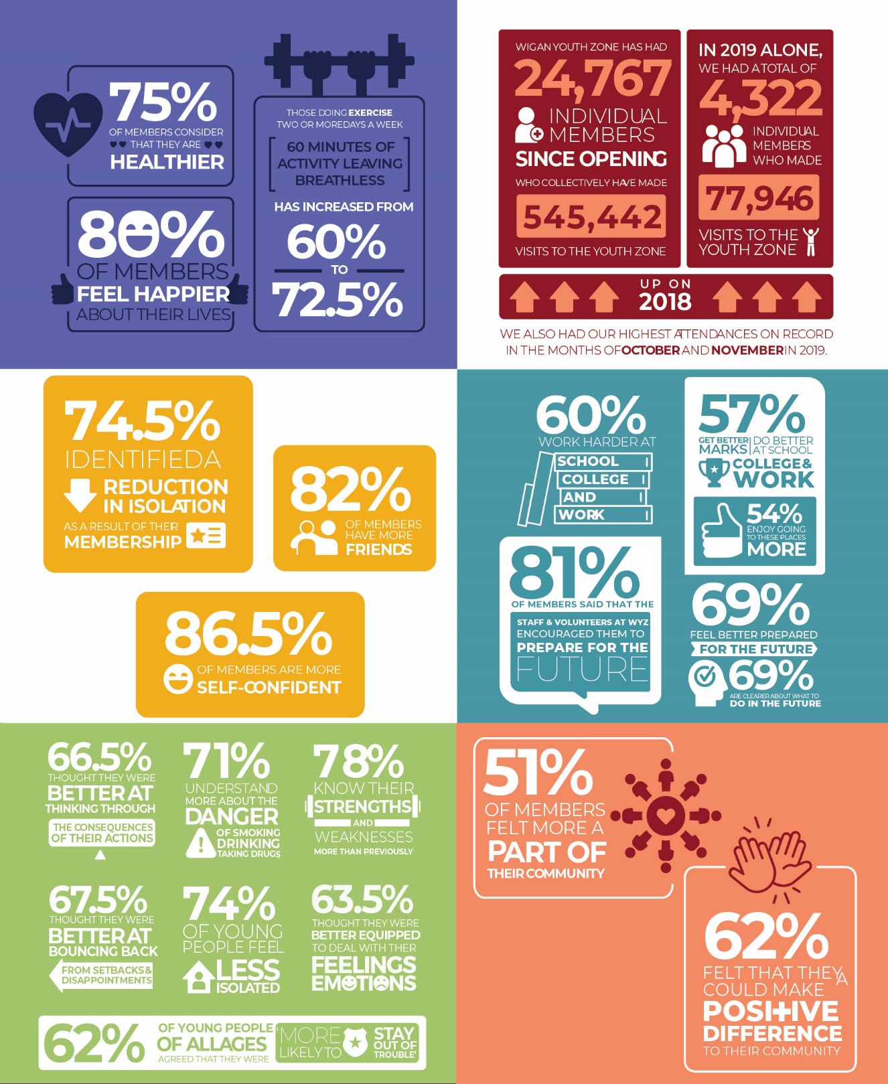

Our Vision
Our vision is to inspire and empower young people in Wigan and Leigh to fulfil their potential.

Our Mission
Our mission is to give young people in Wigan and Leigh aged 8-19 (up to 25 with a disability) the freedom to discover themselves in an innovative, safe and social environment and to support their transition into adulthood.

Our Values
Y oung person centred approach
O pen, inclusive and respectful environment
U niversal programming consistently on offer which is inspirational and aspirational
T ruly meaningful opportunities for the youth voice and empowerment
H elping young people to build positive relationships to enable them to reach their potential

