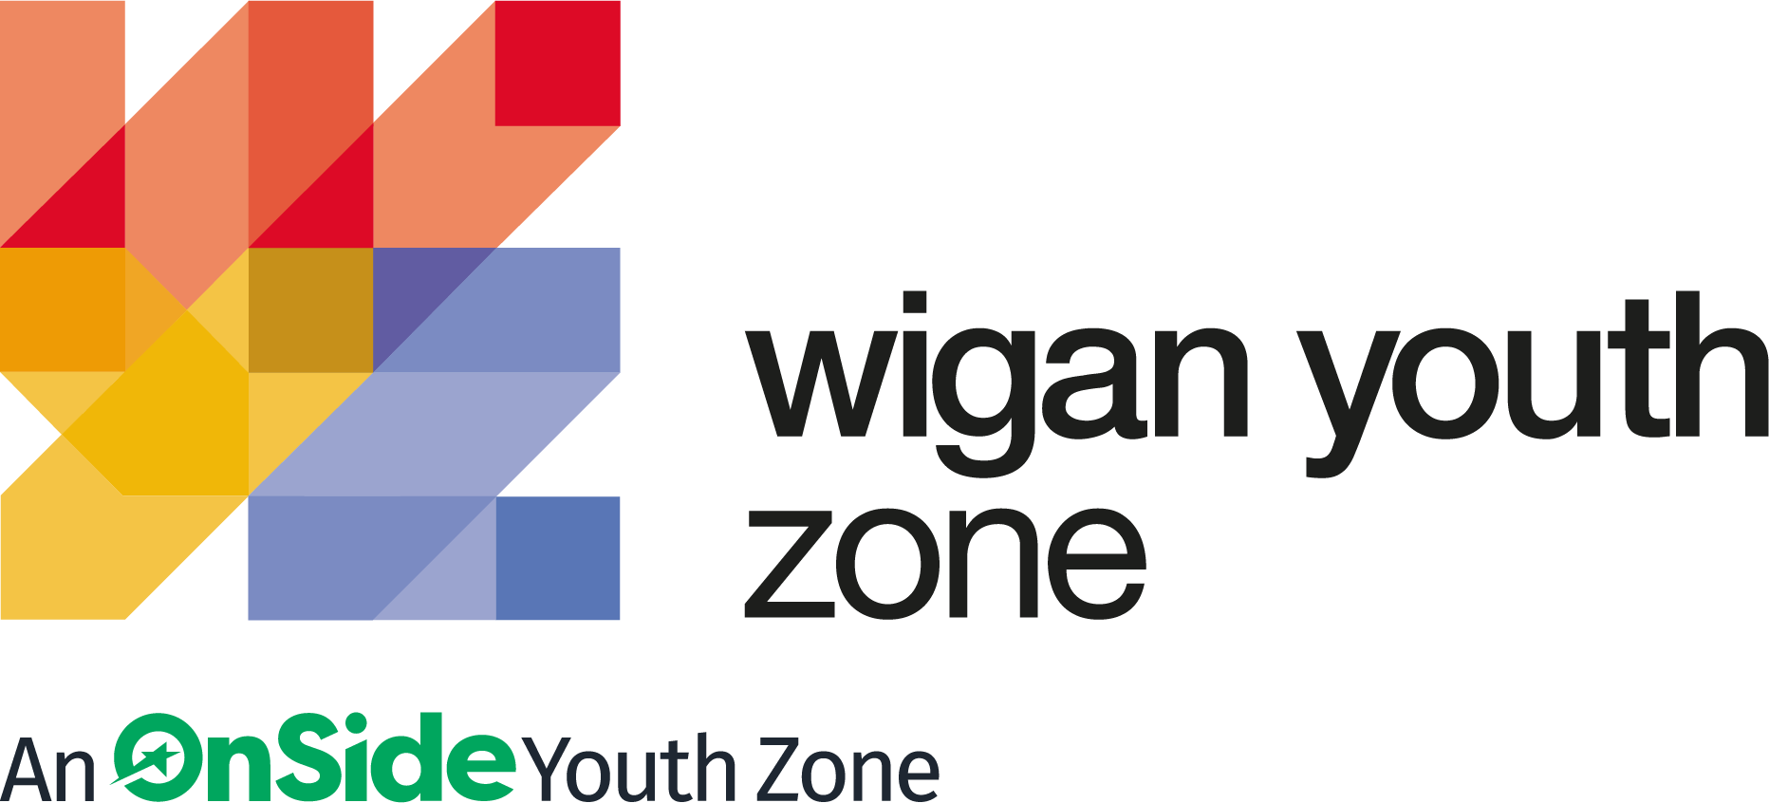

ROLE PROFILE
EMPLOYABILITY YOUTH WORKER

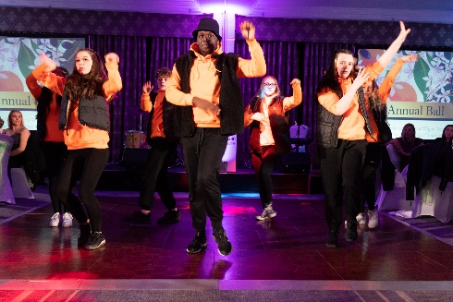
ROLE PROFILE

POST:
EMPLOYABILITY YOUTH WORKER

SALARY:
£9.39 - £9.67 per hour

LOCATION:
Wigan Youth Zone

REPORTING TO:
Enterprise and Employability Co-ordinator

CONTRACT:
Permanent: Part time – 12 hours per week – 11am – 3pm Wednesday, Thursday and Friday (flexibility required, includes weekends and evenings)

BENEFITS:
Hybrid working offered; Gym access; Training opportunities and CPD delivered in-house or by partner organisations (such as Wigan Council and the OnSide Talent Academy) – including First Aid, Safeguarding and Health and Safety; Career Development Opportunities; Birthday Off; Employee Assistance Programme (EAP); Cycle to Work Scheme; Strong team culture.

We are a proud Supporter of the Greater Manchester Good Employment Charter, first of its kind in the UK, which aims to improve employment standards across GM. #GoodEmployment.

JOB PURPOSE

To support your line manager delivering an Employability programme of workshops and activities that will raise young people’s aspirations alongside developing their employability and softer skills ready for their chosen positive destination.

ABOUT WIGAN YOUTH ZONE

We’re Wigan Youth Zone and our vision is to inspire and empower young people in Wigan and Leigh to fulfil their potential. We do this by giving young people in Wigan and Leigh aged 8-19 (up to 25 with additional needs) the freedom to discover themselves in an innovative, safe and social environment and to support their transition into adulthood.

Centrally located in Wigan Town Centre, Wigan Youth Zone is the largest youth club in Europe and makes a bold statement about the importance of giving young people high quality places to go in their leisure time. The two-storey building has a four-court sports hall with climbing wall, a fully fitted fitness suite, a boxing gym, dance and performing arts studios, as well as music, media and visual arts facilities.

There is also a cafe, together with recreational and social areas. Externally there are four all-weather kick-pitches and full-size skate park. In addition to the work which happens in the facility, there is also a team who work across the borough to meet young people on their turf – whether this is through street-based youth work or via a satellite centre.

The services provided by the exceptional Wigan Youth Zone staff are delivered 7 days a week, 52 weeks a year, providing local young people with somewhere to go, something to do and someone to talk to. Since opening, the Youth Zone has facilitated over 675,000 visits to over 29,000 young people with impressive outcomes for those members across a range of measures such as confidence building, facilitating positive relationships and instilling ambition for adulthood.

CONTEXT OF THE ROLE

Wigan Youth Zone, the largest youth club in Europe, is centrally located, dedicated to young people and makes a bold statement about the importance of giving young people high quality places to go in their leisure time. The two-storey building has a four-court sports hall with climbing wall, a fully fitted fitness suite, a boxing gym, dance and performing arts studios, as well as music, media and visual arts facilities. There is also a cafe, together with recreational and social areas. Externally there are four all-weather kick-pitches and full-size skate park. Wigan Youth Zone is open 7 days a week, 52 weeks a year, providing local young people with somewhere to go, something to do and someone to talk to for almost eight years, winning UK Youth’s award ‘Youth Organisation of the Year’ in 2018 and shortlisted for the ‘Youth Work Award’ in the Children and Young People Now Awards 2020.

DUTIES AND RESPOSIBILITIES – GENERAL

- Be a role model for young people and present a positive “can do” attitude
- Take personal responsibility for own actions
- Commit to a culture of continuous improvement
- Work within the performance framework of Wigan Youth Zone and OnSide
- Represent Wigan Youth Zone positively and effectively in all dealings with internal colleagues, and external partners
- Comply with all policies and procedures, with particular reference to safeguarding, codes of conduct health and safety and equality and diversity to ensure all activities are accessible
- Represent Wigan Youth Zone positively and effectively in all dealings with internal colleagues, and external partners
- To be alert to issues of safeguarding and child protection, ensuring the welfare and safety of Youth Zone members is promoted and safeguarded, and to report any child protection concerns to the designated Child Protection Officers using the safeguarding policies, procedures and practice (training to be provided)
- To assist with any promotional activities and visits that take place at the Youth Zone
- To actively promote the Youth Zone and positively contribute towards increasing Youth Zone membership
- To carry out any other duty with the Youth Zone provision and facility operations, and within the competencies of the post holder, as directed by your line manager or a senior manager.

DUTIES AND RESPONSIBILITIES – DETAILED

Young People Experience

- Experience of working with NEET young people aged 15 to 24 with additional needs
- Experience of working with young people looking to get into employment, further education, training or volunteering
- Understanding of the current barriers young people face getting into employment, training and further education
- Experience supporting young people to build on their confidence and social skills
- Ideally have previous experience recruiting students on to courses or further training
- Ideally previous experience of School engagement work and/or IAG sessions

Facilitating Employability Skills Workshops

Our workshops are designed and delivered to put young people at ease so they can relax and be open and honest. Module examples:

- CV Writing
- Cover Letter Writing
- Interview Techniques
- Completing Job Applications
- Presentation Skills
- Team Building
- Customer Service Skills
- Mock Interview

Job Brokering for Students- out of cohort (Cohorts are run on a rolling basis throughout the year

An important part of the role and the Employability support we can offer our young people is the relationships we have with local Businesses. Their support enables us to offer Company Visit days, Mock Interviews, Guaranteed Interviews for Job Vacancies, Volunteering and Work Experience placements.
To continue building on our offering and expand on the variety of companies we have connected with we will proactively -

- Attend Local Business networking events such as regional Expo’s & Employability events
- Online business networking
- Attend local Community events to raise the profile of WYZ
- Ability to transition students into brokered job opportunities - Casual, Part-time, Full Time and Apprenticeships

THE POWER OF YOUTH WORK

We believe all young people deserve the opportunity to shine. But opportunity is about more than bricks and mortar, sports courts and sound studios. The amazing equipment in our Youth Zones is important. But their real impact comes from the life-changing youth work that is at the heart of everything we do.
With every workout or kick a bout, every mock interview or muck around with mates, young people develop the resilience to face challenges and the skills to solve problems.

They find confidence to aim high and the determination to become who they want to be. They build positive relationships based on being given the space to talk, an understanding of their own self-worth, and a sense of belonging to something bigger.

This approach, since opening in 2013, has led to the work of the Youth Zone generating a social value for the community of over 2:1 – meaning that for every £1 generated into the charity, the impact is more than doubled. These outcomes have been continually recognised locally, regionally and nationally by a variety of award-giving organisations such as UK Youth, Children and Young People Now and the North West Charity Awards.

That’s the power of exceptional youth work.

INSIDE A YOUTH ZONE
Youth Zones give 8-19 year olds, and up to 25 for young people with additional needs, affordable access to a broad range of services. Containing state-of-the-art facilities, Youth Zones give young people the opportunity to take part in over 20 sporting, artistic, cultural and recreational activities every evening and weekend throughout the year plus all through the school holidays.

Facilities include an indoor sports hall; music room and recording studio; training kitchen; boxing gym and mixed martial arts studio; enterprise and employability room; outdoor 4G sports MUGA; wellbeing room; climbing wall; café; media room and more.

Employing high ratios of exceptional youth and activity workers and volunteers, our Youth Zones change the lives of many thousands of young people each month, delivering social impact on an incredible scale.

Wigan Youth Zone is a place of activity, adventure and fun for all young people where they can try new experiences and learn new skills. Wigan Youth Zone supports young people to reach their full potential, grow their dreams and achieve their goals.
Learn more here
https://www.wiganyouthzone.org/our-present-our-past-our-impact/
We are looking for someone who can deliver this aspiration for Wigan’s young people and share the following values:

- Is a positive role model for young people and who believes in and recognises young people’s potential

- Has a positive and “can do” attitude

- Takes responsibility for their own actions

- Is committed to a culture of continuous improvement and subscribes to a “tonight’s better than last night” philosophy

- Is willing to go the extra mile to ensure great provision for young people

SELECTION CRITERIA | REQUIREMENT
EXPERIENCE
- Face to face activity delivery, working with children and young  people (aged 11 plus) both in groups and individually | Essential
- Experience of supporting young people who are  disaffected, underachieving and / or have social / emotional barriers to participation | Essential
- Experience working in a team and with volunteers | Essential
- Experience of youth work and delivering youth work programmes | Essential
- Organising a programme of youth work activities | Essential
- Experience of work with those with disabilities and additional needs | Desirable
- Experience of working in an outreach or detached setting | Desirable
- Residential work with young people | Desirable
- Experience of running job skills workshops | Desirable
- Experience of working with young women’s groups | Desirable
- Experience working in the commercial sector (for example retail or  service) | Desirable
Skills
- Excellent written and verbal communication | Essential
- Strong commitment to children and young people and an ability to  engage and build positive relationships with all young people,  including disengaged and disadvantaged young people | Essential
- Ability to work with young people to develop their social education by providing programmes of activities that are fun and enable young  people to develop | Essential
- Ability to coach, encourage, motivate and provide reliable support to children and young people | Essential
- Confident in managing a group of children and young people | Essential
- Ability to manage and organise several tasks at a time | Essential
- Ability to take initiative and work creativity | Essential
- IT literate | Essential
- Ability to identify and challenge discrimination and  discriminatory behaviour, taking appropriate action as necessary | Essential
- Positive and enthusiastic | Essential
- Punctual and reliable | Essential
- Commitment to personal and professional development | Essential
- A flexible attitude to work and a willingness to perform a variety of  duties to ensure an efficient and effective service | Essential
Knowledge
- Knowledge of the issues affecting young people | Essential
- Understanding of the principles of working with children and  young people | Essential
- Knowledge of health and safety, diversity awareness  and safeguarding best practice and how these relate to children  and young people | Desirable
Educational/Vocational qualification
- Introduction to Youth Work or Youth and Community Work  - NVQ / VRQ Level 1 or Level 1 Sports Leaders Award | Desirable
- GCSE or equivalent literacy and numeracy | Essential
Special requirements
- A willingness to work unsociable hours when required | Essential
- DBS clearance and committed to Safeguarding children | Essential
- The ability and willingness to travel to meetings and events both in  the region and beyond | Essential

GENERAL INFORMATION

In accordance with our Child Protection and Safeguarding procedures, this position requires an enhanced DBS check and positive references.

Please note that, for Safeguarding reasons, all applicants have to be in-active as Wigan Youth Zone members for the last 12 months before applying for roles. Also, all applicants must be over 18 to work with the Juniors’ and Holiday Club and over 21 to work with the Seniors at WYZ.
RECRUITMENT PACKAGE

SALARY:
£9.39 - £9.67 per hour

HOLIDAYS:
33 Days per annum (pro rata)

APPLICATION DETAILS

CLOSING DATE FOR APPLICATIONS:
Friday 12th August 2022

INTERVIEW DATES:

Week commencing Monday 15th August 2022

START DATE:
ASAP
We reserve the right to close this vacancy early if we receive sufficient applications for the role. Therefore, if you are interested, please submit your application as early as possible.

As an equal opportunities employer, we welcome applications from under-represented groups; in particular from Black, Asian and Minority Ethnic individuals, people with disabilities and members of LGBTQ+ community. Our Senior Management Team, actively ensures a culture where everyone can be themselves and thrive.

For information on how Wigan Youth Zone processes your data, go to
https://www.wiganyouthzone.org/privacy-policy/

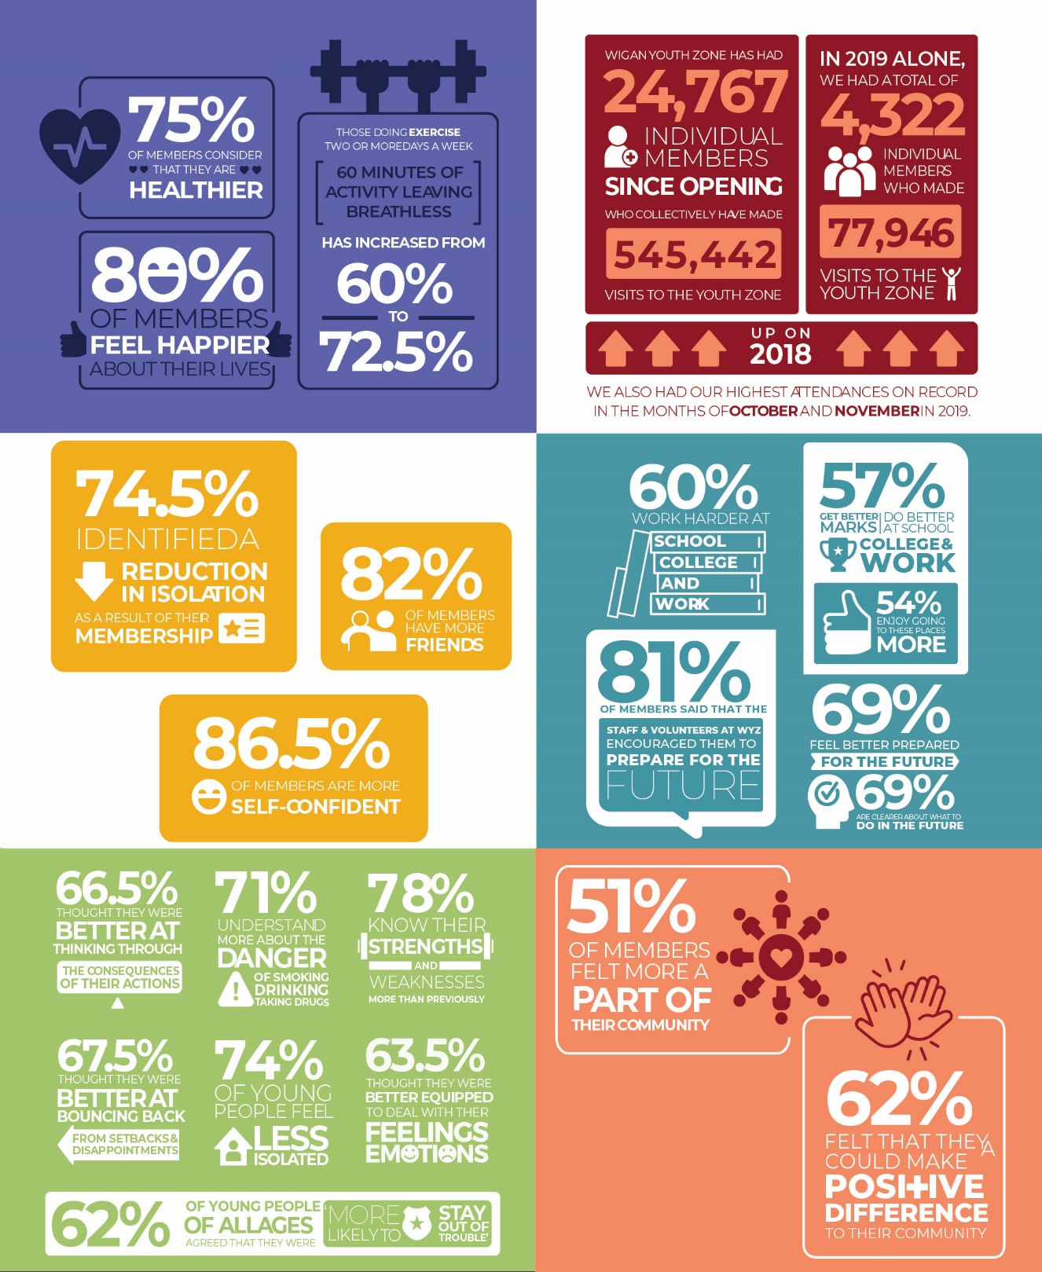

Our Vision
Our vision is to inspire and empower young people in Wigan and Leigh to fulfil their potential.

Our Mission
Our mission is to give young people in Wigan and Leigh aged 8-19 (up to 25 with a disability) the freedom to discover themselves in an innovative, safe and social environment and to support their transition into adulthood.

Our Values
Y oung person centred approach
O pen, inclusive and respectful environment
U niversal programming consistently on offer which is inspirational and aspirational
T ruly meaningful opportunities for the youth voice and empowerment
H elping young people to build positive relationships to enable them to reach their potential

