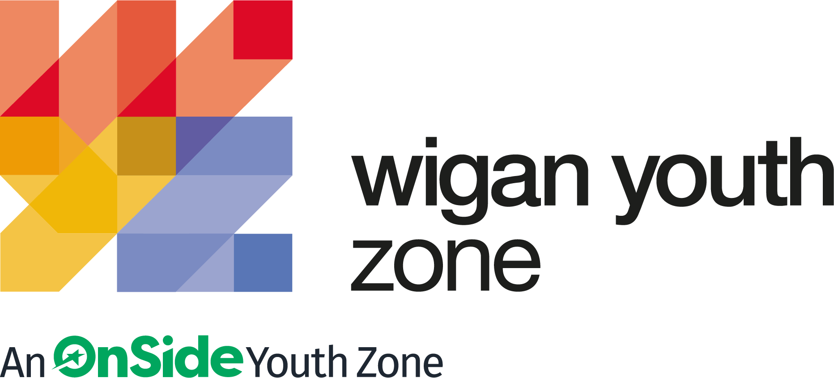

ROLE PROFILE
MULTI-SPORTS YOUTH WORKER/SPORTS COACH

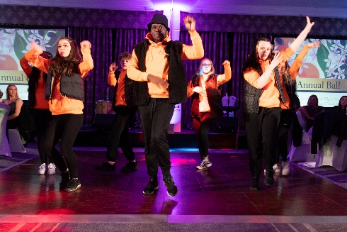
ROLE PROFILE

POST:
MULTI-SPORTS YOUTH WORKER/SPORTS COACH

SALARY:
£9.39 - £9.67 per hour

LOCATION:
Wigan Youth Zone

REPORTING TO:
Head of Sports

CONTRACT:
Permanent: Part time – 18 hours

BENEFITS:
Gym access; Training opportunities and CPD delivered in-house or by partner organisations (such as Wigan Council and the OnSide Talent Academy) – including First Aid, Safeguarding and Health and Safety; Career Development Opportunities; Birthday Off; Employee Assistance Programme (EAP); Cycle to Work Scheme; Strong team culture.
We are a proud Supporter of the Greater Manchester Good Employment Charter, first of its kind in the UK, which aims to improve employment standards across GM. #GoodEmployment.

ROLE PURPOSE:

Multi Sports Youth Worker - To work within the Sports Hall at Wigan Youth Zone, and develop and deliver an exciting and varied programme which will engage young people and which embraces our TRY, TRAIN, TEAM philosophy.

ABOUT WIGAN YOUTH ZONE
We’re Wigan Youth Zone and our vision is to inspire and empower young people in Wigan and Leigh to fulfil their potential. We do this by giving young people in Wigan and Leigh aged 8-19 (up to 25 with additional needs) the freedom to discover themselves in an innovative, safe and social environment and to support their transition into adulthood.

Centrally located in Wigan Town Centre, Wigan Youth Zone is the largest youth club in Europe and makes a bold statement about the importance of giving young people high quality places to go in their leisure time. The two-storey building has a four-court sports hall with climbing wall, a fully fitted fitness suite, a boxing gym, dance and performing arts studios, as well as music, media and visual arts facilities.

There is also a cafe, together with recreational and social areas. Externally there are four all-weather kick-pitches and full-size skate park. In addition to the work which happens in the facility, there is also a team who work across the borough to meet young people on their turf – whether this is through street-based youth work or via a satellite centre.

The services provided by the exceptional Wigan Youth Zone staff are delivered 7 days a week, 52 weeks a year, providing local young people with somewhere to go, something to do and someone to talk to. Since opening, the Youth Zone has facilitated over 675,000 visits to over 29,000 young people with impressive outcomes for those members across a range of measures such as confidence
building, facilitating positive relationships and instilling ambition for adulthood.

CONTEXT OF THE ROLE
We are looking for somebody who can ensure Wigan Youth Zone and all its activities are inclusive to all young people. The ideal candidate will support community cohesion and provide an environment where members from diverse demographics, and those with disabilities and additional support needs feel safe.

This role will have clear targets to broaden and increase overall participation rates and ensure participation is representative of the demographics of Wigan and Leigh. You will carry out targeted outreach and partnership work across the borough to promote Wigan Youth Zone and gain an understanding of the barriers to participation and work to overcome these. Most importantly ensure all young people are welcome and feel able to participate in all activities, no matter who they are.

THE ROLE
Since opening, the Youth Zone has facilitated over 670,000 visits to over 29,000 young people with impressive outcomes for those members across a range of measures such as confidence building, facilitating positive relationships and instilling ambition for adulthood. Last year we supported over two hundred individuals with special additional needs or disabilities including ADHD, anxiety and depression, autism, Asperger syndrome, cerebral palsy, Down’s syndrome, social and emotional problems, musculoskeletal conditions, and visual/auditory/sensory conditions.

We are ideally placed to make a huge difference to the lives of young people with additional support needs and disability in Wigan and Leigh and are looking for a highly motivated person to join us on that journey to take forward the charity’s inclusion provision to the next level.

With a framework of programmes and sessions already established, the ideal candidate will be able to hit the ground running and identify how provision can be enhanced to have a greater impact, identify areas for growth and help shape our inclusion work into best in field provision.

We are particularly keen to hear from people from a youth work/social care/health worker background who can adapt to their skill set.

Our vision is to create an environment where children and young people with additional support needs or disabilities can take part in any of the activities at the Youth Zone alongside their peers.

THE POWER OF YOUTH WORK
We believe all young people deserve the opportunity to shine. But opportunity is about more than bricks and mortar, sports courts and sound studios. The amazing equipment in our Youth Zones is important. But their real impact comes from the life-changing youth work that is at the heart of everything we do.
With every workout or kick a bout, every mock interview or muck around with mates, young people develop the resilience to face challenges and the skills to solve problems.

They find confidence to aim high and the determination to become who they want to be. They build positive relationships based on being given the space to talk, an understanding of their own self-worth, and a sense of belonging to something bigger.

This approach, since opening in 2013, has led to the work of the Youth Zone generating a social value for the community of over 2:1 – meaning that for every £1 generated into the charity, the impact is more than doubled. These outcomes have been continually recognised locally, regionally and nationally by a variety of award-giving organisations such as UK Youth, Children and Young People Now and the North West Charity Awards.

That’s the power of exceptional youth work.

INSIDE A YOUTH ZONE
Youth Zones give 8-19 year olds, and up to 25 for young people with additional needs, affordable access to a broad range of services. Containing state-of-the-art facilities, Youth Zones give young people the opportunity to take part in over 20 sporting, artistic, cultural and recreational activities every evening and weekend throughout the year plus all through the school holidays.

Facilities include an indoor sports hall; music room and recording studio; training kitchen; boxing gym and mixed martial arts studio; enterprise and employability room; outdoor 4G sports MUGA; wellbeing room; climbing wall; café; media room and more.

Employing high ratios of exceptional youth and activity workers and volunteers, our Youth Zones change the lives of many thousands of young people each month, delivering social impact on an incredible scale.

Wigan Youth Zone is a place of activity, adventure and fun for all young people where they can try new experiences and learn new skills. Wigan Youth Zone supports young people to reach their full potential, grow their dreams and achieve their goals.
Learn more here
https://www.wiganyouthzone.org/our-present-our-past-our-impact/
We are looking for someone who can deliver this aspiration for Wigan’s young people and share the following values:
Is a positive role model for young people and who believes in and recognises young people’s potential
Has a positive and “can do” attitude
- Takes responsibility for their own actions
- Is committed to a culture of continuous improvement and subscribes to a “tonight’s better than last night” philosophy
- Is willing to go the extra mile to ensure great provision for young people

KEY RESPONSIBILITIES
- To deliver a comprehensive sports programme for young people which will enable them to build their confidence, social skills and overall wellbeing;

- To motivate, encourage and support young people to participate fully in sports sessions;

- To manage, support and coordinate sessional staffing requirements for sports activities;

- To maintain a comprehensive and detailed up-to-date inventory of all equipment owned and / or used by the department;

- To ensure that staff, volunteers and young people comply with health and safety procedures and child protection legislation at all times;

- To deal with any problems during Youth Zone sessions;
- In conjunction with other partners, identify, support and develop talented young performers;

- To ensure that the members maintain a high standard of behaviour and discipline during sessions;

- To promote and safeguard the welfare of children and young people at all times;
- To be an active member of the team and operate in line with the values and principles of Wigan Youth Zone.

- Positively influence the general programme of events at the Youth Zone so it is attractive to young people from diverse backgrounds and abilities.

- Manage allocated budget effectively and efficiently.

- Carry out any other reasonable duties as requested by line manager or senior manager.

Duties and Responsibilities – General

- Work within the performance framework of Wigan Youth Zone and OnSide;

- Represent Wigan Youth Zone positively and effectively in all dealings with internal colleagues, and external partners;

- To be alert to issues of safeguarding and child protection, ensuring the welfare and safety of Youth Zone members is promoted and safeguarded, and to report any child protection concerns to the designated Child Protection
- Officers using the safeguarding policies, procedures and practice (training to be provided);

- To assist with any promotional activities and visits that take place at the Youth Zone;

- To actively promote the Youth Zone and positively contribute towards increasing Youth Zone membership;

- To adhere to Wigan Youth Zone policies at all times, with particular reference to Health and Safety, Safeguarding and Equal Opportunities.
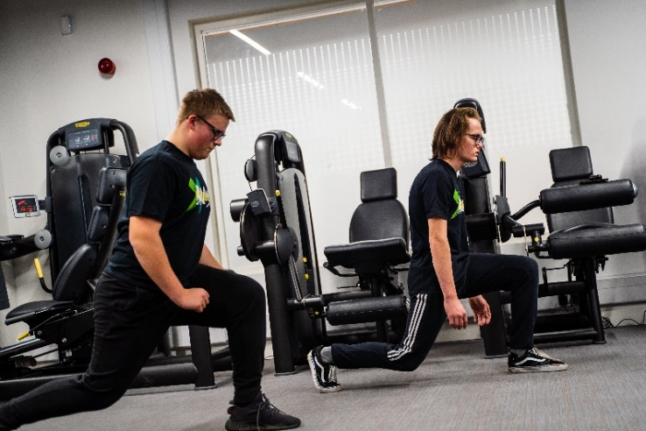

PERSON SPECIFICATION
Applicants will be expected to demonstrate these experience, skills, abilities and attributes.
SELECTION CRITERIA | REQUIREMENT
EXPERIENCE
Extensive experience of delivering sporting activities to young people | Essential
Experience of working with young people | Desirable
Proven experience of engaging vulnerable, disengaged or hard to reach youth people in sport activities. | Desirable
Experience of working in a team and alongside volunteers | Essential
Organising a programme of youth work activities | Essential
Experience of working with young people with additional needs and disabilities | Essential
Experience of monitoring and evaluating processes | Desirable
Residential work with young people | Desirable
SKILLS, KNOWLEDGE AND APTITUDE
Excellent communication skills to deliver activity programme to a wide range of young people
Ability to motivate and engage staff, volunteers and young people through sessional work
Ability to engage and build positive relationships with disengaged young people
Basic skills in officiating major sports
Ability to manage and organise several tasks at a time
Good team worker and leader
Ability to work with challenging behaviour and complex needs
Knowledge and Understanding
Knowledge and understanding of how to develop and deliver a high quality and varied sports programmes | Essential
Sound knowledge of sports qualifications and the quality standards expected for the successful delivery of accredited sports activities
Understanding of national and local initiatives which influence provision of youth work to young people
Understanding of the principles of working with children and young people
Understanding of issues affecting young people’s lives
Knowledge of health and safety, diversity awareness and safeguarding best practice and how these relate to children and young people
Delivery of youth work within an equality framework
Knowledge of methods of organising and scheduling groups into teams and leagues for various sports activities | Essential
First aid knowledge | Essential
Qualifications
Introduction to Youth Work or Youth and Community Work NVQ / VRQ Level 2 | Essential
Any NGB Coaching qualification | Essential
IT literate | Essential
Degree level qualification in a sporting field | Desirable
Personal attributes
A team player | Essential
Commitment to the Youth Zone’s mission and values | Essential
Able to negotiate and balance competing priorities with consideration to ethical implications. | Essential
Passionate about helping young people access positive activities | Essential
A flexible attitude to work and a willingness to perform a variety of duties to ensure an efficient and effective service | Essential
Punctual and reliable | Essential

WORK PATTERN:

· Mon – 4-9pm
· Wednesday – 4-9pm
· Thursday – 4-9pm
· Saturday – 6-9pm

GENERAL INFORMATION

In accordance with our Child Protection and Safeguarding procedures, this position requires an enhanced DBS check and positive references.

Please note that, for Safeguarding reasons, all applicants have to be in-active as Wigan Youth Zone members for the last 12 months before applying for roles. Also, all applicants must be over 18 to work with the Juniors’ and Holiday Club and over 21 to work with the Seniors at WYZ.

APPLICATION DETAILS
RECRUITMENT PACKAGE

SALARY:
£9.39 – 9.67 per hour

HOLIDAYS:
33 Days per annum (pro rata)

CLOSING DATE FOR APPLICATIONS:
Friday 5th August 2022

START DATE:
ASAP

As an equal opportunities employer, we welcome applications from under-represented groups; in particular from Black, Asian and Minority Ethnic individuals, people with disabilities and members of LGBTQ+ community. Our Senior Management Team, actively ensures a culture where everyone can be themselves and thrive.

For information on how Wigan Youth Zone processes your data, go to
https://www.wiganyouthzone.org/privacy-policy/

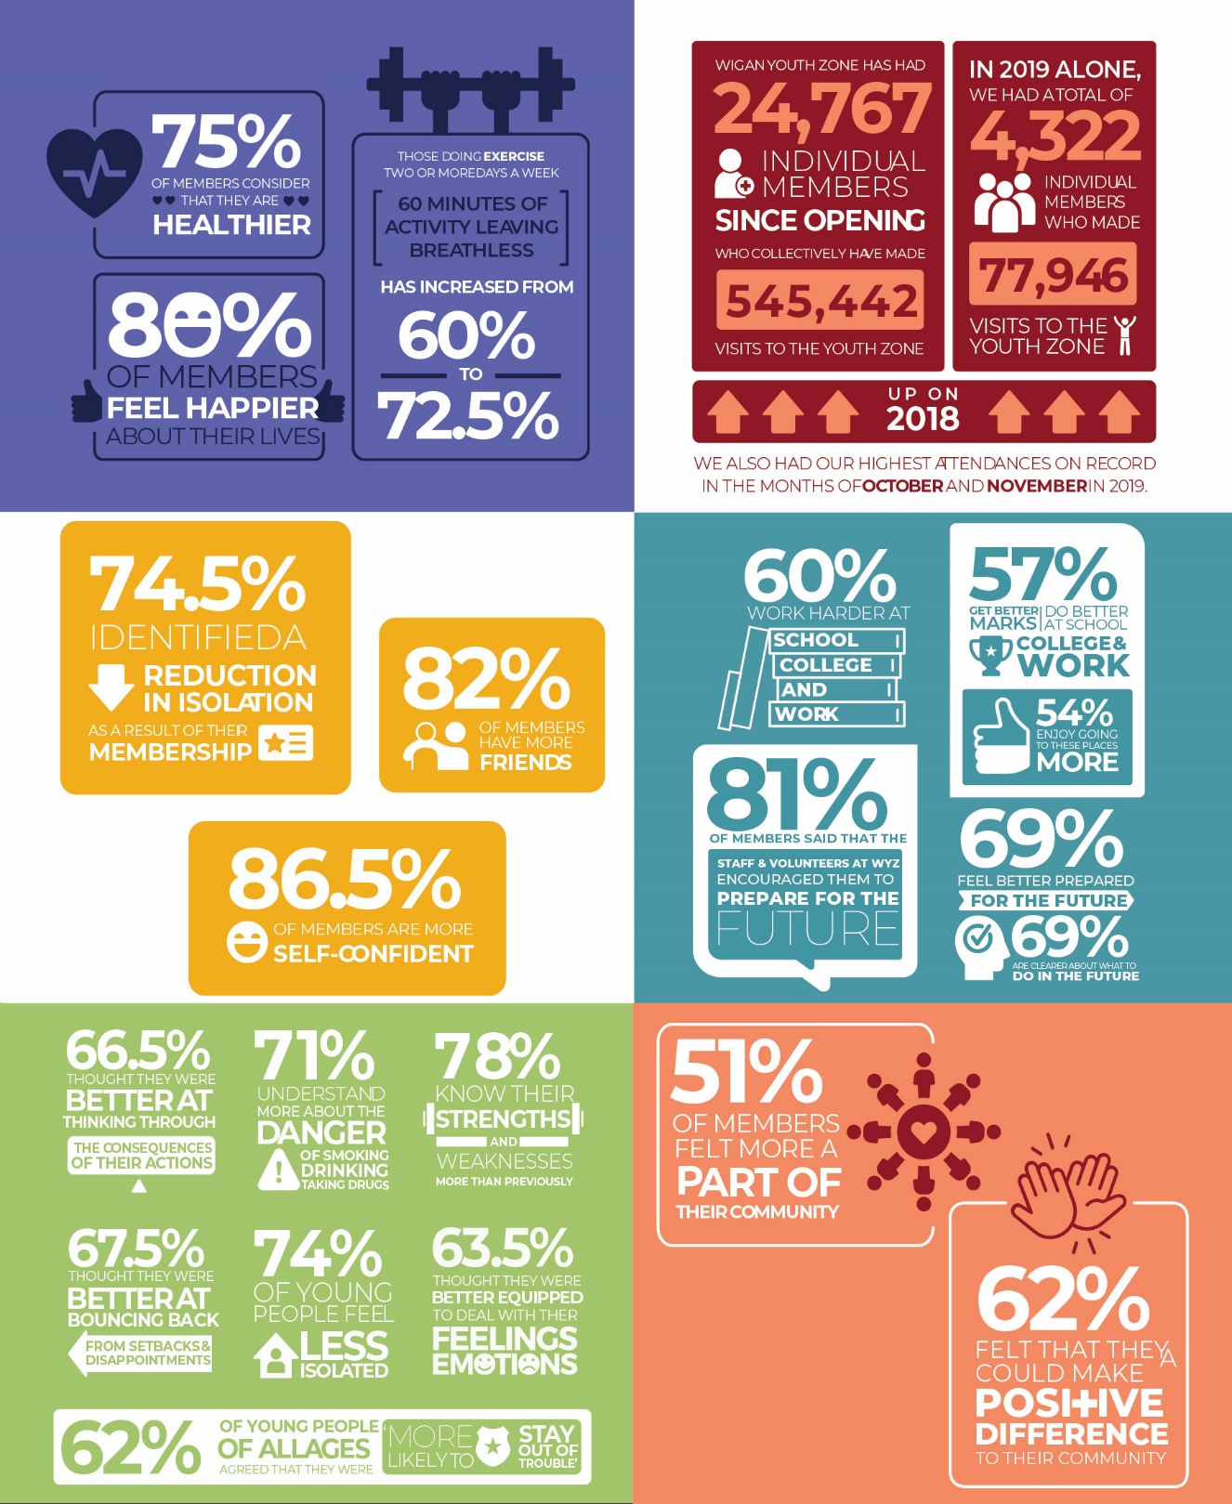

Our Vision
Our vision is to inspire and empower young people in Wigan and Leigh to fulfil their potential.

Our Mission
Our mission is to give young people in Wigan and Leigh aged 8-19 (up to 25 with a disability) the freedom to discover themselves in an innovative, safe and social environment and to support their transition into adulthood.

Our Values
Y oung person centred approach
O pen, inclusive and respectful environment
U niversal programming consistently on offer which is inspirational and aspirational
T ruly meaningful opportunities for the youth voice and empowerment
H elping young people to build positive relationships to enable them to reach their potential

