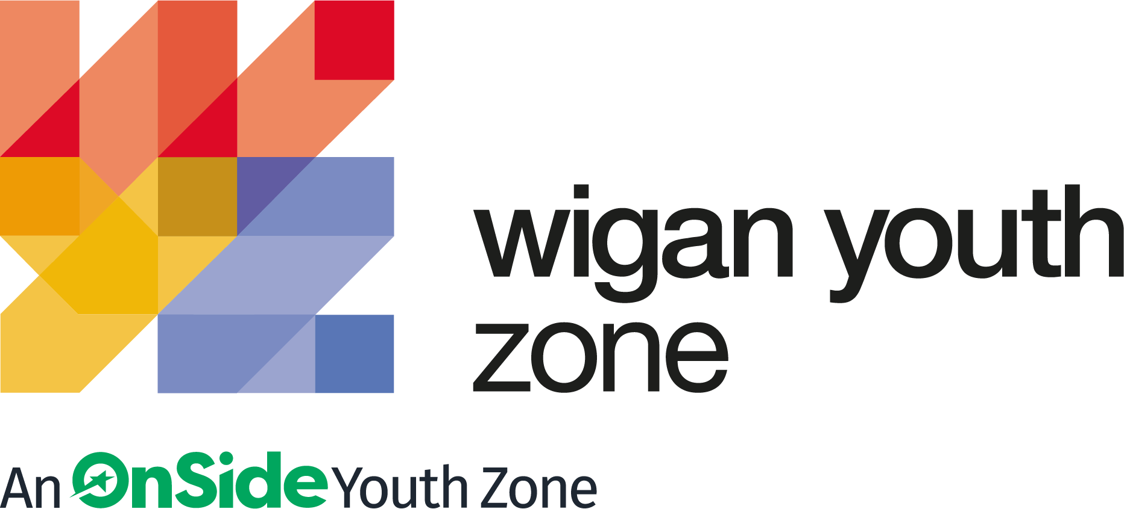
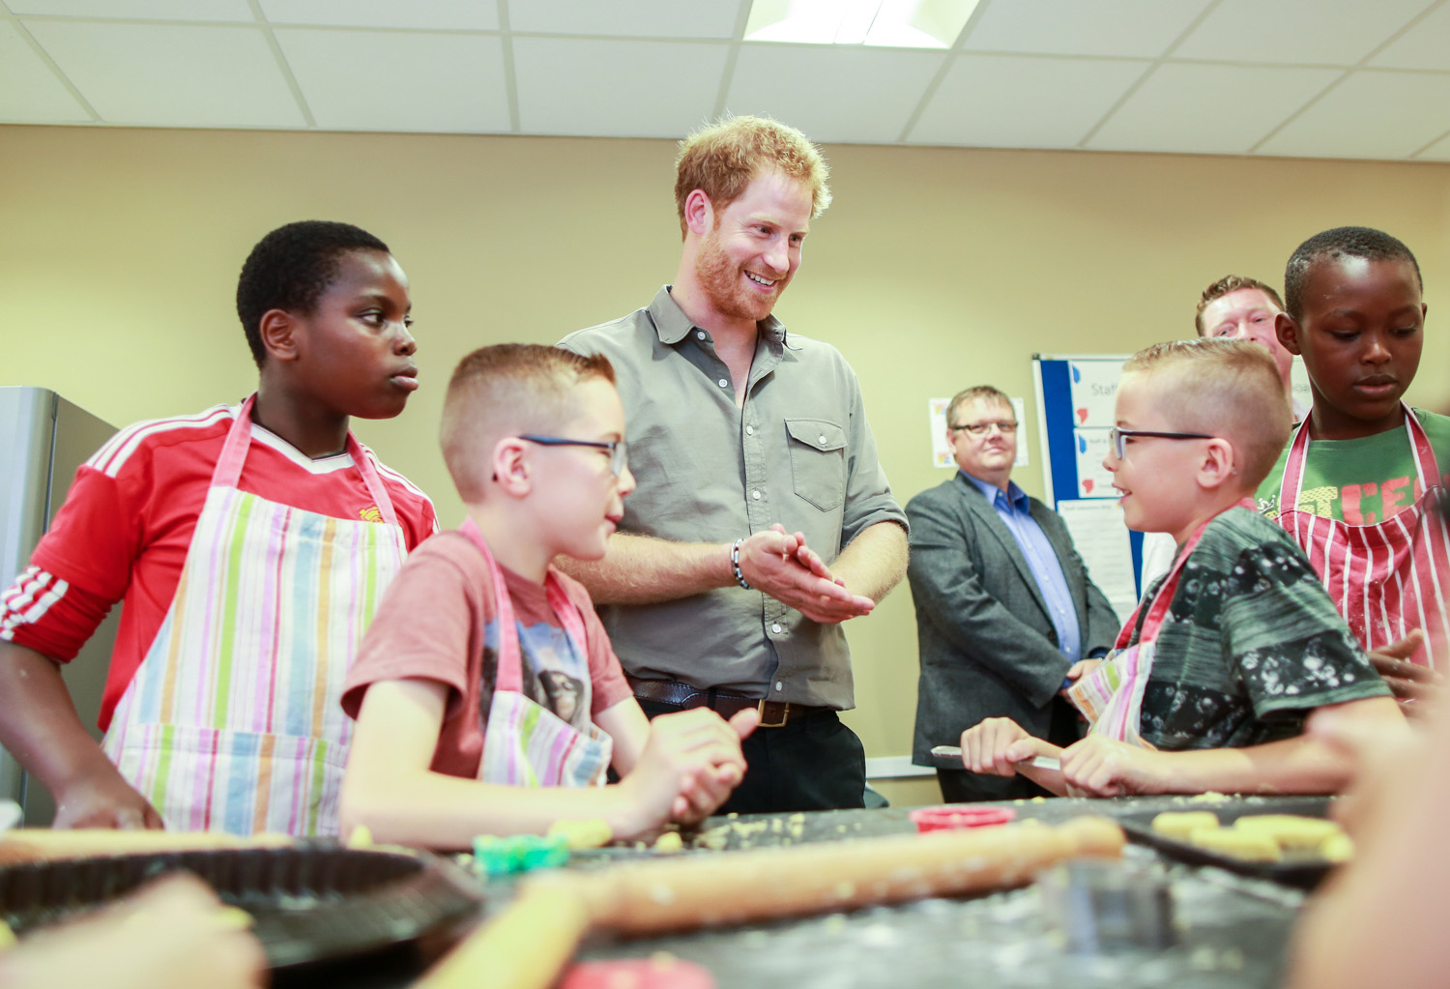

ROLE PROFILE
INCLUSION YOUTH WORKER

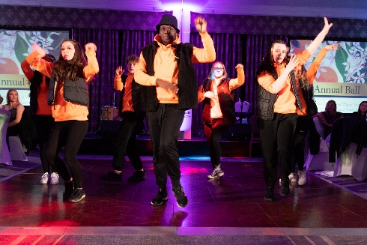
ROLE PROFILE

POST:
INCLUSION YOUTH WORKER

SALARY:
£9.39 - £9.67 per hour

LOCATION:
Wigan Youth Zone

REPORTING TO:
Head of Rec and Participation

CONTRACT:
Permanent: 14 hours per week

BENEFITS:
Agile working organisation with flexibility in working hours; Hybrid working offered; Gym access; Training opportunities and CPD delivered in-house or by partner organisations (such as Wigan Council and the OnSide Talent Academy) – including First Aid, Safeguarding and Health and Safety; Career Development Opportunities; Birthday Off; Employee Assistance Programme (EAP); Cycle to Work Scheme; Strong team culture.

We are a proud Supporter of the Greater Manchester Good Employment Charter, first of its kind in the UK, which aims to improve employment standards across GM. #GoodEmployment.

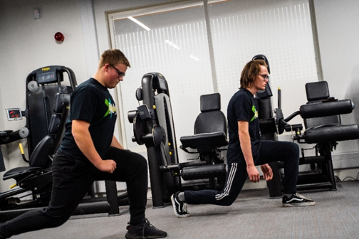

ABOUT WIGAN YOUTH ZONE
We’re Wigan Youth Zone and our vision is to inspire and empower young people in Wigan and Leigh to fulfil their potential. We do this by giving young people in Wigan and Leigh aged 8-19 (up to 25 with additional needs) the freedom to discover themselves in an innovative, safe and social environment and to support their transition into adulthood.

Centrally located in Wigan Town Centre, Wigan Youth Zone is the largest youth club in Europe and makes a bold statement about the importance of giving young people high quality places to go in their leisure time. The two-storey building has a four-court sports hall with climbing wall, a fully fitted fitness suite, a boxing gym, dance and performing arts studios, as well as music, media and visual arts facilities.

There is also a cafe, together with recreational and social areas. Externally there are four all-weather kick-pitches and full-size skate park. In addition to the work which happens in the facility, there is also a team who work across the borough to meet young people on their turf – whether this is through street-based youth work or via a satellite centre.

The services provided by the exceptional Wigan Youth Zone staff are delivered 7 days a week, 52 weeks a year, providing local young people with somewhere to go, something to do and someone to talk to. Since opening, the Youth Zone has facilitated over 675,000 visits to over 29,000 young people with impressive outcomes for those members across a range of measures such as confidence building, facilitating positive relationships and instilling ambition for adulthood.

CONTEXT OF THE ROLE
We are looking for somebody who can ensure Wigan Youth Zone and all its activities are inclusive to all young people. The ideal candidate will support community cohesion and provide an environment where members from diverse demographics, and those with disabilities and additional support needs feel safe.

This role will have clear targets to broaden and increase overall participation rates and ensure participation is representative of the demographics of Wigan and Leigh. You will carry out targeted outreach and partnership work across the borough to promote Wigan Youth Zone and gain an understanding of the barriers to participation and work to overcome these. Most importantly ensure all young people are welcome and feel able to participate in all activities, no matter who they are.

THE ROLE
Since opening, the Youth Zone has facilitated over 670,000 visits to over 29,000 young people with impressive outcomes for those members across a range of measures such as confidence building, facilitating positive relationships and instilling ambition for adulthood. Last year we supported over two hundred individuals with special additional needs or disabilities including ADHD, anxiety and depression, autism, Asperger syndrome, cerebral palsy, Down’s syndrome, social and emotional problems, musculoskeletal conditions, physical, visual/auditory and sensory conditions.
We are ideally placed to make a huge difference to the lives of young people with additional support needs and disability in Wigan and Leigh and are looking for a highly motivated person to join us on that journey to help take forward the charity’s inclusion provision to the next level.
With a framework of programmes and sessions already established, the ideal candidate will be able to hit the ground running and support the Inclusion Coordinator to identify how provision can be enhanced to have a greater impact, identify areas for growth and help shape our inclusion work into best in field provision.
We are particularly keen to hear from people from a youth work/social care/health worker background who can adapt to their skill set.
Our vision is to create an environment where children and young people with additional support needs or disabilities can take part in any of the activities at the Youth Zone alongside their peers.
The role of Inclusion Youth Worker will allow us to liaise better with parents/carers, raising issues, providing feedback, passing on information – having the knowledge and experience to be able to ask the right questions, instil confidence and offer the correct level of support.
We will be able to ensure that an experienced team member is always on hand to respond to needs such as medication, behaviour support, sensory overload, mobility, anxiety, disengagement, eating, time out, parent/carer handover, information sharing, session recording, and gathering information from staff, highlighting areas of support requirement.
We will be better able to give more voice to young people with special additional needs or disabilities (and their parents/carers), using their feedback to continually fine-tune our offer.
We will be able to develop stronger links with external organisations (joint working practices, promoting our work, community involvement) and local support providers.

THE POWER OF YOUTH WORK
We believe all young people deserve the opportunity to shine. But opportunity is about more than bricks and mortar, sports courts and sound studios. The amazing equipment in our Youth Zones is important. But their real impact comes from the life-changing youth work that is at the heart of everything we do.
With every workout or kick a bout, every mock interview or muck around with mates, young people develop the resilience to face challenges and the skills to solve problems.
They find confidence to aim high and the determination to become who they want to be. They build positive relationships based on being given the space to talk, an understanding of their own self-worth, and a sense of belonging to something bigger.
This approach, since opening in 2013, has led to the work of the Youth Zone generating a social value for the community of over 2:1 – meaning that for every £1 generated into the charity, the impact is more than doubled. These outcomes have been continually recognised locally, regionally and nationally by a variety of award-giving organisations such as UK Youth, Children and Young People Now and the North West Charity Awards.

That’s the power of exceptional youth work.

INSIDE A YOUTH ZONE
Youth Zones give 8-19 year olds, and up to 25 for young people with additional needs, affordable access to a broad range of services. Containing state-of-the-art facilities, Youth Zones give young people the opportunity to take part in over 20 sporting, artistic, cultural and recreational activities every evening and weekend throughout the year plus all through the school holidays.

Facilities include an indoor sports hall; music room and recording studio; training kitchen; boxing gym and mixed martial arts studio; enterprise and employability room; outdoor 4G sports MUGA; wellbeing room; climbing wall; café; media room and more.

Employing high ratios of exceptional youth and activity workers and volunteers, our Youth Zones change the lives of many thousands of young people each month, delivering social impact on an incredible scale.

Wigan Youth Zone is a place of activity, adventure and fun for all young people where they can try new experiences and learn new skills. Wigan Youth Zone supports young people to reach their full potential, grow their dreams and achieve their goals.
Learn more here
https://www.wiganyouthzone.org/our-present-our-past-our-impact/
We are looking for someone who can deliver this aspiration for Wigan’s young people and share the following values:

- Is a positive role model for young people and who believes in and recognises young people’s potential

- Has a positive and “can do” attitude

- Takes responsibility for their own actions

- Is committed to a culture of continuous improvement and subscribes to a “tonight’s better than last night” philosophy

- Is willing to go the extra mile to ensure great provision for young people
KEY RESPONSIBILITIES
- To ensure the individual members with additional support requirements have equality access to all the opportunities and activities available.
- Support young people to take steps towards achieving personal goals and greater independence.

- Encourage and support young people to engage with other young people, participate in group work and gain new experiences.
- Promote all aspects of equality and inclusion to staff, members and families whilst liaising directly with their carers and social care teams to ensure effort is made to enable the member to achieve their full potential.
- To support the development of positive relationship with the young people, their parents and carers.
- To support and empower young people to engage in positive activities of their choice.
- To work directly with children and young people to develop their social skills and build their confidence by delivering programmes of activities, services and facilities at Wigan Youth Zone which will take place during the evenings, at weekends and during school holidays and will occasionally include residential work.
- To directly deliver a high quality programme of issue based work that is exciting, safe, innovative, and developmental and directly responds to the diverse needs, concerns and interests of the members.

- To understand the community issues around young people with special educational needs and disabilities. To build trust with these young people and their families and SEND support networks and partners to build stronger community cohesion and inclusion.

- Positively influence the general programme of events at the Youth Zone so it is attractive to young people from diverse backgrounds and abilities.

- To ensure the participation of young people in activities and that their ideas contribute fully in the delivery and evaluation of activities;
- Carry out any other reasonable duties as requested by line manager or senior manager.

DUTIES AND RESPONSIBILITIES – GENERAL

- Work within the performance framework of Wigan Youth Zone and OnSide;

- Represent Wigan Youth Zone positively and effectively in all dealings with internal colleagues, and external partners;

- To be alert to issues of safeguarding and child protection, ensuring the welfare and safety of Youth Zone members is promoted and safeguarded, and to report any child protection concerns to the designated Child Protection
- Officers using the safeguarding policies, procedures and practice (training to be provided);

- To assist with any promotional activities and visits that take place at the Youth Zone;

- To actively promote the Youth Zone and positively contribute towards increasing Youth Zone membership;
- To adhere to Wigan Youth Zone policies at all times, with particular reference to Health and Safety, Safeguarding and Equal Opportunities.

SELECTION CRITERIA | REQUIREMENT
EXPERIENCE
Face to face activity delivery, working with children and young people both in groups and individually | Essential
Experience of delivering informal education sessions to young people | Desirable
Experience of working with young people’s forums to ensure young people have a voice | Desirable
Experience of supporting young people who are disaffected, underachieving and / or have social / emotional barriers to participation | Essential
Experience of working in a team and alongside volunteers | Essential
Organising a programme of youth work activities | Essential
Experience of motivating staff and volunteers | Essential
Experience of working in an outreach or detached setting | Desirable
Residential work with young people | Desirable
SKILLS, KNOWLEDGE AND APTITUDE
Delivery of activities within an equality framework | Essential
Ability to work with young people to develop their social education by providing programmes of activities, services and facilities that are fun and enable young people to develop | Essential
Ability to develop good professional relationships with children, young people and adults | Essential
Ability to coach, encourage, motivate and provide reliable support to children and young people | Essential
Confident in managing a group of children and young people | Essential
Ability to deliver high quality activity programmes with children and young people who face social exclusion, disadvantage and disaffection | Essential
Excellent written and verbal communication skills | Essential
Ability to identify and challenge discrimination and discriminatory behaviour, taking appropriate action as necessary
Understanding of the principles of working with children and young people | Essential
Understanding of issues affecting young people’s lives | Essential
Knowledge of health and safety, diversity awareness and safeguarding best practice and how these relate to children and young people | Essential
QUALIFICATIONS
Introduction to Youth Work or Youth and Community Work NVQ / VRQ Level 2 | Essential
Relevant qualifications or awareness of SEND | Essential
PERSONAL ATTRIBUTES
A team player | Essential
Commitment to the Youth Zone’s mission and values | Essential
Able to negotiate and balance competing priorities with consideration to ethical implications. | Essential
Passionate about helping young people access positive activities | Essential
A flexible attitude to work and a willingness to perform a variety of duties to ensure an efficient and effective service | Essential
Punctual and reliable | Essential
GENERAL INFORMATION
In accordance with our Child Protection and Safeguarding procedures, this position requires an enhanced DBS check and positive references.

Please note that, for Safeguarding reasons, all applicants have to be in-active as Wigan Youth Zone members for the last 12 months before applying for roles. Also, all applicants must be over 18 to work with the Juniors’ and Holiday Club and over 21 to work with the Seniors at WYZ.

PERSON SPECIFICATION
Applicants will be expected to demonstrate these experience, skills, abilities and attributes.

APPLICATION DETAILS
RECRUITMENT PACKAGE

SALARY:
£9.39 - £9.67 per hour

HOLIDAYS:
33 Days per annum (pro rata)

CLOSING DATE FOR APPLICATIONS:
Sunday 14th August 2022

FIRST STAGE INTERVIEWS:
Week Commencing 15th August 2022

SECOND STAGE INTERVIEWS:
To be confirmed (if applicable)
START DATE:
To be confirmed

We reserve the right to close this vacancy early if we receive sufficient applications for the role. Therefore, if you are interested, please submit your application as early as possible.

As an equal opportunities employer, we welcome applications from under-represented groups; in particular from Black, Asian and Minority Ethnic individuals, people with disabilities and members of LGBTQ+ community. Our Senior Management Team, actively ensures a culture where everyone can be themselves and thrive.

For information on how Wigan Youth Zone processes your data, go to
https://www.wiganyouthzone.org/privacy-policy/

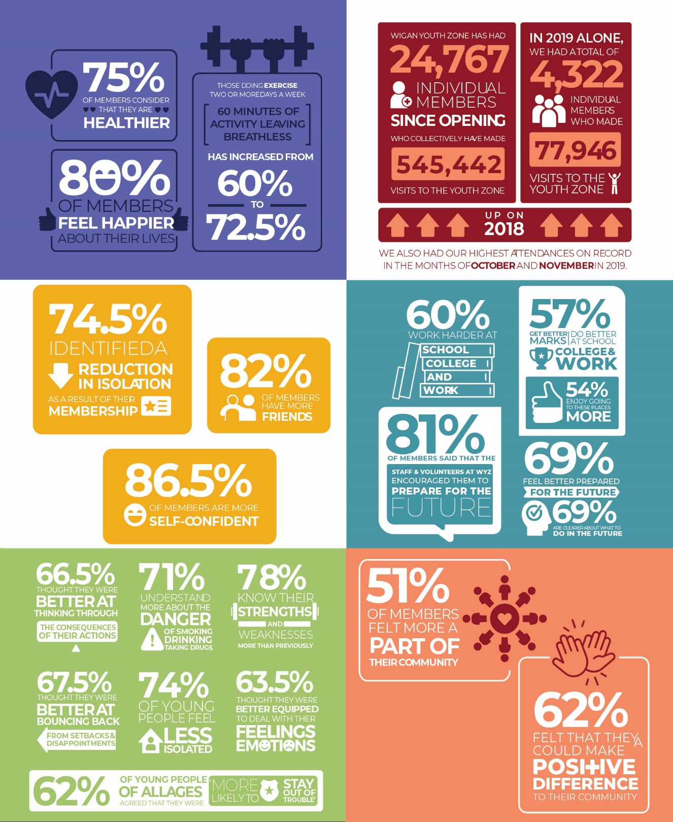

Our Vision
Our vision is to inspire and empower young people in Wigan and Leigh to fulfil their potential.

Our Mission
Our mission is to give young people in Wigan and Leigh aged 8-19 (up to 25 with a disability) the freedom to discover themselves in an innovative, safe and social environment and to support their transition into adulthood.

Our Values
Y oung person centred approach
O pen, inclusive and respectful environment
U niversal programming consistently on offer which is inspirational and aspirational
T ruly meaningful opportunities for the youth voice and empowerment
H elping young people to build positive relationships to enable them to reach their potential

