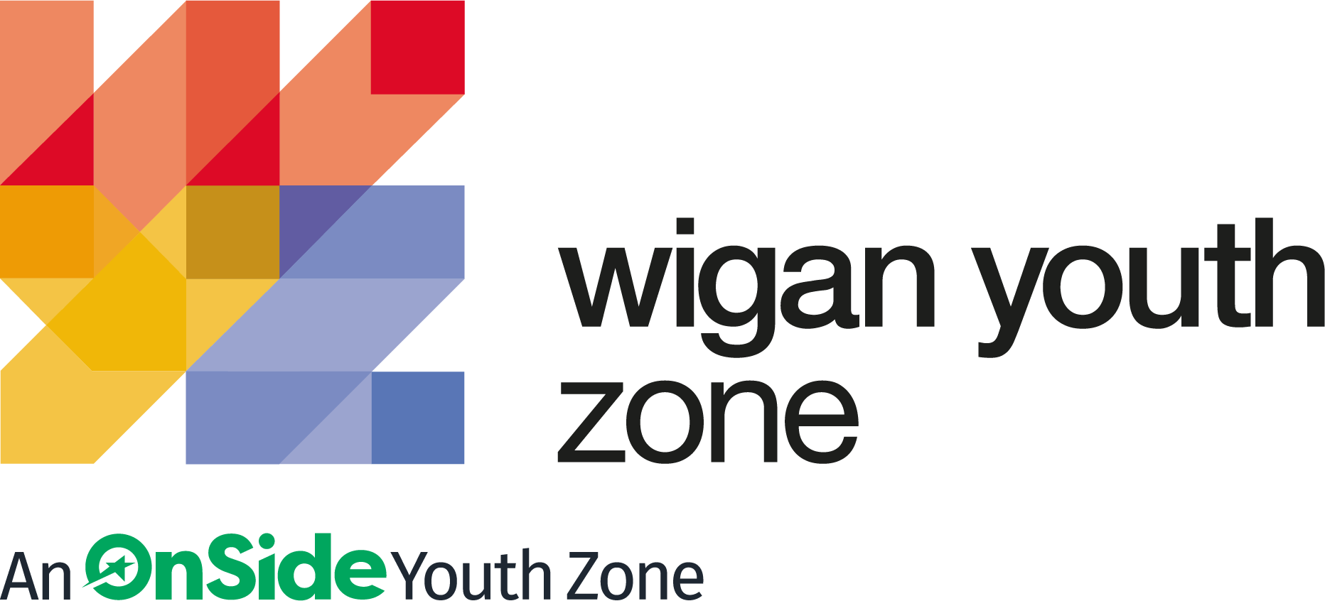

ROLE PROFILE
Employment Advisor

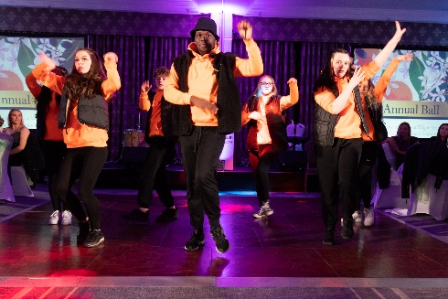
ROLE PROFILE

POST:
Employment Advisor

SALARY:
£20,000 - £22,000

LOCATION:
Leigh Youth Hub - Wigan Youth Zone

REPORTING TO:
Senior Employment Advisor

CONTRACT:
12 month Full time 40 hours per week- (continuous funding based on contract success with DWP) Sept 22 – Jul 23

BENEFITS:
Hybrid working offered; Gym access; Training opportunities and CPD delivered in-house or by partner organisations (such as Wigan Council and the OnSide Talent Academy) – including First Aid, Safeguarding and Health and Safety; Career Development Opportunities; Birthday Off; Employee Assistance Programme (EAP); Cycle to Work Scheme; Strong team culture.

We are a proud Supporter of the Greater Manchester Good Employment Charter, first of its kind in the UK, which aims to improve employment standards across GM. #GoodEmployment.

JOB PURPOSE

Wigan Youth Zone is excited to form a brand-new partnership with DWP to deliver Employability initiatives in the Borough of Leigh in the brand new State of the Art Leigh Youth Hub opening September 2022. The future of the programme will be based on the first 12 months and we are seeking a self - motivated individual to support the development of this new area of work for Wigan Youth Zone.
The post also involves the delivery of targeted programmes to support young people not currently in education, employment or training into positive destinations.

ABOUT WIGAN YOUTH ZONE

We’re Wigan Youth Zone and our vision is to inspire and empower young people in Wigan and Leigh to fulfil their potential. We do this by giving young people in Wigan and Leigh aged 8-19 (up to 25 with additional needs) the freedom to discover themselves in an innovative, safe and social environment and to support their transition into adulthood.

Centrally located in Wigan Town Centre, Wigan Youth Zone is the largest youth club in Europe and makes a bold statement about the importance of giving young people high quality places to go in their leisure time. The two-storey building has a four-court sports hall with climbing wall, a fully fitted fitness suite, a boxing gym, dance and performing arts studios, as well as music, media and visual arts facilities.

There is also a cafe, together with recreational and social areas. Externally there are four all-weather kick-pitches and full-size skate park. In addition to the work which happens in the facility, there is also a team who work across the borough to meet young people on their turf – whether this is through street-based youth work or via a satellite centre.

The services provided by the exceptional Wigan Youth Zone staff are delivered 7 days a week, 52 weeks a year, providing local young people with somewhere to go, something to do and someone to talk to. Since opening, the Youth Zone has facilitated over 675,000 visits to over 29,000 young people with impressive outcomes for those members across a range of measures such as confidence building, facilitating positive relationships and instilling ambition for adulthood.

CONTEXT OF THE ROLE

Wigan Youth Zone, the largest youth club in Europe, is centrally located, dedicated to young people and makes a bold statement about the importance of giving young people high quality places to go in their leisure time. The two-storey building has a four-court sports hall with climbing wall, a fully fitted fitness suite, a boxing gym, dance and performing arts studios, as well as music, media and visual arts facilities. There is also a cafe, together with recreational and social areas. Externally there are four all-weather kick-pitches and full-size skate park. Wigan Youth Zone is open 7 days a week, 52 weeks a year, providing local young people with somewhere to go, something to do and someone to talk to for almost eight years, winning UK Youth’s award ‘Youth Organisation of the Year’ in 2018 and shortlisted for the ‘Youth Work Award’ in the Children and Young People Now Awards 2020.

We are excited to be part of the new partnership at Leigh Youth Hub working alongside DWP, Wigan Council and Leigh Sports Village on this exciting new programme. The team will be based in Leigh Youth Hub which is on the site of Leigh Sports Village and will have regular liaison with the wider team at Wigan Youth Zone. The role of the Employment Advisor would be to deliver employability programmes to groups of cohorts of young people and ensure young people are recruited and outcomes achieved.

DUTIES AND RESPOSIBILITIES – GENERAL

- Be a role model for young people and present a positive “can do” attitude
- Take personal responsibility for own actions
- Commit to a culture of continuous improvement
- Work within the performance framework of Wigan Youth Zone and OnSide
- Represent Wigan Youth Zone positively and effectively in all dealings with internal colleagues, and external partners
- Comply with all policies and procedures, with particular reference to safeguarding, codes of conduct health and safety and equality and diversity to ensure all activities are accessible
- Represent Wigan Youth Zone positively and effectively in all dealings with internal colleagues, and external partners
- To be alert to issues of safeguarding and child protection, ensuring the welfare and safety of Youth Zone members is promoted and safeguarded, and to report any child protection concerns to the designated Child Protection Officers using the safeguarding policies, procedures and practice (training to be provided)
- To assist with any promotional activities and visits that take place at the Youth Zone
- To actively promote the Youth Zone and positively contribute towards increasing Youth Zone membership

DUTIES AND RESPONSIBILITIES – DETAILED

- To support the Leigh Youth Hub Employability programme team and contract from:
  - Recruitment
  - Delivery
  - Retention
  - Positive Outcomes
- Develop meaningful relationships with young people to support them, whilst maintaining professional boundaries, in order to achieve positive outcomes;
- Provide personalised support and high quality advice to enable young people to overcome personal and practical barriers, based on individual needs;
- Deliver in line with the programmes ‘test-and-learn’ approach by developing and testing new and varied approaches to find out the impact in progressing different young people toward employment;
- Implement effective and timely reviews in line with the programmes monitoring requirements;
- Job Brokering for students, working with local employers and patrons to secure live opportunities for our young people
- Carry out regular review and evaluation of terms on the current DWP bid, including capturing the outcomes and positive impacts, recording soft and hard outcomes, presenting case studies and celebrating the achievements of young people
- To achieve KPI’s set by the Board, Chief Executive, Head of Operations and external funders, including for example, progression into employment and training or the development of employability skills
- To ensure the team outcomes are met.
- To deliver accreditation such as PEARL or BTEC to young people, including taking responsibility for related administration.
- To manage, train, support and develop another Employability advisor to contribute to the programme.
- To motivate, encourage and support young people to participate fully in sessions
- To manage the budget and other resources effectively to maximise the benefits to young people
- To work with the Youth Zone staff to identify opportunities and funding for additional experiences and openings for young people relating to enterprise and employability
- To develop effective joint working with job centres and other training providers and other agencies to ensure a holistic approach in service delivery to young people, including representing Wigan Youth Zone at meetings with partner agencies
- To collaborate with the offer at Wigan Youth Zone and occasionally at events and special occasions be made available to support the Wigan Youth Zone team.
- Carry out any other reasonable duties as requested by management

THE POWER OF YOUTH WORK

We believe all young people deserve the opportunity to shine. But opportunity is about more than bricks and mortar, sports courts and sound studios. The amazing equipment in our Youth Zones is important. But their real impact comes from the life-changing youth work that is at the heart of everything we do.
With every workout or kick a bout, every mock interview or muck around with mates, young people develop the resilience to face challenges and the skills to solve problems.

They find confidence to aim high and the determination to become who they want to be. They build positive relationships based on being given the space to talk, an understanding of their own self-worth, and a sense of belonging to something bigger.

This approach, since opening in 2013, has led to the work of the Youth Zone generating a social value for the community of over 2:1 – meaning that for every £1 generated into the charity, the impact is more than doubled. These outcomes have been continually recognised locally, regionally and nationally by a variety of award-giving organisations such as UK Youth, Children and Young People Now and the North West Charity Awards.

That’s the power of exceptional youth work.

INSIDE A YOUTH ZONE
Youth Zones give 8-19 year olds, and up to 25 for young people with additional needs, affordable access to a broad range of services. Containing state-of-the-art facilities, Youth Zones give young people the opportunity to take part in over 20 sporting, artistic, cultural and recreational activities every evening and weekend throughout the year plus all through the school holidays.

Facilities include an indoor sports hall; music room and recording studio; training kitchen; boxing gym and mixed martial arts studio; enterprise and employability room; outdoor 4G sports MUGA; wellbeing room; climbing wall; café; media room and more.

Employing high ratios of exceptional youth and activity workers and volunteers, our Youth Zones change the lives of many thousands of young people each month, delivering social impact on an incredible scale.

Wigan Youth Zone is a place of activity, adventure and fun for all young people where they can try new experiences and learn new skills. Wigan Youth Zone supports young people to reach their full potential, grow their dreams and achieve their goals.
Learn more here
https://www.wiganyouthzone.org/our-present-our-past-our-impact/
We are looking for someone who can deliver this aspiration for Wigan’s young people and share the following values:

- Is a positive role model for young people and who believes in and recognises young people’s potential

- Has a positive and “can do” attitude

- Takes responsibility for their own actions

- Is committed to a culture of continuous improvement and subscribes to a “tonight’s better than last night” philosophy

- Is willing to go the extra mile to ensure great provision for young people

SELECTION CRITERIA | REQUIREMENT
EXPERIENCE
- Proven experience of working with young people aged 8 to 19 (25 with disabilities) in a range of settings | Essential
- Proven experience of engaging vulnerable, disengaged or hard to reach young people | Essential
- Experience working in a team and with volunteers | Essential
- Experience of youth work and delivering youth work programmes | Essential
- Experience of delivering employability programmes and workshops to with young people | Essential
- Experience supporting NEET 16-21 year olds into positive destinations | Essential
Experience of monitoring and evaluation processes | Desirable
- Experience of work with those with disabilities and additional needs | Desirable
- Experience managing externally funded projects | Desirable
- Experience providing information, advice, guidance and support to young people | Desirable
- Experience of dealing with safeguarding issues within a multi-agency setting | Desirable
Skills
- Excellent written and verbal communication | Essential
- Ability to coach, encourage, motivate and provide reliable support to children and young people | Essential
- Ability to work with groups of young people | Essential
- Strong commitment to young people and ability to engage and build positive relationships with disengaged young people | Essential
- Ability to establish good professional relationships with young people, adults and partner agencies/organisations | Essential
- Ability to manage and organise several tasks at a time | Essential
- Ability to take initiative and work creativity | Essential
- IT literate | Essential
Knowledge
- Knowledge of the issues affecting young people | Essential
- Understanding of the principles of working with children and young people | Essential
- Knowledge of recruitment and selection process | Desirable
- Knowledge of health and safety, diversity awareness  and safeguarding best practice and how these relate to children and young people | Desirable
Educational/Vocational qualification
- A professional qualification at level 4 or above | Essential
- GCSE or equivalent literacy and numeracy | Essential
- A professional youth work or teaching qualification at level 3 or above (or equivalent) | Desirible
Special requirements
- A willingness to work unsociable hours when required | Essential
- DBS clearance and committed to Safeguarding children | Essential
- The ability and willingness to travel to meetings and events both in the region and beyond | Essential

GENERAL INFORMATION

In accordance with our Child Protection and Safeguarding procedures, this position requires an enhanced DBS check and positive references.

Please note that, for Safeguarding reasons, all applicants have to be in-active as Wigan Youth Zone members for the last 12 months before applying for roles. Also, all applicants must be over 18 to work with the Juniors’ and Holiday Club and over 21 to work with the Seniors at WYZ.

APPLICATION DETAILS
RECRUITMENT PACKAGE

SALARY:
£20,000 - £22,000

HOLIDAYS:
33 Days per annum

CLOSING DATE FOR APPLICATIONS:
Sunday 7th August 2022

START DATE:
ASAP

We reserve the right to close this vacancy early if we receive sufficient applications for the role. Therefore, if you are interested, please submit your application as early as possible.

As an equal opportunities employer, we welcome applications from under-represented groups; in particular from Black, Asian and Minority Ethnic individuals, people with disabilities and members of LGBTQ+ community. Our Senior Management Team, actively ensures a culture where everyone can be themselves and thrive.

For information on how Wigan Youth Zone processes your data, go to
https://www.wiganyouthzone.org/privacy-policy/

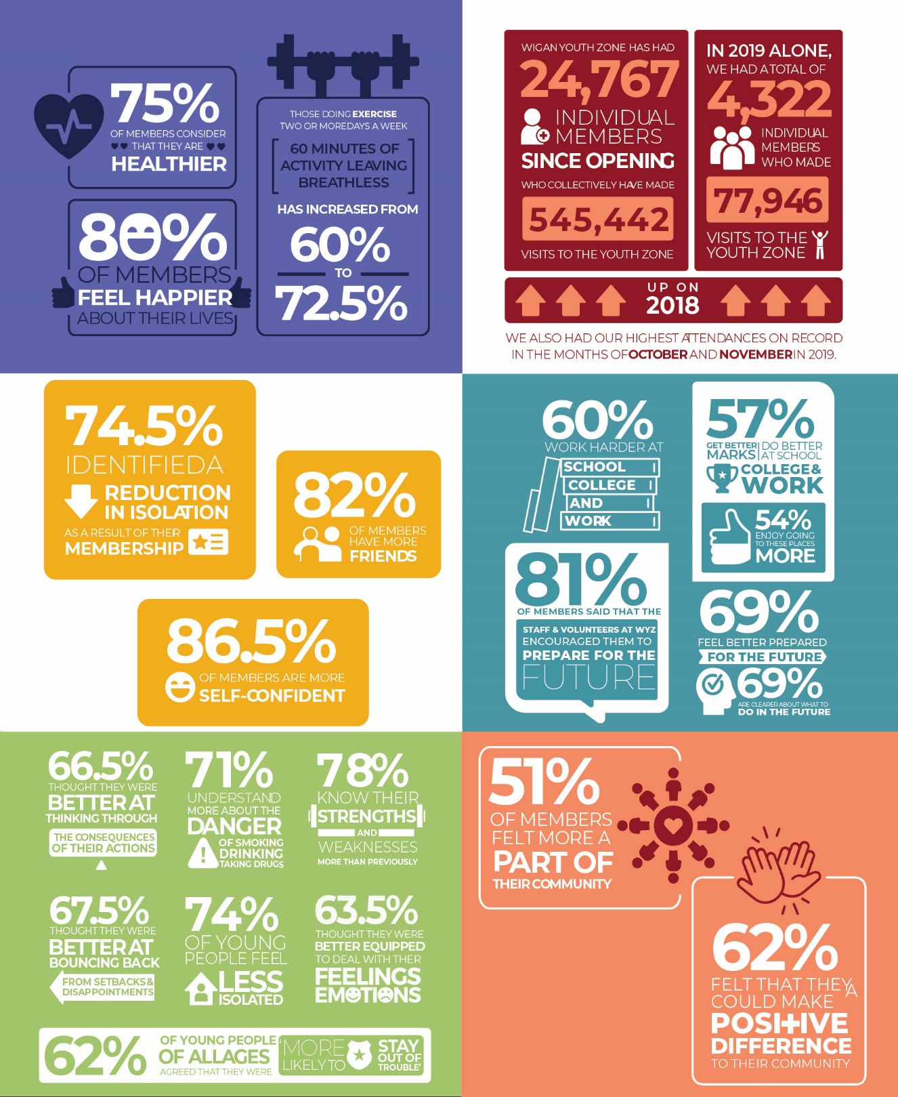

Our Vision
Our vision is to inspire and empower young people in Wigan and Leigh to fulfil their potential.

Our Mission
Our mission is to give young people in Wigan and Leigh aged 8-19 (up to 25 with a disability) the freedom to discover themselves in an innovative, safe and social environment and to support their transition into adulthood.

Our Values
Y oung person centred approach
O pen, inclusive and respectful environment
U niversal programming consistently on offer which is inspirational and aspirational
T ruly meaningful opportunities for the youth voice and empowerment
H elping young people to build positive relationships to enable them to reach their potential

